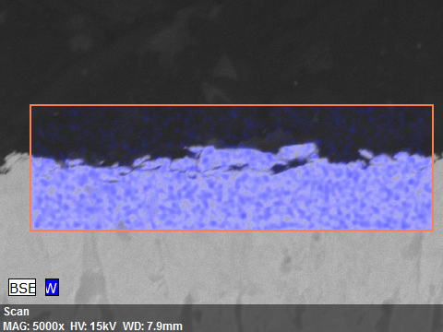
ScanDate:30-Aug-22 11:06:12 AMImage size:480 x 360Mag:5000xHV:15.0kV

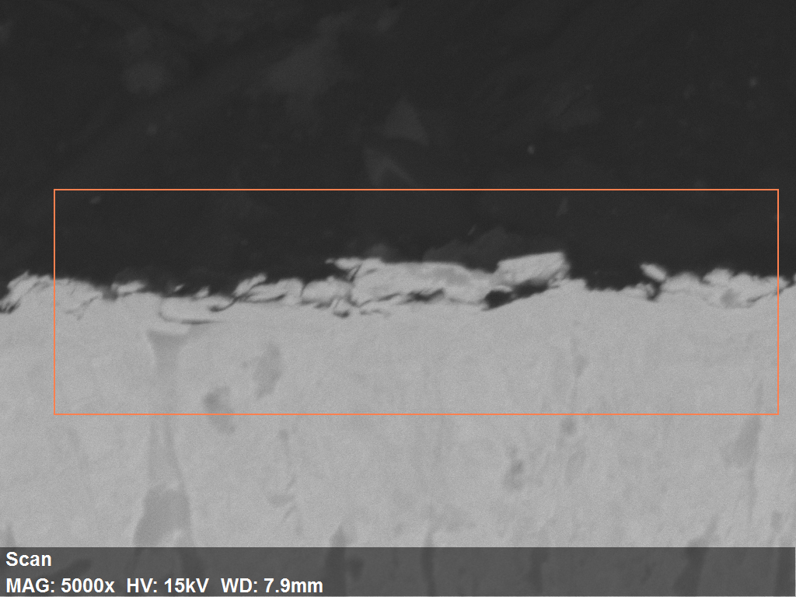

1.
30-Aug-22

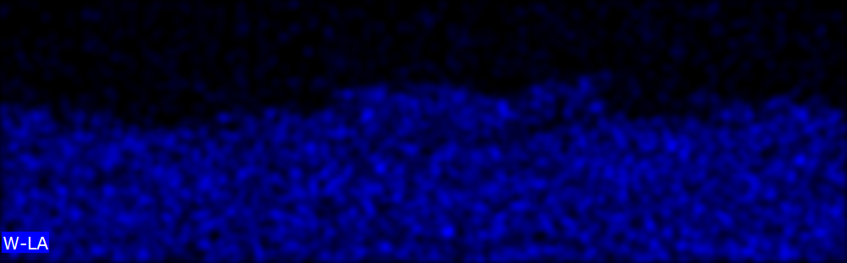

2.

