Consumer Driven Orange-Flavoured Beverage Formulation and Manufacturing
You are invited to participate in a research project engaging consumers to formulate & manufacture orange flavoured beverages. This will involve a sensory evaluation workshop using a novel technique which is interval-valued sensory evaluation to taste our very own orange beverage recipes.
The workshop takes around 1 hour. You will be asked to answer a series of questions regarding certain attributes of an orange beverage you’ve been given. The purpose of the exercise is understand how people’s perceptions of orange drinks map to measured ingredients.
Every participant will be rewarded will be rewarded with £5 Premier Foods Voucher which you use for number of brands under Premier Foods umbrella in any UK supermarkets. Also your participation will be a valuable addition to our research and your responses could lead the customized beverage formulation in the food industry.
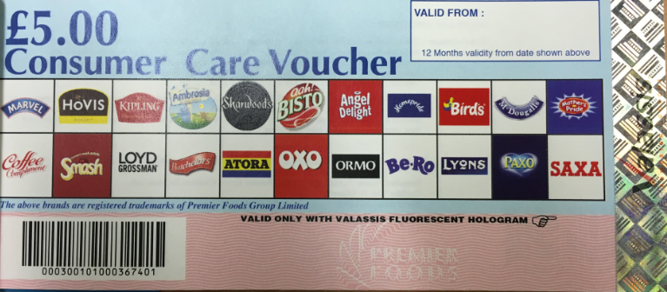
If you are willing to participate please register at the following link. If you have any question please do not hesitate to ask.
https://www.eventbrite.co.uk/e/consumer-driven-orange-flavoured-beverage-formulation-tickets-41105429446?utm_term=eventurl_text
Sensory Evaluation Workshop:
Date: 14th Dec 2017 between 13.00 and 15.00, Building 83, B. Wallis Main Room
This workshop is to measure sensory attributes of orange beverages and how these relate the consumer preferences.
Best wishes
Samet

