Yield-SAFE
Description and Calibration Guide

School of Water, Energy and Environment
October 2023
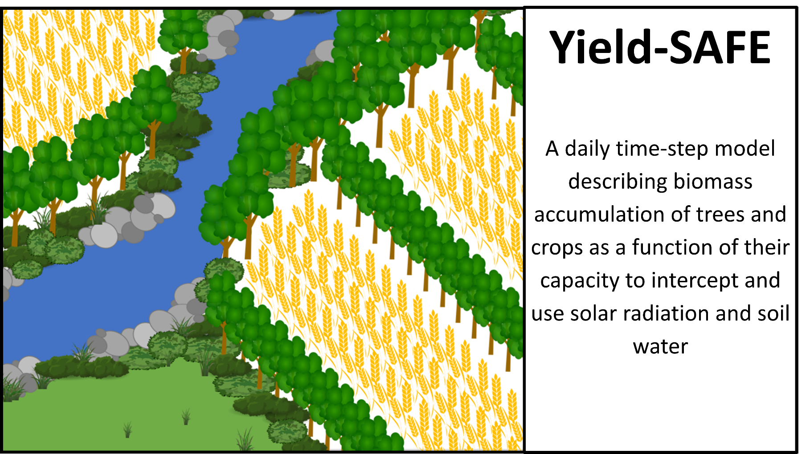

Executive summary
This description and calibration guide describes:
• the data and equations used in the Yield-SAFE biophysical model,
• the parameters used in the Yield-SAFE model, based on field data collected at the Silsoe silvoarable site.
• the calibration of the parameterised model to optimise the fit between actual and predicted data.
• the validation of parameterisation and calibration by comparing model predictions to actual data from the Leeds silvoarable site.

Paul Burgess¹, Anil Graves¹, Matt Upson¹, Catherine Wiltshire¹, Michail Giannitsopoulos¹, Klaas Metselaar², Roel Stappers², Karel Keesman², João Palma³, David, J, Pilbeam⁴, and Wopke van Der Werf²

¹Cranfield University, Cranfield, Bedfordshire MK43 0AL,
²Wageningen University, P.O. Box 43, 6700 AA, Wageningen, The Netherlands.
³MVARC, Moinhos de Vento, Espirito Santo, Mertola 7750-217, Portugal
⁴School of Biology, University of Leeds, Leeds LS2 9JT, UK

P.Burgess@cranfield.ac.uk

Suggested reference: Burgess, P.J., Graves, A.R., Upson, M., Wiltshire, C., Giannitsopoulos, M., Metselaar, K., Stappers, R., Keesman, K., Palma, J., Pilbeam, D.J., van der Werf, W. (2023). Yield-SAFE Description and Calibration Guide. Cranfield, Bedfordshire, UK, Cranfield University. 46 pp.

Table of contents
1 Description of the Yield-SAFE model 3
2 Data and parameters used in Yield-SAFE 4
2.1 Meteorological 4
2.2 Tree data 5
2.3 Crop parameters 7
2.4 Soil, irrigation and environmental parameters 8
3 Equations used in Yield-SAFE 9
3.1 The Yield-SAFE worksheet 9
3.2 Date and meteorological data 9
3.3 Tree growth calculations 10
3.4 Crop dynamics 14
3.5 Soil water dynamics 16
3.6 Environmental assessment 18
4 Model parameterisation and calibration 19
4.1 Description of the calibration site 19
4.2 Meteorological data 20
4.3 Parameterisation 22
5 Validation 33
5.1 Site – Leeds 33
5.2 Parameterisation 35
5.3 Model fitting 36
6 Acknowledgements 39
7 References 39
8 Appendix 41
Appendix A. Initial shoot number and biomass of trees 41
Appendix B. Maximum number of shoots per tree 42
Appendix C. Effect of tau on deciduous trees 43
Appendix D. Phased light extinction coefficient for trees 44
Appendix E. Tree root length 45

Cranfield University assumes no liability for any losses resulting from the use of the research results or recommendations in this report

Description of the Yield-SAFE model
Agroforestry can be defined as the integration of trees with grass and/or arable crops on the same parcel of land. Compared to monoculture arable or grassland systems, agroforestry can enhance soil conservation, carbon sequestration, species and habitat diversity, and provide additional sources of farm income. As the trees increase in size, the grass and arable yields will tend to decline due to the space allocated to tree rows in arable systems, and due to light and water competition. However, the form of the tree-crop yield relationships will vary with the level of solar radiation, rainfall, the species being grown, management actions such as choice of planting date and pruning, the soil type, and the time from tree planting.

To enable the prediction of the relationship between tree and crop yields over the rotation of the tree component, typically 20-60 years, a computer simulation model called Yield-SAFE was developed as part of the EU sponsored SAFE project (van der Werf et al., 2007; Graves et al. 2010). The full name for Yield-SAFE is the “YIeld Estimator for Long term Design of Silvoarable AgroForestry in Europe”. Companion models include Plot-SAFE (a plot-scale bio-economic model) (Burgess et al. 2004), Farm-SAFE (a farm-scale economic model using yield responses from Yield-SAFE) (Graves et al. 2011), and Hi-sAFe (a detailed 3-D model for more detailed biophysical assessments of tree-crop interactions) (Dupraz et al. 2019). Versions of Yield-SAFE have been used to assess the financial and economic impact of agroforestry systems (García de Jalón et al., 2018; Giannitsopoulos et al., 2020). This document describes Yield-SAFE v2, which is the name that we have given to the model used by Matt Upson in his PhD for modelling a silvoarable agroforestry system with poplar (Upson, 2014).
The general principle we followed in developing Yield-SAFE was to minimise the number of state variables and parameters as much as possible, whilst still being able to describe the main aspects of the capture of solar radiation and water by tree and understorey crops. This document can be read alongside a description of the layout of the different worksheets in a Microsoft Excel version of the model (Burgess et al., 2023).

The state variables include:
- Biomass of the tree component used to derive tree volumes
- Biomass of the crop component used to derive crop yields
- Leaf area of the tree component used to determine radiation capture
- Leaf area of the crop component used to determine radiation capture
- Number of shoots of tree which constrains the potential leaf area within a given year
- Heat sum of crop development
- Available soil water which determines the degree of drought stress

Data and parameters used in Yield-SAFE
This section describes the algorithms used with the Yield-SAFE model as implemented in Microsoft Excel.

The first section describes the meteorological data. Further sections focus on the tree component, the crop component, and the soil component (including irrigation and environmental data).

Meteorological
The daily meteorological data required for Yield-SAFE are daily incoming total shortwave radiation, the daily precipitation and the mean temperature (Table 1).

Table 1. Meteorological parameters required for Yield-SAFE
 | Inputs
I | Daily incoming total shortwave radiation | MJ m⁻²
P | Daily precipitation | mm³ (mm² tree area)⁻¹
T | Mean temperature at 150 cm above soil surface | °C

Finding meteorological data for sites is not easy. One possible source of the data is using the CliPick model developed by Joao Palma (Figure 1) (Palma 2017).

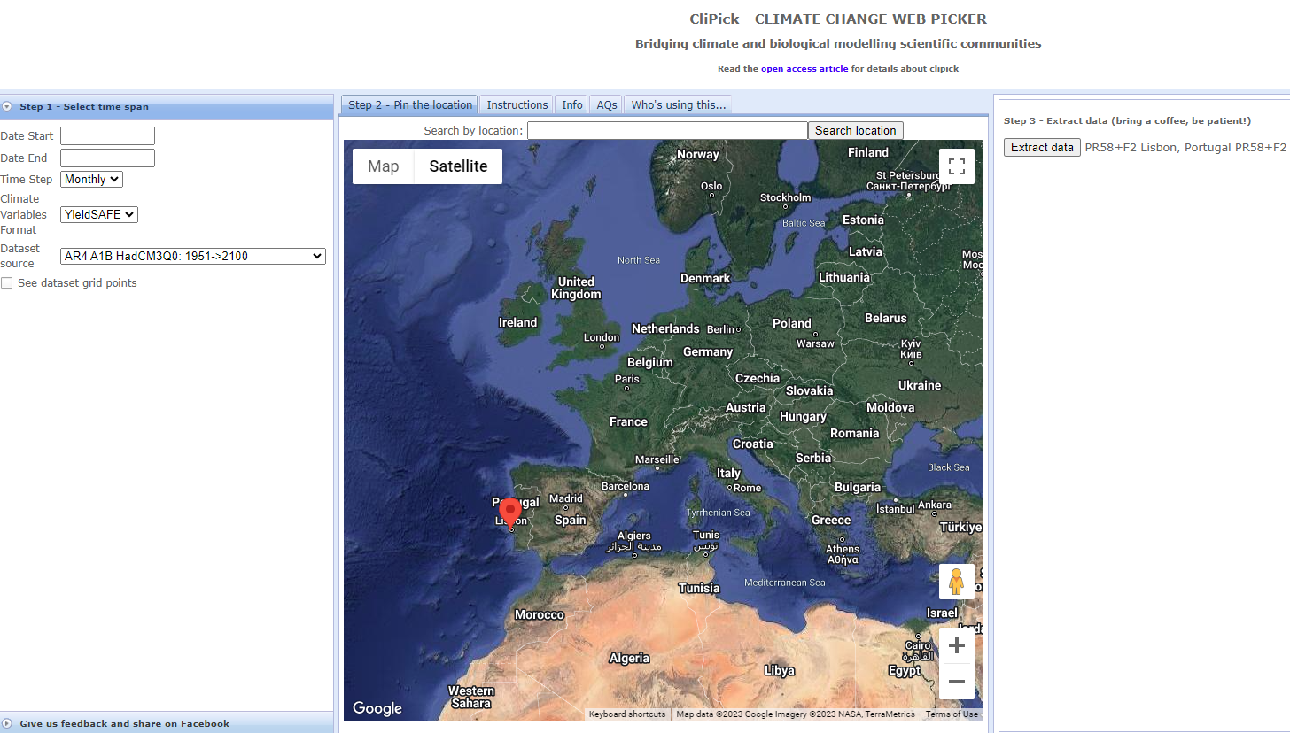
Figure 1. The CliPick model provides daily time step meteorological data for a range of locations in Europe using existing climate datasets (Palma 2017)

Tree data
The tree data include parameters describing the initial tree conditions, tree management parameters, and parameters that are used on a daily time-step to describe tree development and growth (Table 2). The height of the bole is the height of trunk without side branches, which can be determined by incremental pruning.

Table 2. List of initial conditions for the tree component
Tree parameters
Initial conditions
ρ_{t} | Tree density | tree m⁻²
N_{shoots0} | Initial number of shoots (See Appendix A) | Shoots tree⁻¹
B_{to} | Initial biomass of tree (See Appendix A) | g tree⁻¹
B_{heighto} | Initial bole height of tree | m
LA_{o} | Initial leaf area of the tree | m² tree⁻¹
Tree parameters
Management parameters
DOY_{planting} | Day of year of planting | Day of year
DOY_{pruning} | Day of year of pruning | Day of year
H_{prune} | Increment of prune height | m
π_{b} | Proportion of the tree biomass pruned
π_{s} | Proportion of the shoots pruned
B_{height} | Maximum height of the bole | m
DOY_{thinning} | Day of year of thinning


Bole height
Figure 2. Schematic representation of some of the tree parameters

Table 3. List of operational tree parameters
Parameters
Ap | Power function for relationship between tree height and diameter
DOY_{budburst} | Day of year of budburst | Day of year
DOY_{leaffall} | Day of year of leaf fall | Day of year
ε_{t} | Above-ground dry matter to shortwave intercepted radiation | g MJ⁻¹
F | Form factor for the tree
γ_{t} | Water needed to produce 1 g of above-ground biomass | m³ g⁻¹
k_{t} | Radiation extinction coefficient
K_{shoot} | Calculated value
K_{Main} | Maintenance coefficient (fraction of biomass)
$$LA_{tree}^{max}$$ | Maximum leaf area of an individual tree (See Appendix B) | m² tree⁻¹
$LA_{tree}^{max}$ratio | Ratio between $LA_{ss}^{max}$and $n_{Shoots}^{max}$ (See Appendix B)
$$LA_{ss}^{max}$$ | Calculated maximum leaf area for a single shoot (See Appendix B) | m² shoot⁻¹
$$n_{Shoots}^{max}$$ | Calculated maximum number of shoots (See Appendix B) | Shoots tree⁻¹
π_{branch} | Proportion of the above-ground biomass that forms branches
π_{timber} | Proportion of the above-ground biomass that forms timber
ρ_{timber} | Density of dry timber | g m⁻³
pFcrit_{c} | Critical pF value for tree growth | log(cm)
PWP_{t} | Permanent wilting point for the tree | log(cm)
$$σ_{height}$$ | Ratio of tree height to tree diameter for a free growing tree
$$\frac{dσ_{height}}{∂ρ_{t}}$$ | The change in $σ_{height}$ with density | (tree m⁻²)⁻¹
$$σ_{canopy}$$ | Ratio of canopy width (C_{width}) to canopy depth (C_{depth}) i.e. (C_{width}/C_{depth})
τ_{t} | Time constant (tau) representing the number after bud-burst at each the leaf area reached 63.2% of its maximum leaf area (See Appendix C) | day
 | Wood moisture content
a | Light extinction "a" value (See Appendix D)
b | Light extinction "b" value (See Appendix D)
π_{S R} | Ratio of structural roots to aboveground biomass (added March 2014; See Appendix E)
r | Length of fine root per gram of structural root (added March 2014; See Appendix E) | m g⁻¹
k_{r} | Extinction coefficient determining the interception of water per unit of root length (added March 2014; See Appendix E)
DOY_{fruitset} | DOY fruit set | Day of year
π_{bf} | Proportion of biomass to fruit

Crop parameters
The parameters used for the crop component of the Yield-SAFE model are outlined in Table 4.

Table 4. List of crop parameters
Crop parameters
Management parameters
DOY_{sowing} | Day of year of sowing | Day of year
DOY_{harvest} | Day of harvest (if T_{sumharvest} not reached) | Day of year
T₀ | Temperature threshold | °C
T_{sumEmerge} | T_{sum} to plant emergence | °C d
T_{sum}R_{B} | T_{sum} at which partitioning to leaves starts to reduce | °C d
T_{sum}R_{E} | T_{sum} at which partitioning to leaves =0 | °C d
T_{sumharvest} | Temperature sum till harvest | °C d
Initial conditions
B_{cropo} | Initial above-ground biomass of crop | g (m² crop area)⁻¹
LA0 | Initial leaf area | m² m⁻²
p_{lo} | Initial partitioning factor of above-ground biomass to the leaves
Parameters
ε_{c} | Above-ground dry matter to intercepted shortwave radiation coefficient | g MJ⁻¹
γ_{c} | Water need to produce 1 g above-ground biomass -regional | m³ g⁻¹
HI_{crop1} | Harvest index for first crop component
HI_{crop2} | Harvest index for second crop component
k_{c} | Radiation extinction coefficient for crop
pFcrit_{c} | Critical pF value for crop growth | log(cm)
PWP_{c} | Permanent wilting point for the crop | log(cm)
θ_{crop1} | Water content (wet basis) of first crop component
θ_{crop2} | Water content (wet basis) of second crop component
s_{c} | Specific leaf area | m² g⁻¹
Irrigation Regime
Flag | (1 = yes; 0 = no)
 | Assumed critical deficit | mm
 | Application at critical deficit | mm
Notes:
- The initial leaf area need not be the same as initial biomass x initial partitioning to leaf coefficient / specific leaf area.
- It is possible to add harvest indices for two crop components i.e., grain and straw.
- An option (θ_{crop1}) has been added to account for the water content of a crop.

Soil, irrigation and environmental parameters
The list of soil parameters included in the Yield-SAFE model are described in Table 5. The model includes a “water use model” switch which allows the user to enable or disable the water-use component of the model. The model also includes irrigation parameters (Table 6) and environmental parameters (Table 7).

Table 5. List of soil parameters
Parameter | Description | Unit
$$α$$ | van Genuchten parameter | cm⁻¹
$$δ$$ | Hydraulic conductivity as a fraction of K_{s}
D | Effective soil depth | mm
$$∂_{eva}$$ | Potential evaporation per unit energy | mm MJ⁻¹
FC | Field capacity pF value
K_{s} | Hydraulic conductivity at saturation | mm d⁻¹
n | van Genuchten parameter
pFcrit_{E} | Critical pF value for evaporation | log(cm)
$$pF_{offset}^{E}$$ | pF where soil evaporation is 0 (comparable to permanent wilting point) | log(cm)
$$θ_{s}$$ | Saturated volumetric water content | mm mm⁻¹
$$θ_{r}$$ | Residual volumetric water content | mm mm⁻¹

Table 6. List of irrigation parameters
Parameter | Description | Unit
 | Irrigation model switch (yes/no)
Year_{Irrstart} | Year for starting irrigation
DOY_{Irrstart} | Day of year for starting irrigation
Year_{Irrend} | Year for finishing irrigation
DOY_{Irrend} | Day of year for finishing irrigation
Irr_{int} | Interval between irrigation events | d
Irr_{amount} | Amount of irrigation | mm d⁻¹

Table 7. List of environmental parameters
Symbol | Description | Units
RSR | Root to shoot ratio
Soil OM | % of organic matter in soil | 0-1
Depth of soil OM | Depth until the OM is present | m
Atmospheric deposition |  | kg ha⁻¹
N in organic fertilizer |  | kg ha⁻¹
N in mineral fertilizer |  | kg ha⁻¹
Soil bulk density |  | kg m⁻³
OM | Organic matter in soil | kg ha⁻¹
Beta | Recovery factor

Equations used in Yield-SAFE

The Yield-SAFE worksheet
The Yield-SAFE worksheet (Figure 3) updates the tree, crop and soil variables on a daily time-step. Each row in the worksheet represents a single day. The general flow of the calculations is from left to right with each column implementing a different equation. Within the description of the equations used in Yield-SAFE, the column number of the equation is indicated below.

This worksheet comprises five sections.
- Date and meteorological data: daily meteorological data for the specific period examined.
- Tree growth calculations: tree growth calculations based on a single tree.
- Crop dynamics: crop variables expressed relative to the cropped area.
- Soil water dynamics: soil water content, evaporation and water uptake
- Environmental assessment: calculation of root biomass and carbon and CO₂ sequestration
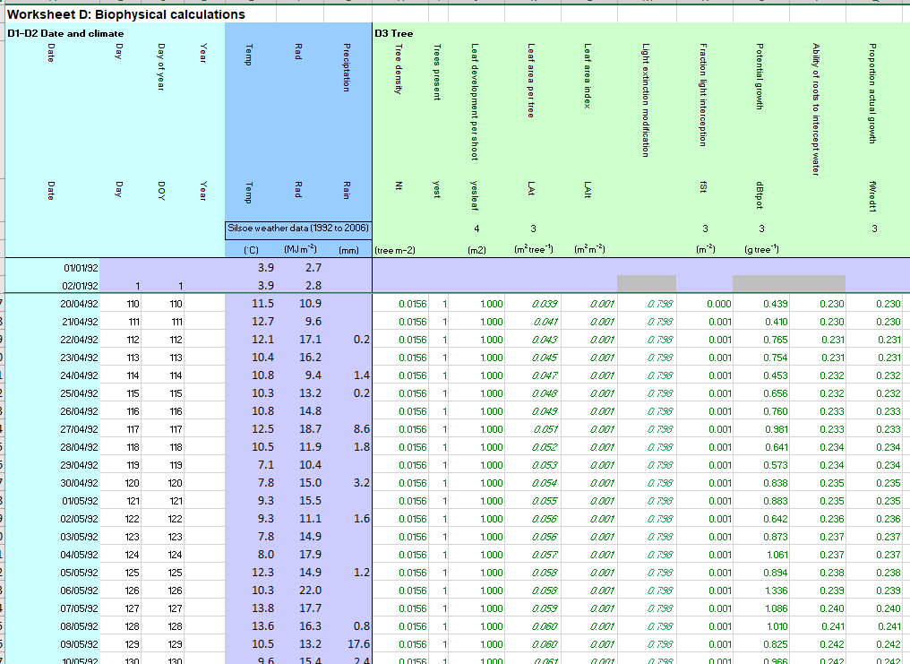
Figure 3. Example appearance of the Yield-SAFE worksheet

Date and meteorological data
The first seven columns of the worksheet describe the data, the Julian day, the temperature, the solar radiation, and the rainfall for each day.

Tree growth calculations
The tree growth calculations are based on a single tree, with state variable including the leaf area of the tree (LA_{t}) and the biomass of the tree (B_{t}) (Table 8).

Table 8. List of tree states
Symbol | Description | Units
$$ρ_{t}$$ | Tree density | Trees m⁻²
B_{t} | Biomass of tree | g tree⁻¹
CanopyArea | Proportion of the ground covered by tree canopy | %
C_{Depth} | Depth of tree canopy | m
C_{Width} | Maximum tree canopy width | m
Dbh | Diameter at breast height | m
H | Tree height | m
H_{prune} | Height of pruning | m
LA_{ss} | Leaf area per single shoot | m² shoot⁻¹
LA_{t} | Leaf area per tree | m² tree⁻¹
n_{Shoots} | Number of shoots per tree | Shoots tree⁻¹
V | Volume of timber | m³ tree⁻¹

Tree states

Leaf area
The initial condition for the leaf area of the tree (LA_{to}) = 0.
The process of increasing leaf area is enabled when the day of the year (DOY) is greater than the day of the year when bud burst occurs:
$DOY_{budburst}<DOY<DOY_{leaffall}$ (1.1)
The dynamics of the leaf area of a single shoot LA_{ss} (first-order dynamics) is given by:
$\frac{dLA_{ss}}{dt}=\frac{1}{τ_{t}}\left({LA}_{ss}^{max}- {LA}_{ss}\right)$ (1.2)

The discrete time equivalent is given by
$LA_{ss}\left(k+1\right)=LA_{ss}+(1-e^{\frac{-dt}{τ_{t}}})\left({LA}_{ss}^{max}- {LA}_{ss}(k)\right)$ (1.3)

The total leaf area of a tree LA_{t} is obtained by multiplying with the number of shoots n_{Shoots}
$LA_{t}=LA_{ss}n_{Shoots}$ (1.4)

Equations 1.3 and 1.4 can be rewritten as:
$LA_{t}\left(k+1\right)=LA_{t}(k)+(1-e^{\frac{-dt}{τ_{t}}})\left({LA}_{ss}^{max}n_{shoots}-LA_{t}(k) \right)$ (1.5; Column K)
For model calibration, the leaf area of a single shoot can still be used by defining:
(1.6)
The state is disabled when LA_{t} = 0. Error handling has to be in place to avoid division by 0. If division by 0 occurs, the ratio is set to 0.

Biomass
The initial biomass per tree is $B_{to}$. Biomass per tree is given by:
$B_{t}(k+1)=(1-π_{b})B_{t}(k)+ΔB_{t}^{Act}$ (1.7; column U)

This equation is enabled when
$DOY_{budburst}<DOY<DOY_{leaffall}$ or (1.8)
$DOY_{budburst}=DOY_{pruning}$

Number of shoots
The initial number of shoots per tree is $n_{Shootso}$

The number of shoots is based on a Michaelis-Menten type of relation between tree biomass B_{t} and the number of shoots n_{Shoots}
$n_{shoots}= n_{shoots}^{max}\left(\frac{B_{t}}{B_{t}+ K_{shoots}}\right)$ (1.9)
Taking the derivative of (1.9) with respect to time gives:
$\frac{dn_{shoots}}{dt}=n_{shoots}^{max}\frac{K_{shoots}}{{\left(B_{t}+K_{shoots}\right)}^{2}} \frac{dB_{t}}{dt}$ (1.10)

Equation (1.9) can be rewritten as:
$K_{shoots}=\frac{B_{t}\left(n_{shoots}^{max}- n_{shoots}\right)}{n_{shoots}}$ (1.11)

Substitution of equation 1.11 in equation 1.10 and using Euler forward gives:
$n_{shoots}\left(k+1\right)=\left(1-π_{s}\right)n_{shoots}\left(k\right)+\frac{n_{shoots}\left(k\right)}{B_{t}}\left(1-\frac{n_{shoots}(k)}{n_{shoots}^{max}}∆B_{t}^{Act}\left(k\right)\right)$ (1.12; column V)

An alternative switching function is given by
$n_{shoots}=n_{shoots}^{max}\left(1-e^{-α_{shoots}B_{t}}\right)$ (1.13)

A safeguard has to be built in to avoid n_{shoots} exceeding the maximum number of shoots. The ratio n_{shoots} over $n_{shoots}^{max}$ should be set to 1 for values exceeding 1.
$\frac{n_{shoots}\left(k\right)}{n_{shoots}^{max}}=1 if n_{shoots}\left(k\right)> n_{shoots}^{max}$ (1.13b)

In addition, error handling has to avoid a division by 0 in the ratio n_{Shoots}/B_{t}. This division is set to zero, whenever it occurs.
$\frac{n_{shoots}\left(k\right)}{B_{t}}=0 if B_{t}=0$ (1.13c)

Rates and static relations

Radiation
The fraction intercepted by the tree per m² surface.
$f_{i_{t}}=1-e^{-k_{t}LA_{t}ρ_{t}}$ (1.14; column N)

The fraction transmitted by the tree per m² of soil.
$f_{t_{t}}=e^{-k_{t}LA_{t}ρ_{t}}$ (1.15)

The fraction reflected.
$f_{r_{t}}=0$ (1.16)

Potential growth
(1.17a; column O)

Water reduced growth
In March 2014, an addition made to the model was to include the capacity of the roots to intercept water. The capacity of the root to take up water (φ; coefficient between 0 and 1) is determined by the water interception per root length coefficient (k_{r}), and the length of fine root per length of structural root (r), and the proportion of biomass to structural roots (π_{SR}), and the biomass per tree (B_{t}). See Appendix E.

$ϕ=1- e^{\left(B_{t }π_{SR }r{ k}_{r}\right)}$ (1.17b; column P)

If $pF≤pFcrit_{t}, then f_{t}^{W_{red}}=$ φ
If $pFcrit_{t}<pF<PWP_{t}, then f_{t}^{W_{red}}=-\left(\frac{pF-pFcrit_{t}}{PWP_{t}-pFcrit_{t}}\right)$ (1.18)
If $pF≥PWP_{t}, then f_{t}^{W_{red}}=0$

The water reduced growth is given by
$ΔB_{t}^{W_{red}}=f_{t}^{W_{red}}ΔB_{t}^{Pot}$ (1.19; column S)

Actual growth
To avoid decline in tree state variables during winter it is assumed that there is no maintenance respiration in the leafless period.
$ΔB_{t}^{Act}=\begin{matrix}ΔB_{t}^{Wred}-K_{Main}B_{t} & if & DOY_{budburst}<DOY<DOY_{leaffall} \\ 0 & if & \left(DOY<DOY_{budburst}\right) or (DOY>DOY_{Leaffall})\end{matrix}$ (1.20; column T)

Water uptake
Water uptake is described by:
$W_{t}=γ_{t}ΔB_{t}^{W_{red}}$ (1.21; column W)

Tree timber volume
This equation describes the conversion from biomass to merchantable volume. The volume of timber V per m² is given by
$V_{t}ρ_{t}=\frac{π_{timber}B_{t}ρ_{t}}{ρ_{timber}}$ (1.22; column X)

Tree dimensions
The form factor for a tree F is determined from the relationship between the tree timber volume, tree height (H) and diameter at breast height (dbh)
$F=\frac{V}{Hπ{\left(\frac{dbh}{2}\right)}^{2}}$ (1.23a)

Relationship between the height and the diameter at breast height
$H=σ_{height}{\left(dbh\right)}^{ap}$ (1.23b)

Hence rearranging to give tree height and dbh:
$H={\left(\frac{4V{\left(σ_{height}\right)}^{\frac{2}{ap}}}{πF}\right)}^{\left(\frac{ap}{2+ap}\right)}$ (1.24; column Z)

$dbh={\left(\frac{4V}{πFσ_{height}}\right)}^{\left(\frac{1}{2+ap}\right)}$ (1.25; column AA)

The value of σ_{height} can be dependent on the plant density. Hence an additional parameter can be added to account for this. For poplar, as a rule of thumb, the value of is equal to:
$σ_{heightactual}=σ_{height}+\frac{∂σ}{∂ρ_{t}}ρ_{t}$ (1.26)

A relationship is also required to determine maximum canopy diameter. This is the basis for calculating subsidies in Spain.

For poplar it is assumed that there is a linear relationship between maximum canopy width (C_{Width}) and canopy depth (C_{Depth})(Burgess et al., 2003). The height of pruning (H_{prune}) is calculated as the sum of the pruned increments (1.27)

$H_{prune}=\sum_{0}^{t}{pruned increments}$ (1.27)

$C_{Depth}=H-\sum_{0}^{t}{pruned increments}$ (1.28)

$C_{Width}=σ_{canopy}C_{Depth}$ (1.29)

The proportion of the ground covered by the canopy (CanopyArea) is calculated as
If $ρ_{t}$=0, then CanopyArea = 0,
If $ρ_{t}$> 0, then $CanopyArea=100π{\left(\frac{C_{Width}}{2}\right)}^{2}ρ_{t}$, unless (1.30; column AO)
$CanopyArea=100 π{\left(\frac{C_{Width}}{2}\right)}^{2}ρ_{t}$ > 100, then CanopyArea = 100

Tree planting, thinning and harvest
The effect of planting and harvest is described by
$ρ_{t}(k+1)=ρ_{t}(k)+ρ_{tPlant}-ρ_{tHarvest}$ (1.31)

This is enabled when
DOY = DOY_{planting} or DOY = DOY_{harvest} (1.32)

Crop dynamics
Crop development is primarily determined by a designated planting date and the accumulation of thermal time. As the season progresses, leaf area and light interception increases, governing potential biomass accumulation. Actual biomass accretion is limited by the availability of water, which is driven by soil properties, rainfall, evaporation, and removal of water by the crop and trees. Biomass is partitioned to different aboveground tissues, thus driving the increase in leaf area from season to season.

Crop states
All crop variables are expressed relative to the cropped area (e). Typically, in a silvoarable system there is a proportion of the tree area, typically at the base of the trees, that is not cropped (1-Ar_{ct}). In this analysis the two proportions are analysed separately.

Table 9. List of crop states
Symbol | Description | Units
B_{crop} | Crop biomass | g (crop area)⁻¹
LAI_{crop} | Leaf area of crop | m² (m² crop area)⁻¹
p_{l} | Partitioning to leaves
T_{sum} | Thermal time above base temperature | °C d
Y_{crop} | Crop yield | g (crop area)⁻¹

Leaf area
Dynamics of the leaf area index of the crop, per unit cropped area, are given by:
$LAI_{crop}(k+1)=LAI_{crop}(k)+p_{l}(k)ΔB_{crop}^{Act}s_{c}$ (1.33; column BT)

Initial condition LAI_{crop0}
As biomass is expressed per unit cropped area, LAI is entirely comparable to the LAI in a monoculture.
The state is enabled when T_{sum} < T_{sumharvest} and T_{sum}>T_{sumEmerge} (1.34)

Biomass
$B_{crop}(k+1)=B_{crop}(k)+ΔB_{crop}^{Act}$ (1.35; column BU)
The initial biomass per cropped area (g m⁻² cropped area) = B_{crop0}

The state is enabled when T_{sum} < T_{sumharvest} and T_{sum} > T_{sumEmerge} (1.36)

Temperature sum
$T_{sum}(k+1)=T_{sum}(k)+\max\left\{0,T(k)-T_{o}\right\}$ (1.37; column BJ)
Initial condition T_{sum0} = 0
The state is enabled when T_{sum} < T_{sumharvest} and DOY > DOY_{sowing} (1.38)

Partitioning to leaves
Initial condition p_{l0} = 0.8
The partitioning function is defined by
$p_{l}(k+1)=p_{l}(k)-α_{c}ΔT_{sum}\left(k\right)$ (1.39)
where α_{c} is now calculated as
$α_{c}=\frac{p_{l0}}{{T_{sum}}_{RE}-T_{sumRB}}$ (1.40)
and the initial condition is calculated as
p_{l0}*= p_{l0}+ $\frac{T_{sumRB}}{T_{sumRE}-T_{sumRB}}$ (1.41)
The state is enabled when
T_{sum} < T_{sumharvest} and T_{sum} > T_{sumEmerge} (1.42)

If the differential equation is used in Excel, then errors are created. For instance, if the value of T_{sumRB} is 432°Cd and T_{sum} on day k and k+1 is 430°Cd and 434°Cd, then on a daily time-step the above equation would over-estimate the reduction in partitioning to leaves. Hence in Excel version, the following robust series of equations are used.
If $0<T_{sum}<T_{sumRB}, then p_{l}=p_{l0}$
If $T_{sumRB}<=T_{sum}<=T_{sumRE}, then{ p}_{l}=p_{l0}\left(1-\left(\frac{T_{sum}-T_{sumRB}}{T_{sumRE}-T_{sumRB}}\right)\right)$ (1.43; column BN)
If $T_{sum}>T_{sumRE}, then p_{l}=0$

Yield
Yield is described by:
$Y_{crop}=B_{crop}HI$ (1.44; column BZ)
The state is enabled when T_{sum} = T_{sumharvest}

Rates and static relations

Radiation
The fraction of solar radiation incident on the crop, intercepted by the crop per unit crop area
$f_{i_{ccop}}=1-e^{-k_{c}LAI_{crop}}$ (1.45; column BO)

The fraction of solar radiation transmitted by the crop per unit crop area
$f_{tcrop}=e^{-k_{c}LAI_{crop}}$ (1.46)

The fraction reflected
$f_{r_{t}}=0$ (1.47)

Potential growth
The potential growth per unit crop area
$ΔB_{crop}^{Pot}=ε_{c}f_{i_{crop}}f_{t_{t}}I$ (1.48; Column BP)

Actual growth
Water reduced growth is described by:
If $pF≤pFcrit_{c}, then f_{c}^{W_{red}}= 1$
If $pFcrit_{c}<pF<PWP_{c}, then f_{c}^{W_{red}}=1-\left(\frac{pF-pFcrit_{c}}{PWP_{c}-pFcrit_{c}}\right)$ (1.49)
If $pF≥PWP_{c}, then f_{c}^{W_{red}}=0$

The water reduced growth is given by:
$ΔB_{crop}^{Wred}=f_{c}^{Wred}ΔB_{crop}^{Pot}$ (1.50)

The actual growth is equal to the water reduced growth
$ΔB_{crop}^{Act}=ΔB_{crop}^{W_{red}}$ (1.51; column BS)

Water uptake
Water uptake by the crop per unit tree area is described by:
$W_{c}=γ_{c}ΔB_{crop}^{W_{red}}Ar_{ct}$ (1.52)

Soil water dynamics

Soil states
The soil states within the model include the soil water content and the soil water potential (Table 10).

Table 10. List of soil states and auxiliaries
Symbol | Description | Units
pF | log (Ψ) | log (cm)
$$θ$$ | Soil water content | mm mm⁻¹
Ψ | Soil water potential | cm head of water
P | Rainfall | mm³(mm² tree area)⁻¹ d⁻¹
W_{irr} | Irrigation | mm³(mm² tree area)⁻¹ d⁻¹
R | Runoff | mm³(mm² tree area)⁻¹ d⁻¹
F_{gw} | Flux to groundwater | mm³(mm² tree area)⁻¹ d⁻¹
F_{t} | Flux to trees | mm³(mm² tree area)⁻¹ d⁻¹
F_{c} | Flux to crops | mm³(mm² tree area)⁻¹ d⁻¹
E_{Act} | Actual evaporation flux | mm³(mm² tree area)⁻¹ d⁻¹

Volumetric water content
The initial soil water content is $θ_{o}$.

The water balance of the soil water is given by:
$θ(k+1)=θ(k)+\frac{P+W_{irr}-F_{gw}-F_{t}-F_{c}-E^{Act}}{D}$ (1.53)

For the calculation of water reduced growth for crop and tree we need the pF value of the soil. The pF value is given by pF = log (-h) where h is the pressure head (expressed in cm). Two popular function to relate pressure head to volumetric water content are the Brooks-Corey function and the van Genuchten function. In this model the van Genuchten function will be used which is given by:
$θ=θ_{r}+(θ_{s}-θ_{r}){\left[\frac{1}{1+(αΨ)^{n}}\right]}^{m}$ (1.54)
where Ψ is the suction head (cm) (Ψ = -h)

One common assumption which will be used in the model is that m and n are related by:
$m=1-\frac{1}{n}$ (1.55)

Furthermore, two inequality constraints are added to avoid infeasible state trajectories.
$θ_{r}≤θ≤θ_{s}$ (1.56)

Note that these constraints effectively simulate horizontal soil water flow to the soil compartment.ψ
From equation 5.2 it can be derived that
$Ψ=\frac{1}{α}{\left[{\left(\frac{θ-θ_{r}}{θ_{s}-θ_{r}}\right)}^{-\frac{1}{m}}-1\right]}^{\frac{1}{n}}$ (1.57)

The pF value of the soil can now be determined from:
pF = log (Ψ) (1.58 Column CF)

In equation 1.57, if θ = θ_{r} the result is not defined (division by 0). For error handling this may be corrected by adding a small value,$θ_{ε}$ to $θ$scaled =$\frac{θ-θ_{r}}{θ_{s}-θ_{r}}$ if (and only if) θ = θ_{r}. $θ_{ε}$ can be calculated using equation 1.54 with ψ =10⁶ cm (roughly an upper bound to pF-values).${ θ}_{ε}$ is a numerical value (moisture content) required to avoid numerical overflow.

Rates and static relations

Potential evaporation
In this version of the model to correctly describe evaporation the agroforestry system consists of two subsystems: a bare strip, which catches radiation transmitted by the trees, and the cropped area which catches radiation transmitted by the trees and the crop over it.

The potential evaporation is given by
$E^{pot}=∂_{eva}I_{scrop}$ (1.59; column CH)
Note that $I_{scrop}=\left(Ar_{ct}f_{t_{t}}f_{t_{crop}}+(1-Ar_{ct})f_{t_{t}}\right)I$ is the short-wave radiation reaching the soil and not intercepted by the crop and the tree.

Actual evaporation
There are typically two phases for soil evaporation: initially evaporation is determined by atmospheric conditions until a threshold soil moisture content is reached, subsequently the rate of evaporation is reduced in accordance with the rate of water transport from deeper soil levels to the surface (Ritchie, 1972).

The reduction factor is determined from:
If $pF≤pFcrit_{E}, then f_{E}^{w_{red}}=1$
If $pFcrit_{E}<pF<pF_{offset}^{E}, then f_{E}^{W_{red}}=1-\left(\frac{pF-pFcrit_{E}}{PF_{offset}^{E}-pFcrit_{E}}\right)$ (1.60)
If $pF≥PF_{offset}^{E}, then f_{E}^{W_{red}}=0$

Hence the actual evaporation is calculated from:
$E^{Act}=f_{E}^{W_{red}}E^{Pot}$ (1.61; column CK)

Flow to groundwater
Flow to groundwater is modelled by free drainage, assuming drainage to become zero for a soil drier than field capacity (F_{C}, assumed to be at pF 2.3).
$F_{gw}=δK_{s}$ (1.62; column CL)
It is assumed that the value for $δ$ is calculated assuming conductivity to follow a power law. It is calculated as:
$δ=\left\{\begin{matrix}10^{-(pF_{Fc}/2)} & if & pF≤pF_{Fc} \\ 0 & if & pF>pF_{Fc}\end{matrix}\right.$
where pF_{Fc} is the log(abs(pressurehead, cm)). Hence at a field capacity (generally pF_{Fc} = 2.3), this yields a value of roughly 0.07.

Crop water uptake
W_{c} (expressed in m³ (m² tree area)⁻¹ ) must be converted to units of mm³ (mm² tree area)⁻¹.
Crop water uptake:
$F_{c}=1000W_{c}$ (1.63; column CM)

Tree water uptake
Tree water uptake:
$F_{t}=1000ρ_{t}W_{t}$ (1.64; column CN)

Management
The soil water content can be directly affected by irrigation.

$W_{irr}=0,$ unless the irrigation model switch is on,$DOY_{Irrstart}≤DOY≤DOY_{Irrend}$ and
$Year_{Irrstart}≤Year≤Year_{Irrend}$ then:
If $\left(DOY- {DOY}_{irr}+ {Irr}_{int}\right)- {Irr}_{int}Integer\left(\frac{DOY- {DOY}_{irrstart}+{Irr}_{int} }{{Irr}_{int}}\right)=0,$
$then W_{irr}= {Irr}_{int}{Irr}_{amount} , else W_{irr}=0$ (1.65)

Environmental assessment
The environmental parameters are shown in Table 11.

Table 11. Environmental assessment parameters within Yield-SAFE
Symbol | Description | Unit
B_{t_root} | Root biomass | g tree⁻¹
C_{seq_C} | Carbon sequestration | t C ha⁻¹
C_{seq_CO2} | CO₂ sequestration | t CO₂ ha⁻¹

The root biomass is determined from the tree biomass (aboveground) and the root to shoot ratio (RSR)
B_{t_root} = B_{t} RSR (1.65; Column CS)

The carbon sequestration (t C ha⁻¹) is given by the following equation:
$C_{seq_C}=(B_{t}{+ B_{t_{root}}) C}_{w} ρ_{t}×{10}^{-2}$ (1.66)
where B_{t} = maximum aboveground biomass on the day of harvest (g tree⁻¹)
C_{w} = mean carbon content of biomass (assumed to be 0.479402), and
ρ_{t} = tree planting density (tree m⁻²)

CO₂ sequestration (C_{seq_CO2}; t CO₂ ha⁻¹) is obtained by multiplying the carbon sequestration (C_{seq_C}) by the ratio of the molecular weight of carbon dioxide to that of carbon (44/12 = 3.67).

Model parameterisation and calibration
This example parameterisation and calibration has been adapted from Upson (2014).

Description of the calibration site
In 1992 experimental sites incorporating hybrid poplar with arable crops were established at Cirencester, Leeds, and Silsoe as part of a Ministry of Agriculture, Fisheries and Food (MAFF) sponsored UK silvoarable trial. The Silsoe site was later managed as part of the Silvoarable Agroforestry for Europe (SAFE) project which investigated uncertainties related to silvoarable systems (Figure 14) (Burgess et al., 2005). Although management of the site ceased in 2003, following the end of the SAFE project, the site remained a valuable source of data for a poplar silvoarable system nearly two decades after establishment.
- Established: April 1992. Historic mapping suggests site had been under agriculture since at least the 1880s.
- Location: Olney field, Silsoe college site of Cranfield University (N52°0’8.06’’, W0°25’46.80’’).
- Topography: Almost entirely flat, with a minor slope to the east of less than 1%.
- Soil: Predominantly Holdenby series, a typical argilic pelosol, characterised as clay-loam with some flinty stones, overlying a similar mottled clay, passing to calcareous clay or mudstone with depth; slowly permeable, often remaining waterlogged in winter (Verma and Bradley, 1988). Soil shows marked level of swelling and shrinkage in response to wetting and drying. Over a depth of 1 m (Ashby, 2001) found a clay (< 2 µm), silt (2-63 µm), and sand content (63-200 µm) of 53.2%, 26.8%, and 18.4% respectively.

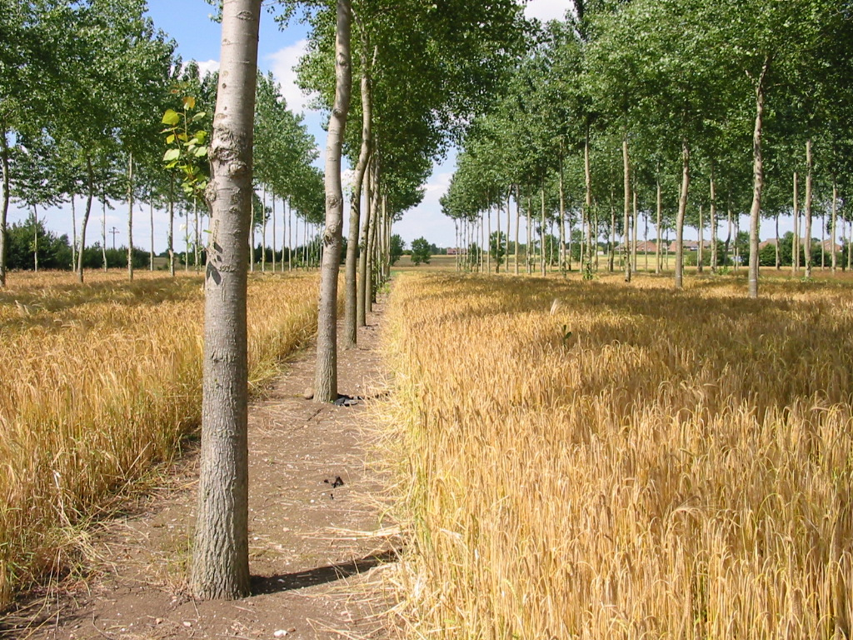
Figure 4. The silvoarable cropped treatment at Silsoe (Photo by Paul Burgess)

Meteorological data
A weather station was maintained at the Silsoe site for many years with data collected between 1992-2006. Data for between January 2008 and January 2012 were obtained from the MIDAS Land Surface Stations data (UK Meteorological Office, 2013). Instrumentation and the nature of the data recorded at MIDAS stations differ, hence data from a number of stations within a 20 mile radius were used. For meteorological values between 2012 and 2022, values between 2007 and 2012 (derived from MIDAS stations) were simply repeated (Figure 5).

Temperature
Temperature data were taken predominantly from the Woburn MIDAS station (ID: 458, Lat: 52.01°, Long: −0.59°, Elevation: 89 m); where gaps in the records exist, these were filled from data recorded at the Bedford MIDAS station (ID: 461, Lat: 52.23°, Long: −0.46°, Elevation: 85 m asl) (Figure 5). Mean daily air temperature recorded at the site was 10.4°C (minimum of −5°C, and maximum 27.7°C). Median monthly values for the years 1992-2006 ranged from 4.7°C (December) to 17.2°C (July).

Precipitation
Precipitation data were obtained from data recorded at the Woburn Sands MIDAS station (ID: 4326, Lat: 52.02°, Long: −0.66°, Elevation: 85 m asl). Missing data were taken from the Wilstead MIDAS station (ID: 4363, Lat: 52.08, Long: −0.43, Elevation: 37 m asl) (Figure 5). Total monthly precipitation varied between 1.2 mm d⁻¹ (March) and 2.3 mm d⁻¹ (October). Mean yearly precipitation was 633 mm, with a minimum of 410 mm in 1996, and a maximum of 867 mm in 2000.

Solar radiation
Mean monthly total shortwave radiation ranged from 1.9 MJ m⁻² d⁻¹ in December to 19.4 MJ m⁻² d⁻¹ in July. A gap in daily solar radiation values between 24 May 1992 and 4 June 1992 was filled with the mean of all extant measurements for May and June in 1992 (19.7 MJ m⁻²). Solar radiation values from MIDAS stations in Bedfordshire were found to be inconsistent, hence, solar radiation data were taken from the Rothamsted MIDAS station (ID: 471, Lat: 51.81°, Long: −0.36°, Elevation: 128 m asl) (Figure 5).

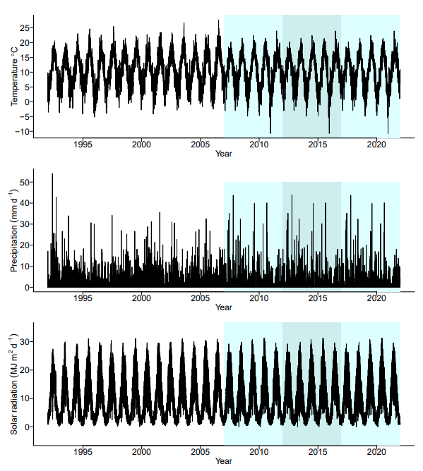
Figure 5. Weather data used in Yield-SAFE for modelling poplar growth. See text for a description of the sources used. Shaded regions indicate where data have been repeated. Reproduced from Upson (2014).

Parameterisation
Table 12 presents the initial parameters used for the poplar at the Silsoe site (Graves et al., 2010). Upson (2014) was able to access additional poplar measurements and used these to update some of the parameters.

Table 12. Initial parameters used in Yield-SAFE (Graves et al., 2010) and updated values reproduced from Upson (2014). Updated values indicated in grey.
Parameter | Description | Units | Graves et al. (2010) | Upson  (2014)
t_{plant} | Date of year – planting | J. day | 2 | 2
t_{prune} | Date of year – pruning | J. day | 350 | 350
h_{prune} | Pruning height | m | 1.5 | 1.5
π_{b} | Proportion of biomass removed per prune |  | 0.1 | 0.1
π_{s} | Proportion of shoots removed per prune |  | 0.2 | 0.2
π_{bole} | Maximum proportion of bole |  | 0.5 | 0.5
B_{height} | Maximum bole height | m | 8.0 | 8.68
t_{thinning} | Day of year – thinning |  | 300 | 300
M | Management factor |  | 1 | 1
ρ_{t} | Number of tree per m2 | m⁻² | 0.0156 | 0.0156
(Nt)₀ | Number of shoots per tree | tree⁻¹ | 0.6225 | 0.6225
(Bt)₀ | Biomass of tree | g tree⁻¹ | 100 | 55
(Hbole)₀ | Initial bole height | m | 0 | 0
(LAt)₀ | Initial leaf area of tree | m² tree⁻¹ | 0 | 0
q | Exponent relating tree diameter to height |  | 1 | 1
t_{budburst} | Time of bud burst | days | 100 | 100
t_{leaffall} | Time of leaf fall | days | 300 | 300
ϵ_{t} | Radiation use efficiency | g MJ⁻¹ | 1.4086 | 1.3
F | Form factor |  | 0.367 | 0.367
ϒ_{t} | Water needed to produce 1 g of tree biomass | m³ g⁻¹ | 0.0004 | 0.00053
k_{t} | Light extinction coefficient |  | 0.8 | 0.8
a | Fraction biomass for maintenance respiration |  | 0.0001 | 0.0003
$${LA}_{tree}^{max}$$ | Maximum leaf area | m² | 500 | 223.4
$${LA}_{tree}^{max}ratio$$ | Ratio |  | 200000 | 23000
π_{ratio} | Ratio of branches to total biomass |  | 0.15 | 0.306
π_{timber} | Ratio of timber to total biomass |  | 0.85 | 0.694
ρ_{timber} | Wood density | g m⁻³ | 410 000 | 411 000
(pFc)_{t} | Critical pF value for tree | log₁₀ cm | 4 | 1.8
(PFpwp)_{t} | Permanent wilting point for trees | log₁₀ cm | 4.2 | 4.2
σ_{timber} | Ratio of height to diameter |  | 68.556 | 70.31
$$\frac{∆σ_{height}}{∆σ_{t}}$$ | Response of height/diameter to density |  | 0 | 0
σ_{canopy} | Ratio of maximum width to canopy depth |  | 0.6 | 0.53
τ_{t} | Number of days after budburst to reach 63.2% of final leaf area | J. days | 10 | 10
π_{SR} | Ratio of root mass to aboveground mass |  | 0.22* | 0.22
r | Fine root length per unit mass structural root | m g⁻¹ | 30.6378* | 30.6378
k_{r} | Root absorption extinction coefficient |  | 1* | 0.0007
*These values were not present in the original (Graves et al., 2010) model; k_{r} was set to 1, setting root absorption to the maximum (i.e., the same as if the new root parameters not been included in the model).

Tree parameters
For the new calibration, data from field tree measurements was restricted the poplar Beaupré hybrid for the Silsoe site (Table 13 and Table 14).

Table 13. Tree and canopy measurements taken from Poplar (Beaupré hybrid) trees in cropped and fallow treatments at the Silsoe silvoarable field site in 2011. CB = crown break, ha = actual (measured height), he = height estimated from trigonometric methods, Dbh = diameter at breast height. Reproduced from Upson (2014).
Treatment | Canopy extents (m) |  |  |  | CB | h_{a} | h_{e} | Dbh
ID | North | East | South | West | (m) | (m) | (m) | (cm)
Cropped treatment
1CB4 | 4.9 | 4.5 | 4.5 | 3.5 | 8.7 | 24.5 | 24.2 | 36.4
2CB4 | 4.4 | 4.8 | 2.2 | 4.4 | 8.3 | 25.0 | 25.4 | 32.7
3CB4 | 3.7 | 4.1 | 3.8 | 3.5 | 10.3 | 25.9 | 25.3 | 36.9
Fallow treatment
1FB4 | 4.4 | 5.3 | 5.4 | 5.5 | 8.7 | 24.0 | 24.4 | 39.5
2FB4 | 3.9 | 4.8 | 4.1 | 4.1 | 7.4 | 26.1 | 24.6 | 34.4
3FB4 | 4.6 | 5.3 | 4.7 | 3.8 | 8.8 | 24.5 | 26.5 | 38.9
Mean | 4.3 | 4.8 | 4.1 | 4.1 | 8.7 | 25.0 | 25.1 | 36.5

Table 14. Poplar (Beaupré hybrid) mass (kg) data collected from destructive harvests at the Silsoe silvoarable field site. Reproduced from Upson (2014)
 | Mass (kg) |  |  |  | π_{branch} | π_{SR}
ID | Branch | Stem | Roots | Total
Cropped treatment
1CB4 | 185 | 412 | 138 | 735 | 0.310 | 0.231
2CB4 | 161 | 376 | 145 | 682 | 0.299 | 0.272
3CB4 | 208 | 503 | 153 | 864 | 0.292 | 0.215
Fallow treatment
1FB4 | 253 | 518 | 192 | 963 | 0.328 | 0.249
2FB4 | 166 | 382 | 152 | 700 | 0.302 | 0.277
3FB4 | 283 | 544 | 186 | 1013 | 0.342 | 0.225
Mean | 209 | 456 | 161 | 826 | 0.312 | 0.245

Maximum bole height
Maximum bole height (H_{bole}) was adjusted from 8 m to 8.68 m based on the median of canopy break measurements taken in 2011 on felled trees. This showed good agreement with pruning data for the Beaupré hybrid, which suggested a maximum pruning height of 8.64 m (Table 13).

Ratio of canopy width to canopy depth
The value of 0.6 for the ratio of canopy width to canopy depth (σ_{canopy}) was changed to 0.53. This figure was arrived at from the data displayed in Table 13. Mean canopy depth was determined by subtracting mean crown break from mean top height. Mean canopy width was obtained by averaging all canopy extent measurements, then multiplying by two. The ratio was arrived at by dividing mean canopy width by mean canopy depth.

Maximum leaf area
Measurements of leaf mass and area suggested that the value of maximum leaf area of 500 m² is an overestimate. In 2011, total leaf weight for tree 2CB4 was 33.6 kg, and the weighted mean of leaf weight was 1.03 g giving an estimate of around 32,563 leaves for this tree. Multiplying this by the average leaf area (43.45 cm²), gives an estimated leaf area of 129.35 m² for a 19-year-old tree. Given that, without thinning, the tree canopies are unlikely to increase greatly in size, this value was revised to 223.40 m² by assuming a linear relationship between tree age and leaf area up to 30 years. Although this was a gross simplification it served as a starting point for optimising the parameter.

Ratio of branches to total (aboveground) biomass
Based on the median of measurements taken in 2011, the ratio of branches to total (aboveground) biomass (π_{ratio}) was changed from 0.15 to 0.31. Consequently, the ratio of biomass allocated to the stem (π_{timber}) was changed to 0.69. A summary of individual branch tree biomass measurements is included in Table 14.

Root parameters
Above ground, canopy models use leaf area index and a light extinction coefficient to describe the capacity of leaves to intercept solar radiation. It is logical, therefore, that the capacity of roots to intercept water is also a function of the fine root length, and an analogous water extinction coefficient.
Yield-SAFE contains a function to take account for an increasing root length as the tree increases in size. This was formulated to account for the changing sensitivity of growing trees to drought. It is characterised by three parameters: the proportion of aboveground biomass allocated to structural roots (π_{SR}), the length of fine roots per unit of structural root mass (r), and an extinction coefficient describing the interception of water per unit of root length (k_{r}). The ratio of aboveground biomass to structural roots was set at 0.23, (median of values found through literature search). The root length parameter r was calculated from fine root mass and specific root length measurements (Upson & Burgess, 2013). Measurements were used from the Silsoe fallow agroforestry treatment, to exclude the influence of grass roots. This yielded a value of 30.6 m g⁻¹. Before parameterisation, the extinction coefficient k_{r} was set at 0.005 (See Appendix E).

Wood density
Wood density (ρ_{timber}) was changed from 410 kg m⁻³ to the mean value for Populus deltoides (411 kg m⁻³) based on the global wood density database (Chave et al., 2009; Zanne et al., 2009 and references within).

Ratio of height to diameter (σ_{timber})
This value was changed from 68.55 to 70.31. This figure was arrived at by dividing Beaupré tree heights by D_{bh}; the median was taken for values derived from measurements taken from trees of at least 7 years of age (and multiplied by 100). It was observed that after the age of about 7 years, σ_{timber} was found to have settled, and that including earlier values would bias this parameter (Figure 6).
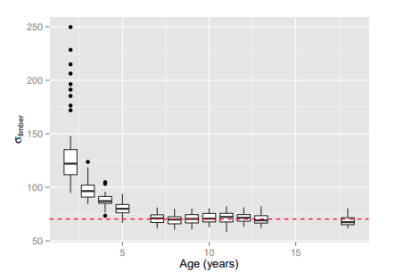
Figure 6. Ratio of tree height to diameter at breast height (Dbh) for Beaupré trees (σ_{timber}), based on measurements at the Silsoe silvoarable trial between 1992 and 2011.0 Red line indicates median (70.31) of trees greater than 7 years old.

Cropping regime
The cropping regime for the cropped agroforestry and pure arable system was specified in accordance with the actual cropping that occurred between 1992 and 2004 at Leeds and Silsoe. Where crops had not been specified in the model, the closest alternative crop was used (Table 15).

Table 15. Actual cropping regime, and that specified in Yield-SAFE for the Silsoe and Leeds sites
 | Silsoe |  |  | Leeds
Year | Actual crop | Yield-SAFE crop |  | Actual crop | Yield-SAFE crop
1992 | Winter wheat | Winter wheat |  | Spring barley | Winter barley
1993 | Linseed | Winter wheat |  | Peas | Winter beans
1994 | Spring wheat | Spring barley |  | Winter wheat | Winter wheat
1995 | Winter wheat | Winter wheat |  | Winter wheat | Winter wheat
1996 | Winter wheat | Winter wheat |  | Winter barley | Winter barley
1997 | Winter wheat | Winter wheat |  | Spring mustard | Spring oilseed rape
1998 | Winter beans | Winter beans |  | Winter wheat | Winter wheat
1999 | Spring barley | Spring barley |  | Winter barley | Winter barley
2000 | Winter wheat | Winter wheat |  | Winter wheat | Winter wheat
2001 | Fallow | Fallow |  | Winter wheat | Winter wheat
2002 | Winter barley | Winter barley |  | Winter barley | Winter barley
2003 | Spring beans | Spring beans |  | Oilseed rape | Spring oilseed rape
2004 | Fallow | Fallow |  | Fallow | Fallow
2005+ | Annual grass | Annual grass |  | Annual grass | Annual grass

Calibration of Yield-SAFE for selected soils
The values of most of the soil components are directly related to the soil type, and hence the parameters used are directly determined by the soil specified by the user (Table 16). The principal source of the values has been a table from Wösten et al. (1999) (Table 17). The soil water release curve predicted by the model, together with actual data collected for a clay soil at Silsoe is shown in Figure 7. Although the absolute values are similar to a very fine soil, the amount of water released between field capacity and permanent wilting point is similar to a fine soil.

Table 16. Provisional calibration values for soil parameters (See Table 5 for explanation of terms)
Soil type | Unit | Coarse | Medium | Medium-fine | Fine | Very fine
$$α$$ | cm⁻¹ | 0.0383 | 0.0314 | 0.0083 | 0.0367 | 0.0265
$δ$ |  | 0.07 | 0.07 | 0.07 | 0.07 | 0.07
$∂_{eva}$ (Note a_ | mm MJ⁻¹ | 0.15 | 0.15 | 0.15 | 0.15 | 0.15
FC (Note b) | log(cm) | 2.3 | 2.3 | 2.3 | 2.3 | 2.3
K_{s} | mm d⁻¹ | 60 | 12.061 | 2.272 | 24.8 | 15
n |  | 1.3774 | 1.1804 | 1.2539 | 1.1012 | 1.1033
m |  | 0.274 | 0.153 | 0.202 | 0.092 | 0.094
pFcrit_{E} (Note c) | log(cm) | 2.30 | 2.30 | 2.30 | 2.30 | 2.30
$pF_{offset}^{E}$ (Note c) | log(cm) | 4.20 | 4.20 | 4.20 | 4.20 | 4.20
θ_{s} | mm mm⁻¹ | 0.403 | 0.439 | 0.43 | 0.52 | 0.614
θ_{r} | mm mm⁻¹ | 0.025 | 0.01 | 0.01 | 0.01 | 0.01
Notes
- A value of 0.15 mm MJ⁻¹ would imply a maximum soil evapotranspiration rate of 3 mm d⁻¹ when the solar radiation receipt of 20 MJ m⁻² d⁻¹. This is possibly low, 0.2 m MJ⁻¹ may be better.
- The field capacity pF value is typically between 60 and 300 cm (Ehlers and Goss, 2003 page 26), corresponding to -6 to -30 kPa and pFs of 1.8-2.5. However in the UK, “retained water capacity” is often determined at -50 cm, or -5 kPa (Hall et al., 1997). This is a pF value of 1.70.
- Ehlers and Goss (2003) page 43 shows that soil evaporation started to decline at a pF of 2 (i.e. 100 cm) and was effectively zero at a pF of 3 (i.e. 1000 cm)

Table 17. Some Mualem-van Genuchten parameters for topsoil of five different soil textures (Wösten et al., 1999)
Soil type |  |  |  | Soil parameter
Soil-type | Clay (%) | Sand (%) |  | $$α$$ | n | $$θ_{s}$$ | $$θ_{r}$$ | Ks
Coarse | <18 | >65 |  | 0.0383 | 1.3774 | 0.403 | 0.025 | 60.000
Medium | <18 | 15-65 |  | 0.0314 | 1.1804 | 0.439 | 0.010 | 12.061
 | or 18-35 | >15
Medium fine | <35 | <15 |  | 0.0083 | 1.2539 | 0.430 | 0.010 | 2.272
Fine | 35-60 | na |  | 0.0367 | 1.1012 | 0.520 | 0.010 | 24.800
Very fine | >60 | na |  | 0.0265 | 1.1033 | 0.614 | 0.010 | 15.000

Figure 7. Relationship between soil water content and soil water tension as predicted by the values in Table 17, together with data for a clay (i.e. fine) soil from Silsoe (Pasturel, 2004)

Model sensitivity to drought
Upson’s initial attempts to parameterise the model showed the presence of a crop made almost no difference to tree growth. This suggested the model was insufficiently sensitive to the competition for water between the crop and the tree components. Therefore, to make the trees more sensitive to drought conditions, pF_{c} – the soil water potential at which trees begin to reduce biomass accretion – was reduced from −1.0 MPa (pF = 4) to −6.3 kPa (pF = 1.8). However, this parameter change impacted trees in the cropped and fallow treatments similarly and was not sufficient to generate the observed differences between the treatments. Consequently, soil parameters which impacted evaporation rates were altered to reduce the amount of water lost by the soil under bare fallow conditions with the aim of producing differences between treatments to match those observed. In Yield-SAFE, when the soil water potential pF drops below a critical value pF_{c}E, evaporation from the soil declines at a rate proportional to the difference between pF_{c}E and a further threshold value pFE_{off} above which evaporation from the soil stops. The onset of soil limited evaporation was changed from 20 kPa (pF = 2.3) to 1 kPa (pF = 1.0). The threshold for ceasing evaporation was changed from 1.5 MPa (pF = 4.2) to 63 kPa (pF = 2.8, Figure 8).

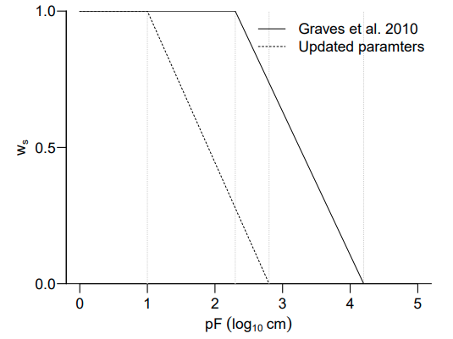
Figure 8. Influence of soil water potential (pF) on w_{s}: a factor used to scale evaporation (E_{act}). The original parameters (Graves et al., 2010) are included alongside the updated set of parameters.

Carbon storage
In Yield-SAFE, carbon storage is output by converting biomass (g dry matter) to carbon by multiplication by a conversion factor. In the original Yield-SAFE model, a tree carbon content (C_{w}) of 50% was assumed. Total organic carbon was measured for six sample trees felled at the Silsoe site on 4 July 2011 (Table 18). Consequently, C_{w} was changed to the weighted mean carbon content of 47.94%.

Table 18. Mean ± SE of the proportion of C (%) present in each tree component and understorey vegetation for six sample trees felled at the Silsoe site on 4 July 2011 (Upson, 2014).
Tissue | Carbon content (%; n = 4)
Leaf | 44.55 ± 0.05
Branch bark | 47.28 ± 0.40
Branch wood | 49.26 ± 0.07
Stem bark | 47.40 ± 0.07
Stem wood | 48.06 ± 0.16
Root wood | 48.73 ± 0.19
Stem bark | 47.40 ± 0.07
Understorey | 43.53 ± 0.72

Model fitting
Following the changes after calibration to the field data, five parameters were adjusted within a specified range until a good fit for the Silsoe poplar data was found (Table 19).

Table 19. Yield-SAFE parameters which were adjusted to provide a good fit between modelled and field-observed data (Upson, 2014)
Parameter | Description | Range
k_{r} | Extinction coefficient to describe the interception of water by fine roots. | 0.0001–0.001
ϒ_{t} | Water used to produce 1 g of aboveground biomass (m³ g⁻¹) | 0.0001–0.001
ϵ_{t} | Radiation use efficiency for trees (g MJ⁻¹) | 0.8–1.3
α | Fraction of biomass needed for maintenance respiration of aboveground dry matter. | 0.0001–0.005
$${LA}_{tree}^{max}ratio$$ | Ratio by which ${LA}_{tree}^{max}$ is divided to give n max shoots | 20 000–200 000

The fit of the model was assessed based on three statistics described below.

Normalised Root Mean Squared Error (nRMSE): measure of the average deviation of observed values from the predicted (expressed as a percentage, Equation 2.1). A smaller number indicates a smaller deviation from the observed data. (Jamieson et al., 1991) suggest that values of < 10% represent an excellent fit to observed data, 10% to 20% a good fit, 20% to 30% only a fair fit, and values above 40% a poor fit.
$nRMSE= {\left[\frac{{\sum_{i=1}^{n}{\left(p_{i}-y_{i}\right)}}^{2}}{n}\right]}^{0.5}× \frac{100}{\overline{y}}$ (2.1)
where p = modelled values, y = field observed values, $\overline{y }$= mean of field observed values, and n = number of observations

d-index: a similar measure presented by (Wellens et al., 2013; Willmott et al., 1985) as the average difference as a value between zero and one (Equation 2.2). Values close to one indicate a good fit of modelled to observed data.
$d=1- \left[\frac{\sum_{i=1}^{n}{{\left(p_{i}- y_{i}\right)}^{2}}}{\sum_{i=1}^{n}{{\left(\left|p_{i}- \overline{y}\right|+ \left|y_{i}-\overline{y}\right|\right)}^{2}}}\right]$ (2.2)

Regression of observed and modelled data, and comparison to a 1:1 line: Informative in assessing model performance - conducted for timber volume.

The above statistics were applied to five model outputs. These were tree height (m), tree diameter at breast-height (cm), and timber volume (m³). The other two outputs were the current annual increment (CAI) and the mean annual increment (MAI). The CAI is current rate of volume change over a given period (essentially a rolling mean) (Equation 2.3; m³ ha⁻¹ year⁻¹)
$CAI= \frac{v_{n}- v_{0}}{n}$ (2.3)
where v₀ = volume at the beginning of the period of n years (m³), and n = number of years between measurements of v_{n} and v₀.

The MAI is the average rate of growth over the life of the tree (equation 2.4; m³ ha⁻¹ year⁻¹). It is by using maximum MAI over the rotation length of the tree, that yield classes are assigned. Hence a tree in yield class 12 would be expected to produce a maximum MAI, over a given rotation length, of 12 m³ ha⁻¹ year⁻¹ (Hamilton, 1996).
$MAI= \frac{v}{a}$ (2.4)
where v = volume of tree (m³) and a = age in years
Using the parameters listed in Table 12, it was possible to achieve a good fit between the model outputs for the cropped agroforestry system and the field data from the Silsoe agroforestry trial. These data are displayed in Figure 9 and Figure 10, and Table 20 and Table 21.

Consideration of nRMSE and d-index indicate that the modelled values generally show a good fit to the calibration data. On average, model outputs for volume deviate by just 3–4% from those observed. Volume expressed as both CAI and MAI show the worst fit to the data, with deviations of between 12 and 20% (Table 20). This is unsurprising, as these values are more closely affected by meteorological changes in a given year. Whilst these values better reflect the ability of the model to predict annual variations and are therefore useful for assessing fit, in practice it is the absolute volume values that are of commercial value, and by this measurement the models fit the observed data extremely well.

Model outputs for volume were further analysed by regression (Figure 11) indicating only small deviations from the 1:1 line. In addition, correlation coefficients (R²) for each of the linear models were uniformly 0.99 or greater.
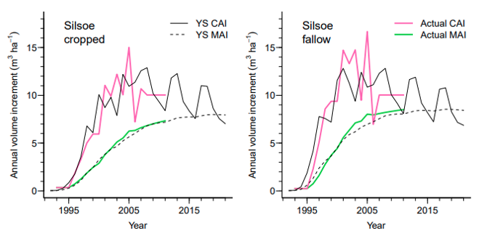
Figure 9. Current annual increment (CAI) and mean annual volume measurement mean annual increment (MAI) (m³ ha⁻¹) from field measurements and modelling in Yield-SAFE for the Cropped (C) and Fallow (F) treatments at Silsoe. Reproduced from (Upson, 2014).

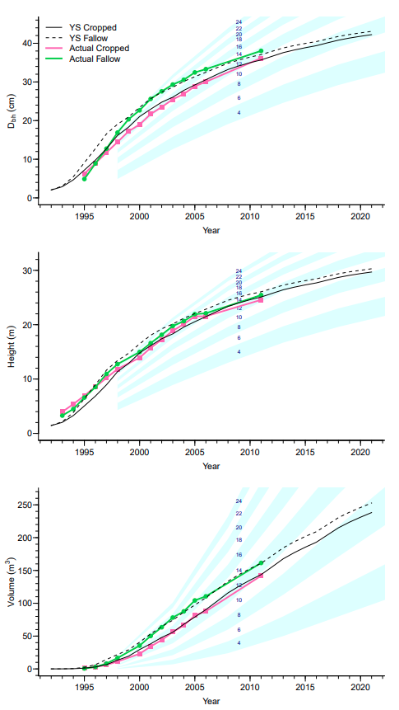
Figure 10. Comparison of diameter at breast height (Dbh) (cm), height (m), and volume (m³) from actual measurements at the Silsoe silvoarable site, and outputs from Yield-SAFE. Reproduced from (Upson, 2014).
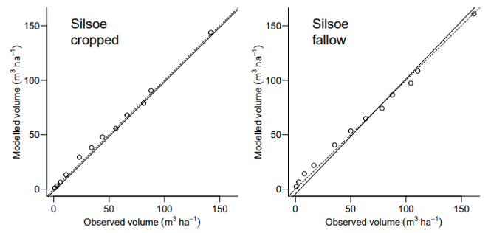
Figure 11. Regression of observed and Yield-SAFE outputs for volume from the cropped and fallow treatments at Silsoe. Dashed line follows a 1:1 relationship, solid line indicates the actual regression between observed and expected. Reproduced from Upson (2014).

Table 20. Modelled and actual mean annual increment (MAI) (m³ ha⁻¹ year⁻¹) for the cropped and fallow treatments at Silsoe as adapted from Upson (2014).
Mean annual increment (MAI) | Time period (years) | Silsoe
Mean annual increment (MAI) | Time period (years) | Cropped | Fallow
Actual | 19 | 7.3 | 8.5
Modelled | 19 | 7.1 | 8.0
Modelled | 30 | 8.0 | 8.5

Table 21. Percentage Root Mean Squared Error (nRMSE), d-index, and number of observations compared (n) for comparisons between model outputs and observed data for current annual increment (CAI), MAI, diameter at breast height (Dbh), height, and volume at Silsoe. Adapted from (Upson, 2014)
 | Silsoe
 | Cropped | Fallow | n
nRMSE*
CAI | 19.9 | 19.4 | 19
MAI | 12.8 | 14.8 | 19
D_{bh} | 4.8 | 6.0 | 13
Height | 7.9 | 6.0 | 14
Volume | 3.5 | 3.3 | 12
d-index**
CAI | 0.92 | 0.90 | 19
MAI | 1.00 | 0.99 | 19
D_{bh} | 1.00 | 0.99 | 13
Height | 0.99 | 1.00 | 14
Volume | 1.00 | 1.00 | 12
*nRMSE – average deviation of modelled from observed values (%)
**d-index – a value close to 1.00 indicates a good fit

Validation
Following parameterisation of the model using the Silsoe data, the model was validated against data collected from Headley Hall, Leeds.

Site – Leeds
The model was validated against data collected from an identical experiment conducted at a different location at an experiment administered by Leeds University (Data from 2005–2012 were kindly provided by Dr. David Pilbeam, Leeds University).
- Established: April 1992.
- Location: Headley Hall, Leeds, North Yorkshire (53°52’20.4’’N, 1°20’3.3’’W).
- Topography: gently sloping, with a west-north-west aspect, at an altitude of 50 m asl.
- Soil: shallow sandy clay loam soils of the Aberford series, sitting on top of Magnesium limestone (Burgess et al., 2003).

Meteorological data
Rainfall at the Leeds (629 mm) and Silsoe site (634 mm) were similar, although mean air temperature was lower at Leeds (9.3°C) than Silsoe (9.8°C) for the first seven years of the experiment (1992–1998)(Burgess et al., 2003). Complete rainfall and temperature data were available from Church Fenton weather station (ID: 533, Lat: 53.84°, Long: −1.20°, Elevation: 8 m asl) at approximately the same latitude as the Leeds site (Figure 12).

A complete set of solar radiation measurements were not available from any one UK Met Office (UKMO) station and therefore partial records from several station were pooled. The years 1993–2009 (excluding 2002, and 2007 which were anomalous), 2002–2008, and 1994–2006 (excluding 1995, 1997, and 2003) were used from UKMO MIDAS stations: Leconfield (ID: 370, Lat: 53.87°, Long: −0.44°, Elevation: 7 m asl), Church Fenton, and Cawood (ID: 535, Lat: 53.83°, Long: −1.15°, Elevation: 6 m asl) respectively. Missing values still remained and solar radiation records from 1993 were duplicated for the year 1992, whilst the years 2009–2014 were repeated to give a complete record until the end of 2028 (Figure 12). Missing values throughout were replaced with values interpolated by linear spline using the na.approx() function in the zoo package (Zeileis & Grothendieck, 2005) for the R statistical environment.
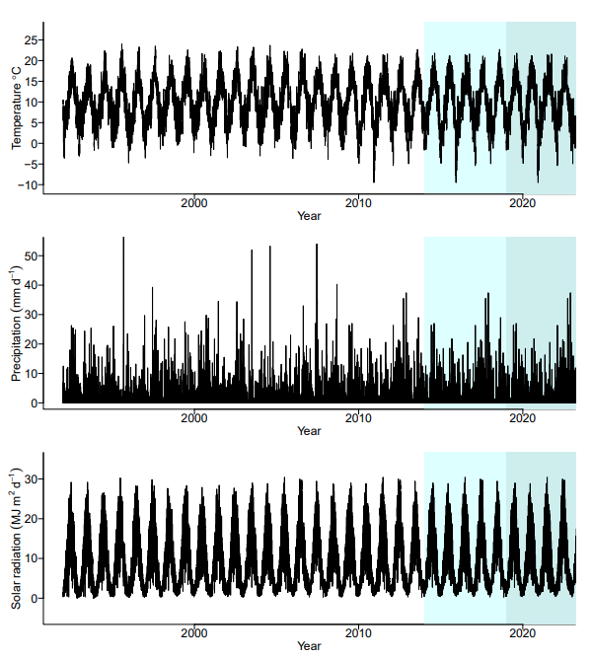
Figure 12. Weather data used in Yield-SAFE for modelling poplar growth at the Leeds site. See text for a description of the sources used. Shading indicates here data has been repeated. Reproduced from Upson (2014).

Parameterisation
Just two changes to the model parameters were made for the Leeds site: the effective soil depth was changed from 1500 cm to 500 cm, and weather data from the local area were used. A summary of the data from Leeds used in validation is shown in Table 22.

Table 22. Diameter at breast height (D_{bh}), height and volume data used for validation of the Yield-SAFE model from the cropped and fallow treatment at the Leeds experiment (Pillbeam, D, personal communication, 2014). The final three years of height measurements were excluded, as they were inconsistent with previous measurements, and no measurements were taken in 2013 or 2014. Means are given with standard errors, and the sample size in parentheses. Adapted from Upson (2014).
 | Cropped |  |  | Fallow
Year | Dbh (mm) | Height (m) | Volume  (m³ ha⁻¹) | Dbh (mm) | Height (m) | Volume  (m³ ha⁻¹)
1993 | 33.7 ± 1.3 (14) | 3.4 ± 0.1 (14) | 0.0 ± 0.0 (14) | 35.8 ± 1.3 (15) | 3.4 ± 0.1 (15) | 0.0 ± 0.0 (15)
1994 | 57.8 ± 3.3 (15) | 4.3 ± 0.2 (15) | 0.0 ± 0.0 (15) | 70.8 ± 1.5 (15) | 5.0 ± 0.1 (15) | 0.0 ± 0.0 (15)
1995 | 83.9 ± 3.9 (15) | 5.4 ± 0.2 (15) | 0.0 ± 0.0 (15) | 114.5 ± 2.2 (15) | 6.8 ± 0.1 (14) | 0.0 ± 0.0 (14)
1996 | 106.5 ± 3.6 (15) | 7.1 ± 0.2 (15) | 0.0 ± 0.0 (15) | 146.1 ± 2.9 (15) | 8.1 ± 0.2 (15) | 0.1 ± 0.0 (15)
1997 | 139.9 ± 3.0 (15) | 8.9 ± 0.2 (15) | 0.1 ± 0.0 (15) | 181.1 ± 3.0 (15) | 10.1 ± 0.2 (14) | 0.1 ± 0.0 (14)
1998 | 175.9 ± 2.7 (15) | 10.5 ± 0.1 (15) | 0.1 ± 0.0 (15) | 218.3 ± 3.6 (15) | 11.6 ± 0.2 (14) | 0.2 ± 0.0 (14)
2000 | 204.3 ± 2.4 (15) | 13.4 ± 0.2 (15) | 0.3 ± 0.0 (15) | 243.7 ± 4.2 (15) | 13.9 ± 0.2 (15) | 0.4 ± 0.0 (15)
2001 | 221.3 ± 2.5 (15) | 15.0 ± 0.1 (15) | 0.3 ± 0.0 (15) | 259.8 ± 5.0 (15) | 15.7 ± 0.2 (14) | 0.5 ± 0.0 (14)
2005 | 271.9 ± 2.2 (15) | 18.0 ± 0.1 (15) | 0.6 ± 0.0 (15) | 303.5 ± 7.1 (15) | 18.6 ± 0.3 (15) | 0.8 ± 0.0 (15)
2006 | 281.7 ± 2.2 (15) | 18.9 ± 0.2 (15) | 0.7 ± 0.0 (15) | 309.4 ± 7.5 (15) | 19.3 ± 0.3 (15) | 0.9 ± 0.1 (15)
2007 | 294.3 ± 2.5 (15) | 19.4 ± 0.2 (13) | 0.8 ± 0.0 (13) | 319.5 ± 8.0 (15) | 20.0 ± 0.3 (14) | 0.9 ± 0.1 (14)
2008 | 309.3 ± 2.8 (15) | 20.1 ± 0.2 (10) | 0.9 ± 0.0 (10) | 330.1 ± 8.4 (15) | 20.9 ± 0.5 (12) | 1.0 ± 0.1 (12)
2009 | 323.9 ± 2.8 (15) | 21.2 ± 0.3 (11) | 1.0 ± 0.0 (11) | 337.4 ± 8.8 (15) | 21.6 ± 0.4 (14) | 1.1 ± 0.1 (14)
2010 | 332.7 ± 3.0 (15) |  |  | 343.0 ± 9.0 (15)
2011 | 340.6 ± 3.2 (15) |  |  | 348.1 ± 9.2 (15)
2012 | 346.3 ± 3.5 (15) |  |  | 351.8 ± 9.3 (15)
2013 | 353.5 ± 3.8 (15) |  |  | 357.3 ± 9.4 (15)
2014 | 359.1 ± 3.8 (15) |  |  | 359.9 ± 9.6 (15)

Model fitting
Using the Yield-SAFE model parameterised using data from the Silsoe, it was possible to achieve a good fit between model outputs for the cropped agroforestry system and the field data from the Leeds agroforestry trial. These data are displayed in Figure 13 and Figure 14, and Table 23 and Table 24.

Model outputs for the Leeds site remain excellent for volume, height and Dbh, but somewhat less good for annual increments. As previously noted, MAI and CAI are most likely to deviate from the actual values as they are heavily influenced by annual variation. Conversely, the nRMSE for volume was under 10% indicating an excellent fit to the data. The relatively poor agreement (at least for D_{bh}) between the model and observed data for the early growth period at the Leeds site (Figure 14) could potentially have been corrected by adjustment of the extinction coefficient k_{r} parameter, at the expense of the fit with Silsoe data. However, the latter part of the growth curve and particularly volume measurements were excellent, despite early inconsistencies. In addition, the d-index values are uniformly greater than 0.9 except in the case of CAI (Table 24).

Model outputs for volume were further analysed by regression (Figure 15) indicating only small deviations from the 1:1 line. In addition, correlation coefficients (R²) for each of the linear models were uniformly 0.99 or greater.

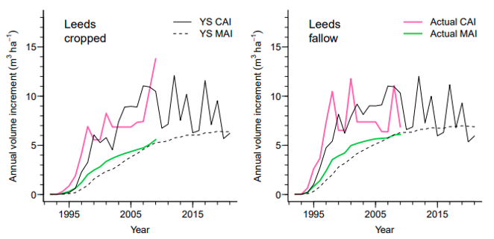
Figure 13. Current annual increment (CAI) and mean annual volume measurement mean annual increment (MAI) (m³ ha⁻¹) from field measurements and modelling in Yield-SAFE for the Cropped (C) and Fallow (F) treatments at Leeds. Reproduced from Upson (2014).
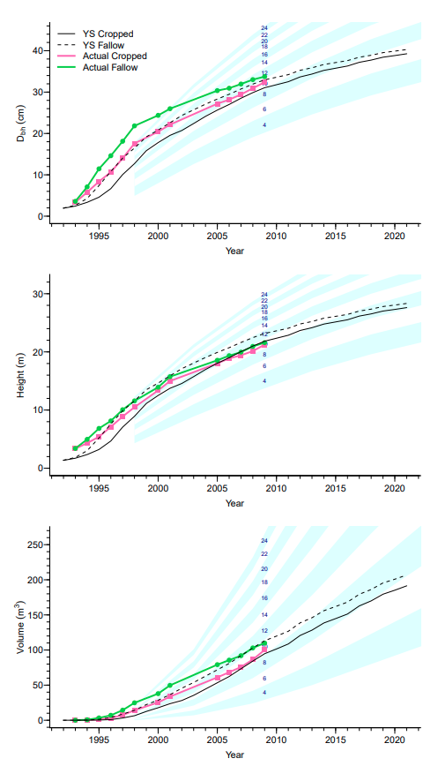
Figure 14. Comparison of diameter at breast height (Dbh) (cm), height (m), and volume (m³) from actual measurements taken at the Leeds silvoarable trial, and outputs from Yield-SAFE parameterised using data from the Silsoe silvoarable trials. Reproduced from Upson (2014).

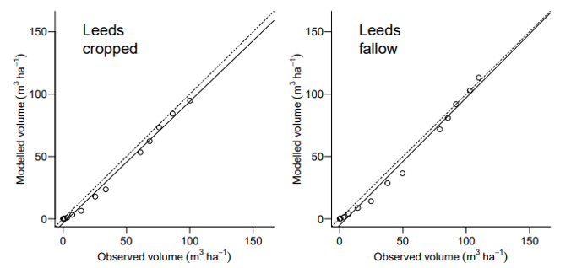
Figure 15. Regression of observed and Yield-SAFE outputs for volume from the cropped and fallow treatments at Silsoe and Leeds. Dashed line follows a 1:1 relationship, solid line indicates the actual regression between observed and expected. Reproduced from Upson (2014).

Table 23. Modelled and actual mean annual increment for the cropped and fallow treatments at Leeds adapted from Upson (2014)
 | Time period (years) | Mean annual increment (MAI)  (m³ ha⁻¹ year⁻¹)
 |  | Cropped | Fallow
Actual | 19 | 5.6 | 6.1
Modelled | 19 | 5.3 | 6.3
Modelled | 30 | 6.4 | 7.0

Table 24. Percentage Root Mean Squared Error (nRMSE), d-index, and number of observations compared (n) for comparisons between model outputs and observed data for current annual increment (CAI), MAI, diameter at breast height (Dbh), height, and volume at Leeds, as adapted from Upson (2014)
 | Leeds
 | Cropped | Fallow | n
nRMSE*
CAI | 26.3 | 24.6 | 18
MAI | 37.1 | 28.0 | 18
Dbh | 9.8 | 8.9 | 18
Height | 10.1 | 8.3 | 13
Volume | 7.2 | 5.9 | 13
d-index**
CAI | 0.93 | 0.88 | 18
MAI | 0.97 | 0.97 | 18
Dbh | 0.98 | 0.98 | 18
Height | 0.99 | 0.99 | 13
Volume | 0.99 | 0.99 | 13
*nRMSE – average deviation of modelled from observed values (%)
**d-index – a value close to 1.00 indicates a good fit.

Acknowledgements
The Yield-SAFE model was developed as part of the collaborative EU research project called “SAFE: Silvoarable Agroforestry for Europe”. Support for SAFE was provided by the Quality of Life Programme of the European Union (contract number QLK5-CT-2001-00560). The UK Ministry of Agriculture, Fisheries and Food sponsored the research at the Silsoe and Leeds agroforestry sites between 1992 and 1995 and in 1997. Matt Upson’s PhD was completed with financial support from the Forestry Commission, Forest Research, and the Scottish Forestry Trust. Some of the Yield-SAFE calibration work was completed using funding from the AGFORWARD (Grant Agreement No 613520) research project co-funded by the European Commission Directorate General for Research & Innovation. The process of creating a default publicly available version of the model has been enabled through the BioForce project funded by the UK Department for Energy Security and Net Zero.

References
Ashby, Z. (2001) Effect of soil characteristics on poplar growth. Unpublished BSc thesis. Cranfield University.
Burgess, P.J., Graves, A.R., Metselaar, K., Stappers, R., Keesman, K., Palma, J., Mayus, M., and van der Werf, W. (2004) Description of the Plot-SAFE version 0.3 model. Cranfield University. 52 pp.
Burgess, P.J., Graves, A.R., Wiltshire, K., Giannitsopoulos, M., Metselaar, K., Stappers, R., Keesman, K., Palma, J., van Der Werf, W. (2023) Description of the Biophysical Yield-SAFE model as implemented in Microsoft Excel. Cranfield, Bedfordshire, UK, Cranfield University. 23 pp.
Burgess, P.J., Incoll, L.D., Hart, B.J., Beaton, A., Piper, R.W., Seymour, I., Reynolds, F.H., Wright, C., Pilbeam, D.J., Graves, A.R. (2003) The Impact of Silvoarable Agroforestry with Poplar on Farm Profitability and Biological Diversity Final Report to DEFRA Project code: AF0105.
Burgess, P.J., Incoll, L.D., Corry, D.T., Beaton, A., Hart, B.J. (2005) Poplar growth and crop yields within a silvoarable agroforestry system at three lowland sites in England. Agroforestry Systems 63, 157-169. http://hdl.handle.net/1826/872
Chave, J., Coomes, D., Jansen, S., Lewis, S.L., Swenson, N.G., Zanne, A.E. (2009) Towards a worldwide wood economics spectrum. Ecological Letters 12, 351–366. https://doi.org/10.1111/j.1461-0248.2009.01285.x
Dupraz, C., Wolz, K.J., Lecomte, I., Talbot, G., Vincent, G., Mulia, R., Bussière, F., Ozier-Lafontaine, H., Andrianarisoa, S., Jackson, N., Lawson, G., Dones, N., Sinoquet, H., Lusiana, B., van Noordwijk, M. (2019) Hi-sAFe: A 3D agroforestry model for integrating dynamic tree–crop interactions. Sustainability, 11, 2293. https://doi.org/10.3390/su11082293
Ehlers, W., Goss, M. (2003) Water Dynamics in Plant Production Oxfordshire: CABI Publishing. 273 pp.
García de Jalón, S., Graves, A., Palma, J.H.N., Williams, A., Upson, M.A., Burgess, P.J. (2018) Modelling and valuing the environmental impacts of arable, forestry and agroforestry systems: a case study. Agroforestry Systems 92:1059–1073. https://doi.org/10.1007/s10457-017-0128-z
Giannitsopoulos, M., Graves, A.R, Burgess, P.J., Crous-Duran, J., Moreno, G., Herzog, F., Palma, J.H.N., Kay, S., García de Jalón, S. (2020) Whole system valuation of arable, agroforestry and tree-only systems at three case study sites in Europe. Journal of Cleaner Production 269, 122283. https://doi.org/10.1016/j.jclepro.2020.122283
Graves, A.R., Burgess, P.J., Liagre, F., Terreaux, J-P., Borrel, T, Dupraz, C., Palma, J., Herzog, F. (2011) Farm-SAFE: the process of developing a plot- and farm-scale model of arable, forestry and silvoarable economics. Agroforestry Systems 81, 93-108.
Graves, A.R., Burgess, P.J., Palma, J., Keesman, K.J., van der Werf, W., Dupraz, C., van Keulen, H., Herzog, F., Mayus, M. (2010) Implementation and calibration of the parameter-sparse Yield-SAFE model to predict production and land equivalent ratio in mixed tree and crop systems under two contrasting production situations in Europe. Ecological Modelling 221, 1744–1756. https://doi.org/10.1016/j.ecolmodel.2010.03.008
Hamilton, G. (1996) Forest Mensuration: Booklet 39, 4th ed. HMSO, Norwich.
Jamieson, P.D., Porter, J.R., Wilson, D.R. (1991) A test of the computer simulation model ARCWHEAT 1 on wheat crops grown in New Zealand. Field Crops Research 27, 337-350. https://doi.org/10.1016/0378-4290(91)90040-3
Keesman, K.J., Graves, A., van der Werf, W., Burgess, P.J., Palma, J., Dupraz, C., Van Keulen, H. (2011) A system identification approach for developing and parameterising an agroforestry system model under constrained availability of data. Environmental Modelling and Software 26: 1540-1553. https://doi.org/10.1016/j.envsoft.2011.07.020
Palma J.H.N. (2017) CliPick – Climate change web picker. A tool bridging daily climate needs in process based modelling in forestry and agriculture. Forest Systems 26(1), eRC01. https://doi.org/10.5424/fs/2017261-10251
Pasturel, P (2004). Light and Water Use in a Poplar Silvoarable System. Thesis, Cranfield
Ritchie, J (1972). Model for predicting evaporation from a row crop with incomplete cover. Water Resources Research, 8 (5).
UK Meteorological Office, 2013. Met Office Integrated Data Archive System (MI-DAS) Land and Marine Surface Stations Data (1853-current), NCAS British Atmospheric Data Centre.
Upson, M.A. (2014) The Carbon Storage Benefits of Agroforestry and Farm Woodlands. Unpublished PhD thesis. Bedfordshire, UK: Cranfield University. https://dspace.lib.cranfield.ac.uk/handle/1826/9298
Upson, M.A., Burgess, P.J. (2013) Soil organic carbon and root distribution in a temperate arable agroforestry system. Plant and Soil 373, 43–58. https://doi.org/10.1007/s11104-013-1733-x
van der Werf, W., Keesman, K., Burgess, P., Graves, A., Pilbeam, D., Incoll, L.D., Metselaar, K., Mayus, M., Stappers, R., van Keulen, H., Palma, J. Dupraz, C. (2007) Yield-SAFE: A parameter-sparse, process-based dynamic model for predicting resource capture, growth, and production in agroforestry systems. Ecological Engineering 29, 419–433. https://doi.org/10.1016/j.ecoleng.2006.09.017
Verma, K., Bradley, R., 1988. Soils of Silsoe College Farm. Cranfield University, Silsoe.
Wellens, J., Raes, D., Denis, A., Djaby, B., Tychon, B., 2013. Performance assessment of the FAO AquaCrop model for irrigated cabbage on farmer plots in a semi-arid environment. Agricultural Water Management 127, 40–47.
Willmott, C., Ackleson, S., Davis, R., Feddema, J., Klink, K., Legates, D., O’Donnell, J., Rowe, C. (1985) Statistics for the evaluation and comparison of models. Journal of Geophysical Research 90, 995-9005. https://doi.org/10.1029/JC090iC05p08995
Wösten, J, Lilly, A, Nemes, A, and Bas, CL (1999). Development and use of a database of hydraulic properties of European soils. Geoderma, 90, 169–185.
Zanne, A., Lopez-Gonzalez, G., Coomes, D., Ilic, J., Jansen, S., Lewis, S., Miller, R., Swenson, N., Wiemann, M., Chave, J. (2009) Data from: Towards a worldwide wood economics spectrum. Dryland Digital Repository.
Zeileis, A., Grothendieck, G. (2005) zoo: S3 infrastructure for regular and irregular time series. Journal of Statistical Software.

Appendix

Appendix A. Initial shoot number and biomass of trees
As one might expect, increasing the initial number of shoots (n_{shootso}) increases the growth rate of the tree (Figure 16).

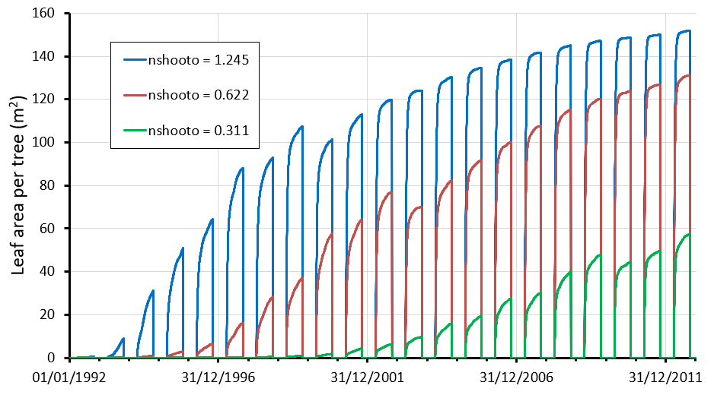
Figure 16. The effect of different values of initial number of shoots (n_{shooto}) on the leaf area of poplar over 20 years. It was assumed that $n_{Shoots}^{max}$ = 2267, $LA_{ss}^{max}$= 0.0986 m², and B_{to} = 55 g

The development of leaf area is also affected by the chosen initial biomass (Figure 17). For a given n_{shooto}, larger values of B_{to} result in lower leaf areas.

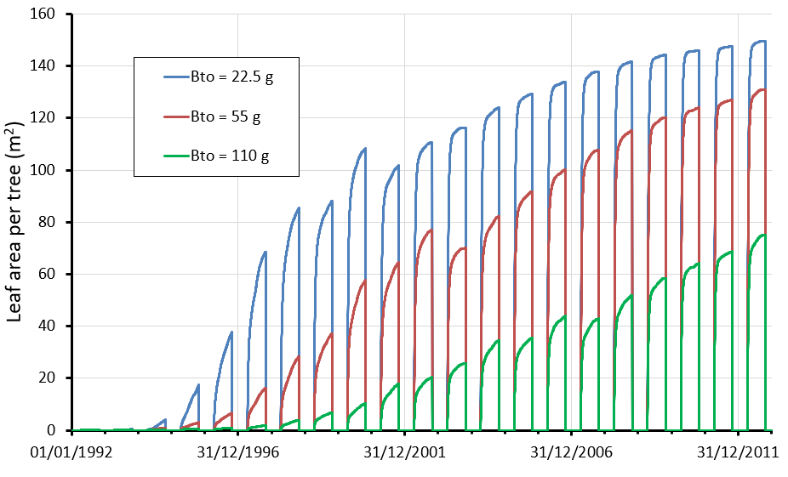
Figure 17. The effect of different values of initial biomass (B_{to}) on the estimated leaf area of poplar over 20 years. It was assumed that $n_{Shoots}^{max}$ = 2267, $LA_{ss}^{max}$= 0.0986 m², and n_{shootso} = 0.6225

Appendix B. Maximum number of shoots per tree
The values of the calculated maximum number of shoots ($n_{Shoots}^{max}$) and the maximum leaf area of a single shoot ($LA_{ss}^{max}$) are difficult to measure. One alternative approach is to specify a value for the maximum leaf area of an individual tree ($LA_{tree}^{max}$) and a $n_{Shoots}^{max}$/$LA_{ss}^{max}$ratio.
$n_{Shoots}^{max}$ =and $LA_{ss}^{max}$=. (B.1)
Figure 18 shows the responses to changing the ratio of the maximum number of shoots and the maximum leaf area per shoot using the parameters for poplar, for a given maximum leaf area per tree.

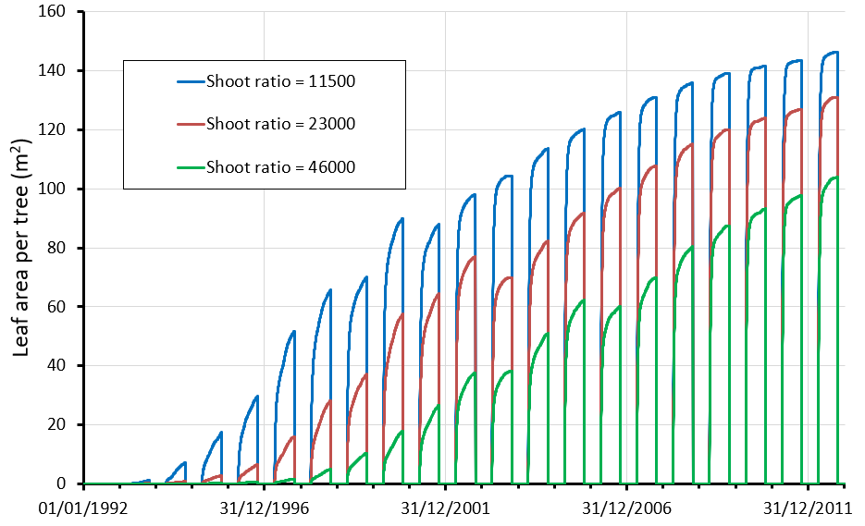
Figure 18. The effect of different ratios of $n_{Shoots}^{max}$ to the value of $LA_{ss}^{max}$ on the predict leaf area of poplar. It is assumed that the product of $n_{Shoots}^{max}$ and $LA_{ss}^{max}$was 223.4 m² per tree. The value of n_{shoots0} was 0.6625.

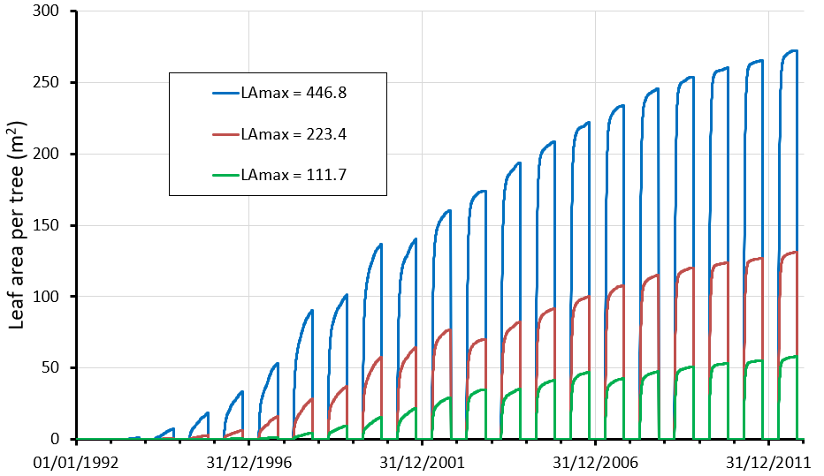
Figure 19. The effect of different values of maximum leaf area per tree on the estimated leaf area of poplar over 20 years. It was assumed that $LA_{ss}^{max}$= 0.0986 m², B_{to} = 5 g, and n_{shooto} = 0.6225.

Appendix C. Effect of tau on deciduous trees
For deciduous trees the development of leaf area can also be altered by selecting different values of tau (τ_{t}) (Figure 20). Tau is defined as the time constant representing the number of days after bud-burst when the leaf area reaches 63.2% of its maximum leaf area. For the analysis a tau value of 10 was chosen.

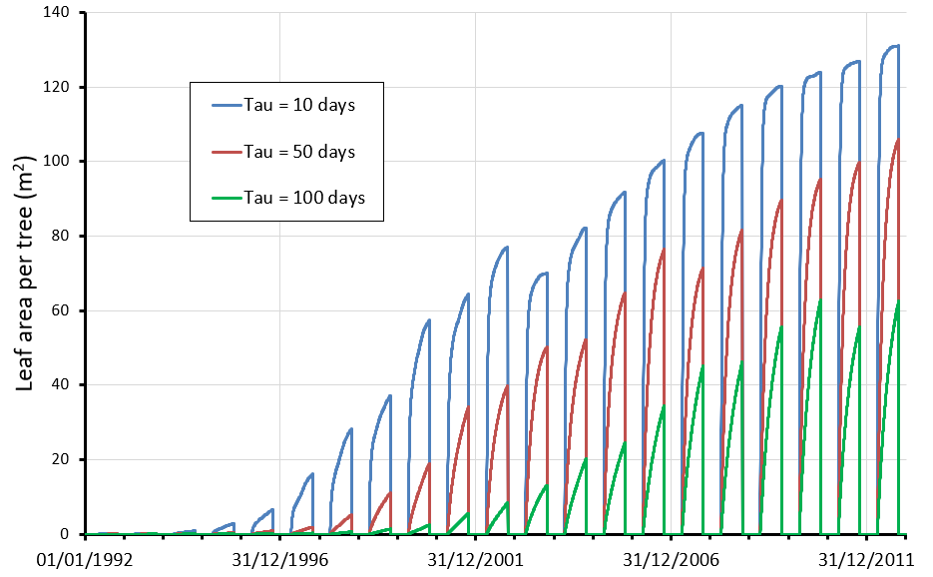
Figure 20. The effect of three values of tau on the development of leaf area per tree over 20 years (DOY_{budburst} = day 100; DOY_{leaffall} =day 300; n_{shooto} = 0.6625; B_{to} = 55 g; $n_{Shoots}^{max}$ = 2207, and$LA_{ss}^{max}$= 0.0986 m²).

Appendix D. Phased light extinction coefficient for trees
The initial use of the model indicated that the use of a constant light extinction coefficient (k_{t}) of 0.8 for tree growth tended to overestimate tree light interception and hence tree growth at low tree densities, for example 50 trees per hectare. The use of the Hi-sAFe model (P. Burgess et al., 2005) suggested that the value of the light extinction coefficient was dependent on the leaf area of an individual tree (Figure 21). Therefore, a phased k_{t} value, dependent on the tree leaf area, was introduced using two parameters a and b (Equation D.1). Use of the function suggested using a constant value of 10 for a and 0.4 for b was appropriate for each tree species. A fuller description is provided by Keesman et al. (2011).

$k_{t}=0.8-b+b\left(\frac{a}{{LA}_{t}+a}\right)$ (D.1)

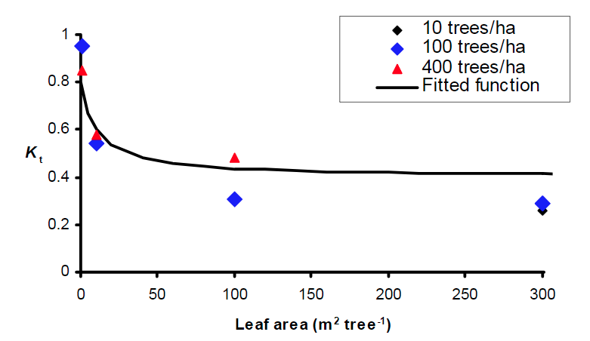

Figure 21. Assumed phased decline in kt with increased leaf area per tree, assuming a = 10 and b = 0.4 from Burgess et al. (2005)

Appendix E. Tree root length
There are three parameters regarding root length: the ratio of structural roots to aboveground biomass (π_{S R}), the length of fine root per gram of structural root (r), and an extinction coefficient determining the interception of water per unit of root length (k_{r}). These parameters interact to give φ, value between 0 and 1 (Equation E.1), which determines the ability of roots to intercept water, following an asymptotic relationship (Figure 22).

$ϕ=1- e^{\left(B_{t }π_{SR }r{ k}_{r}\right)}$ (E.1)

Equation E.1 can be adjusted to incorporate the term φ (Equation E.2).
$\frac{dB_{t}}{dt}= \frac{I f_{t}ϵ_{t}ω_{t}ϕ}{ρ}-aB_{t}$ (E.2)

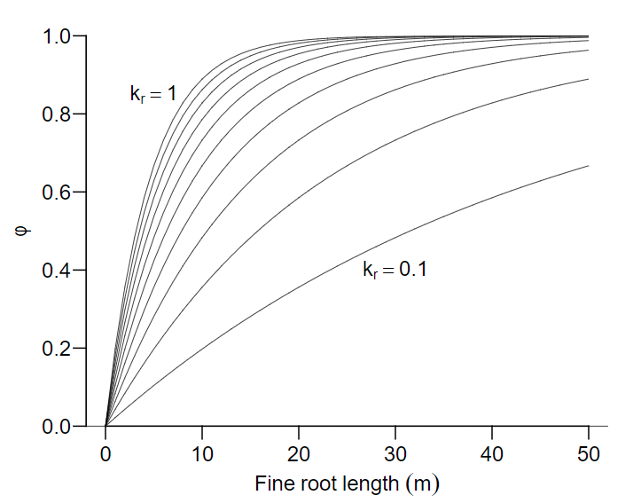
Figure 22. The capacity of tree roots to capture the available water (φ) is assumed to be related to fine root length (r) and a water capture extinction coefficient (k_{r}) from Upson (2014)

