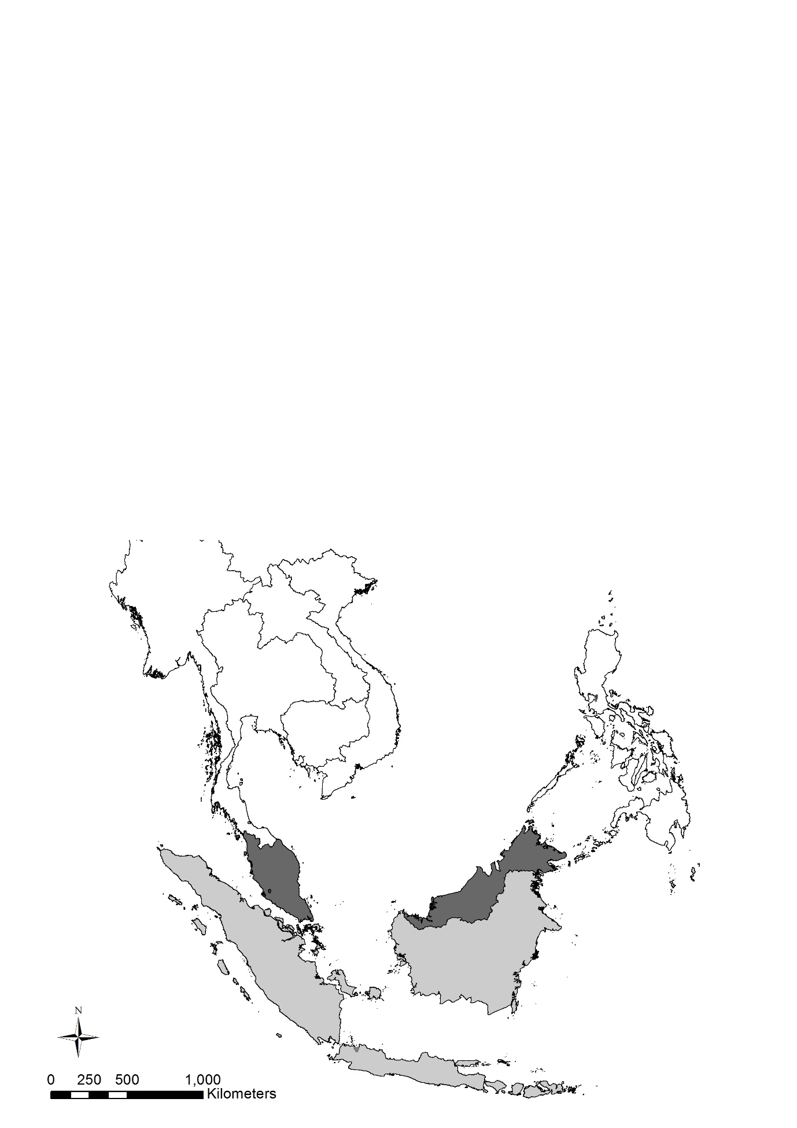
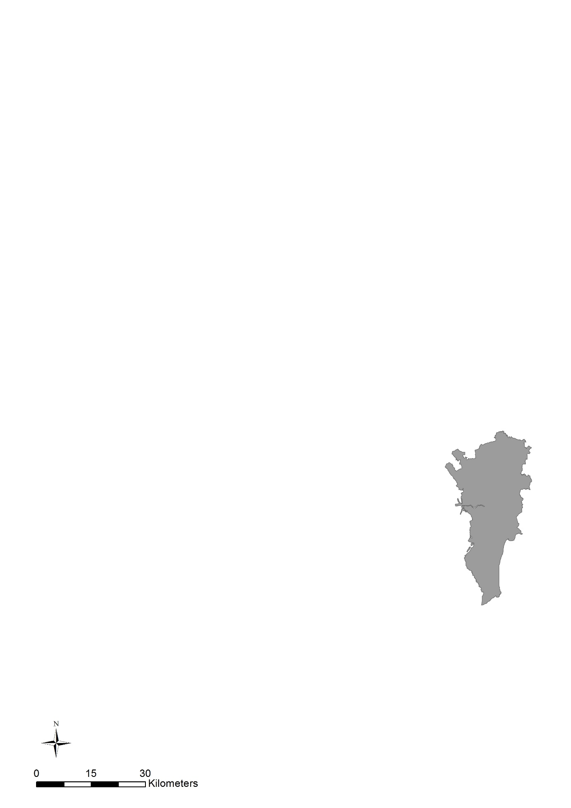
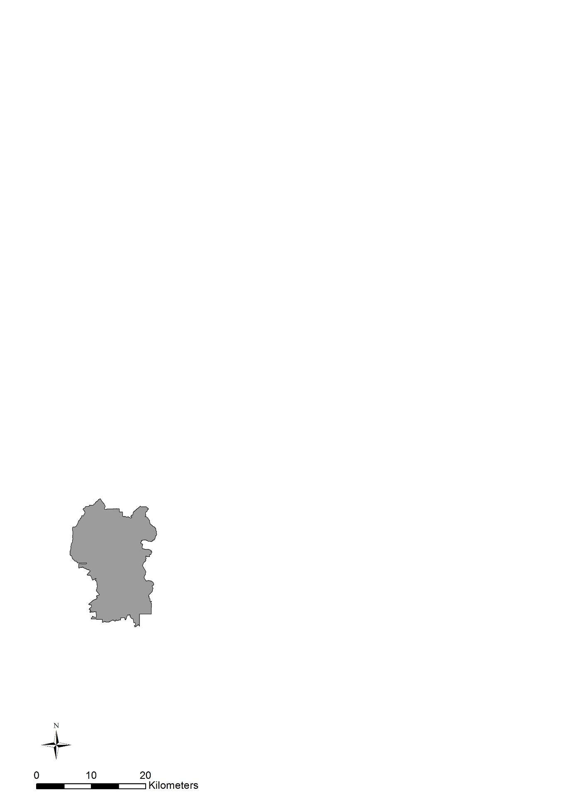
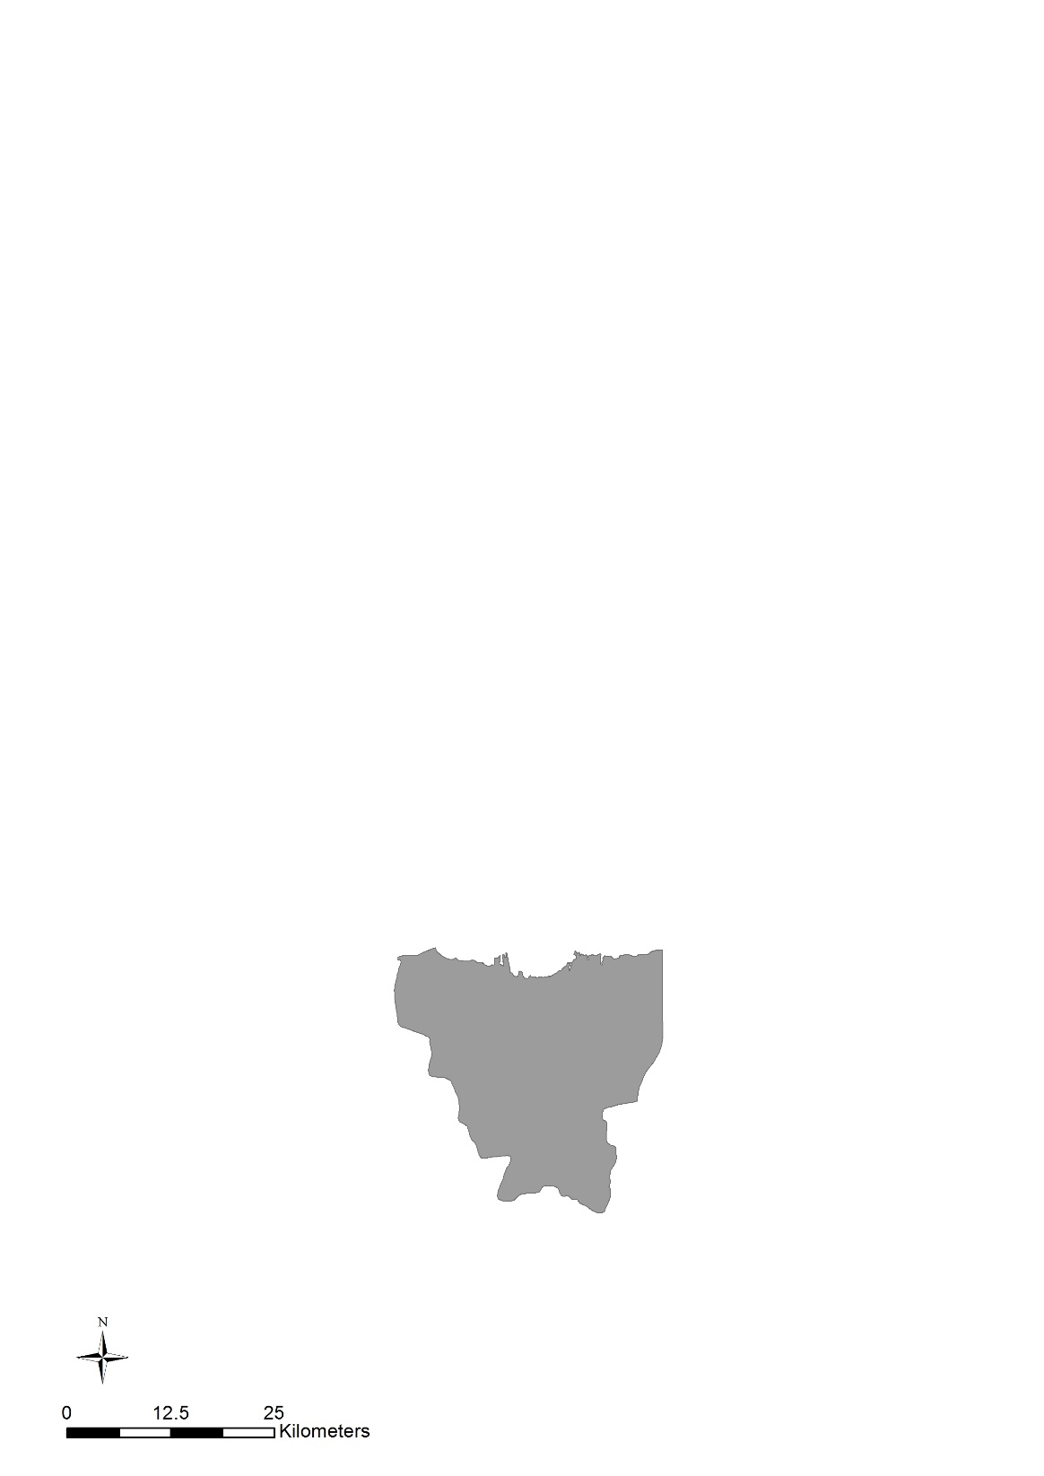
KUALA LUMPUR
MALAYSIA
INDIAN OCEAN
PHILIPPINES
METRO MANILA
SOUTH CHINA SEA
INDONESIA
JAKARTA

