Description of the biophysical
Yield-SAFE v2 model as
implemented in Microsoft® Excel®

School of Water, Energy and Environment
October 2023
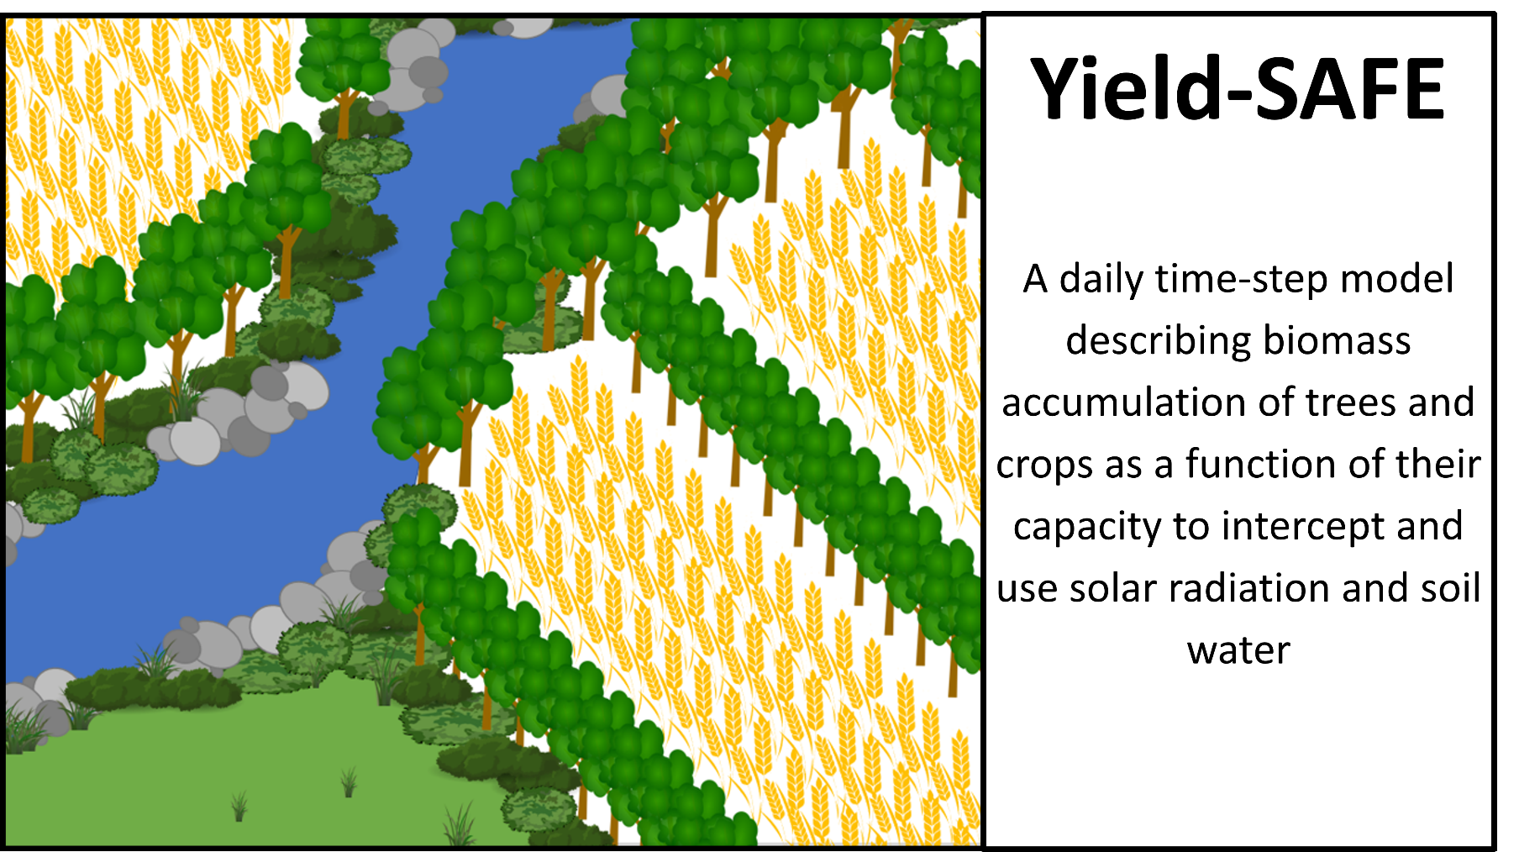

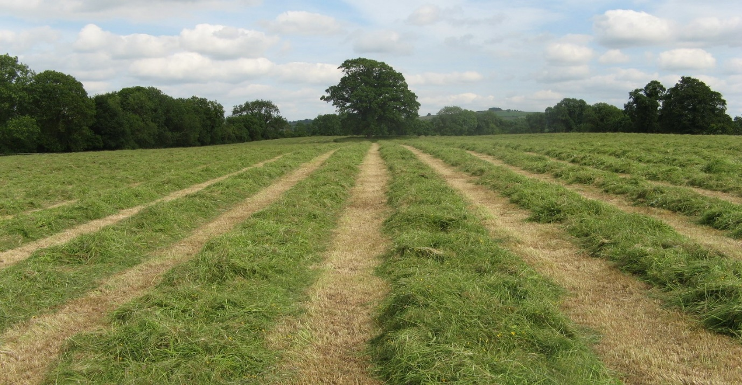
Paul Burgess¹, Anil Graves¹, Catherine Wiltshire¹, Michail Giannitsopoulos¹, Matt Upson¹, Klaas Metselaar², Roel Stappers², Karel Keesman², João Palma³, and Wopke van der Werf²
¹Cranfield University, Cranfield, Bedfordshire MK43 0AL,
²Wageningen University, P.O. Box 43, 6700 AA, Wageningen, The Netherlands.
³MVARC, Moinhos de Vento, Espirito Santo, Mertola 7750-217, Portugal
P.Burgess@cranfield.ac.uk

Suggested reference: Burgess, P.J., Graves, A.R., Wiltshire, C., Giannitsopoulos, M., Upson, M., Metselaar, K., Stappers, R., Keesman, K., Palma, J., van der Werf, W. (2023). Description of the Biophysical Yield-SAFE model as implemented in Microsoft Excel. Cranfield, Bedfordshire, UK, Cranfield University. 22 pp.

Table of contents
1 Overview 2
2 Model requirements 2
2.1 Software 2
2.2 Data 2
3 Model description 3
3.1 Structure 4
3.2 Management worksheet 5
3.3 Crop-manager worksheet 10
3.4 Tree-parameters worksheet 12
3.5 Crop-parameters worksheet 14
3.6 Soil-parameters worksheet 16
3.7 Yield-SAFE worksheet 18
3.8 Bio-graph worksheet 21
4 Acknowledgements 21
5 References 21

Cranfield University assumes no liability for any losses resulting from the use of the research results or recommendations in this report

Overview
Agroforestry can be defined as the integration of trees with grass and/or arable crops on the same parcel of land. Compared to monoculture arable or grassland systems, agroforestry can enhance soil conservation, carbon sequestration, species and habitat diversity, and provide additional sources of farm income. As the trees increase in size, the grass and arable yields will tend to decline due to light and water competition. However, the form of the tree-crop yield relationships will vary with the level of solar radiation, rainfall, the species being grown, management actions such as choice of planting date and pruning, the soil type, and the time from tree planting.

To enable the prediction of the relationship between tree and crop yields over the rotation of the tree component, typically 20-60 years, a computer simulation model called Yield-SAFE was developed as part of the EU sponsored SAFE project (van der Werf et al., 2007). The full name for Yield-SAFE is the “YIeld Estimator for Long term Design of Silvoarable AgroForestry in Europe”. Companion models include Plot-SAFE (a plot-scale bio-economic model) (Burgess et al., 2004), Farm-SAFE (a farm-scale economic model using yield responses from Yield-SAFE) (Graves et al., 2010, 2011), and Hi-sAFe (a detailed 3-D model for more detailed biophysical assessments of tree-crop interactions) (Dupraz et al., 2019). Versions of Yield-SAFE have been used to inform both financial and economic assessments of agroforestry systems (García de Jalón et al., 2018; Giannitsopoulos et al., 2020). This document describes Yield-SAFE v2, which is the name that we have given to the model used by Matt Upson in his PhD for modelling a silvoarable agroforestry system with poplar (Upson, 2014).

This guide describes how to use Yield-SAFE as implemented in Excel including a description of the model objectives and structure. This is followed by a detailed overview of each worksheet within the model. A detailed description of model equations, parameterisation and calibration is provided by Burgess et al. (2023).

Model requirements

Software
Yield-SAFE v2 is a spreadsheet-based biophysical model which has been developed in Microsoft® Excel® for Microsoft 365 MSO (Version 2301 Build 16.0.16026.20214) 64-bit. The memory requirement for storing Yield-SAFE primarily depends on the number of days of tree and crop growth that are simulated. For example, 21900 days of analysis (60 years) requires around 67 MB.

Yield-SAFE v2 is recommended to be run with a computer using Windows 7 (or a more recent version: Windows 10, etc.) and Excel® 2010 or a more recent version (Excel® 2013 or Excel® 2016). The worksheets of Yield-SAFE have been developed at a screen resolution of 1920 x 1080.

Data
Within the main calculation worksheet within Yield-SAFE, the same calculation is completed for each day. To reduce the size of the file for transfer, the calculation for each day beyond day 2 in the calculation worksheet can be removed. If the model is supplied in this way, in order for Yield-SAFE to work for 60 years of meteorological data, then the row of algorithms provided for day 2 needs to be copied down for the full time period of 60 years x 365-366 days. For example, cells ‘H9:CB9’ can be copied down to ‘H22286:CB22286’. The data required can be categorised into the site, the trees, and the crops as shown below – a detailed account of the parameters required can be found in Section 3.

Site: Depth of soil, soil texture and local climate (solar radiation and precipitation)
Trees: Tree species, density of planting, pruning and harvesting regime (rotation length).
Crops: Crop species, rotation and area coverage.

Model description
Yield-SAFE assumes that a specific system (i.e., arable, grassland, tree-only system, or silvoarable/silvopastoral system) is undertaken completely across a specified area. Yield-SAFE describes the dynamics of competitive capture of solar radiation and water and the associated growth of the components in a chosen system allowing the user to compare the effects of agroforestry with those of an arable, grassland or tree-only enterprises.

A version of Yield-SAFE is provided on-line on the Cranfield University repository. This version labelled “Yield-SAFE v2.xls” is a cleaned version of the worksheet used by Matt Upson within his PhD at Cranfield University (Upson, 2014). Since the development of the described model, there are versions of Yield-SAFE that includes additional environmental algorithms such as changes in soil organic matter (Palma et al., 2018).

To provide the best chance that robust parameter values can be identified for use in the model, Yield-SAFE was developed with as few parameters and equations as possible. The model assumes that the competition between the trees and crop is solely determined by light and water competition. In the default version, there is assumed to be no competition for nutrients and no nutrient stress.

The state variables within the model include:
- Biomass of the tree component
- Biomass of the crop component
- Leaf area of the tree component
- Leaf area of the crop component
- Number of shoots of tree
The leaf areas govern radiation capture, and consequently the capacity for dry matter production and the associated water loss through transpiration. The number of tree shoots governs the potential leaf area within a given year.
- Heat sum for the tree component
- Heat sum for the crop component
The development of the tree and crop are determined by the accumulation of “degree days” above a specified base temperature.
- Available soil water
The available water in the soil determines the level of water limitation, and is dependent on precipitation, soil depth and the soil water holding properties.

Structure
The Yield-SAFE model has been constructed as seven worksheets (Figure 1, Table 1). There are three data worksheets covering tree, crop, and soil parameters. There are two control worksheets called “Management” and “Crop-manager”, and a graphical output worksheet called “Bio-graph”. There is also a calculation worksheet called “Yield-SAFE”.

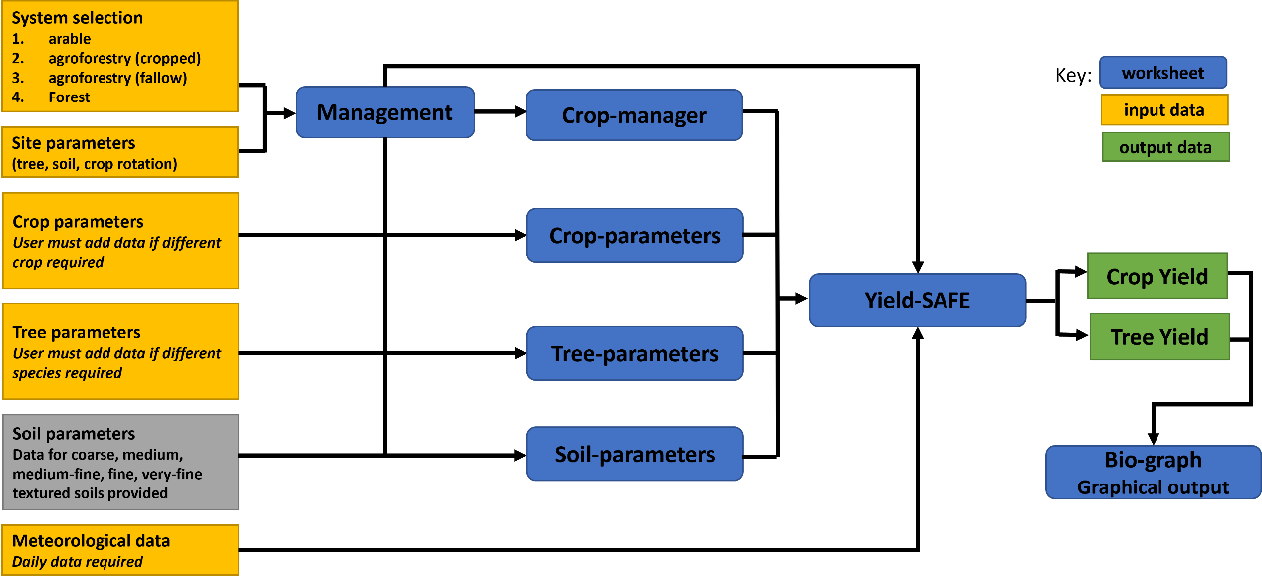
Figure 1. Schematic representation of the Yield-SAFE model, showing the seven worksheets: (in blue) ‘Management’, ‘Crop-manager’, ‘Crop-parameters’, ‘Tree-parameters’, ‘Soil-parameters’, ‘Yield-SAFE’, and ‘Bio-graph’

Table 1. The seven worksheets in Yield-SAFE and a brief description of their function
Worksheet type | Worksheet name | Worksheet function
Control and output | Management | This is the entry worksheet. The user can select required system (e.g., arable, agroforestry, or forest), set tree type, crop rotation, and thinning schedule.
Control and output | Crop-manager | Maintains a yearly summary of Yield-SAFE output
Control and output | Bio-graphs | Presentation of the biophysical outputs from Yield-SAFE
Data | Crop-parameters | List of crop parameters for the biophysical model. Selected crop parameters are already available in the worksheet. User must add data if different crop required.
Data | Tree-parameters | List of tree parameters for the biophysical model. Selected tree species are already available in the worksheet. User must add data if different species required.
Data | Soil-parameters | List of soil, irrigation and environment parameters for the biophysical model.
Calculation | Yield-SAFE | Stores the meteorological data for the biophysical analysis. Calculates on a daily basis the tree and crop yields for the system specified by the worksheet ‘Management’.

Management worksheet
The entry worksheet is entitled ‘Management’. The Management worksheet contains four main sections which are described below. Any parameters in yellow cells (as shown in Figure 2) can be set by the user to describe the required site and tree and/or crop system. The light-blue cells are ‘information’ cells that provide the user with additional information based on their input. For example, with reference to Figure 2, an input of ‘5’ for the ‘Tree template’ parameter reveals the chosen tree to be ‘Atlantic AGF Poplar Upson’.

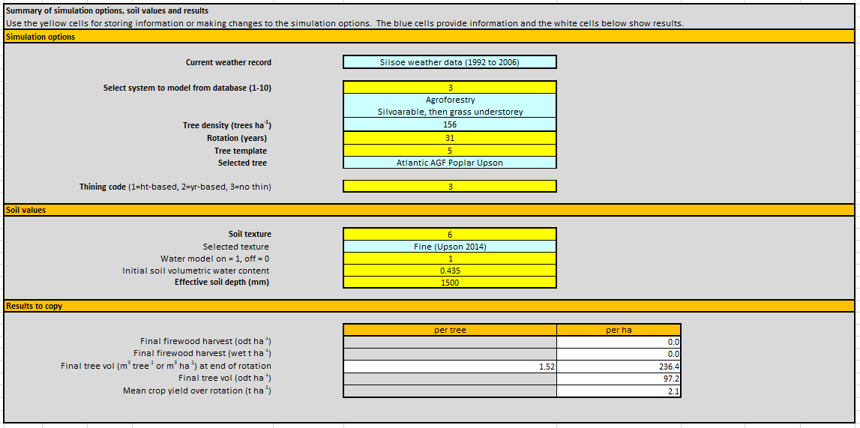
Figure 2. Example of yellow user input cells and light blue ‘information’ cells based on user input

Any sections of this worksheet that are ‘greyed-out’, as shown for the ‘Thinning (height based)’ table in Figure 3, are required for the Yield-SAFE model but do not require user input or change.

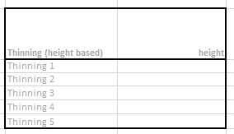

Figure 3. Example of ‘greyed-out’ section of the Management worksheet that is required for the Yield-SAFE model but does not require user input or change.

The first section of the “Management” worksheet is entitled ‘Summary of simulation options, soil values and results’. An example appearance of this section is shown in Figure 2. For a single land unit, the user can select/enter:
- System e.g., arable, agroforestry cropped, agroforestry fallow, or forestry.
- Rotation (years) – the length of the system rotation in years. Note the maximum rotation for this version of Yield-SAFE v2 is 30 years. Additional years could be added by adding extra rows to the ‘Yield-SAFE’ worksheet.
- Tree template - which tree data to use in the ‘Tree-parameters’ worksheet database.
- Thinning code – this code has three possible settings: 1 = thinning will be carried out when the trees have reached a user specified height regardless of the year of growth, 2 = thinning will be carried out in a user specified year regardless of the height the trees have attained, and 3 = no thinning of trees will be modelled.
- Soil texture - the user may select from 1: coarse, 2: medium, 3: medium-fine, 4: fine, and 5: very fine textured soils.
- Water model – this is a flag to indicate whether the water model should be on “1” or off “0”.
- Initial soil volumetric water content – this is set by the user in mm mm⁻¹.
- Effective soil depth of the land unit (mm)

Following calculation by the Yield-SAFE model this section also presents the results for the following parameters:
- Final firewood harvest (in oven dried tonnes (odt) ha⁻¹ and wet t ha⁻¹)
- Final tree volume at end of rotation (in odt ha⁻¹ and m³ ha⁻¹)
- Mean crop yield over the rotation (t ha⁻¹)

The second section contains the system tree density (trees per ha), crop area (fraction of land area used for crops), crop rotation and tree thinning regime parameters. An example appearance of this section is shown in Figure 4.

For each system the following parameters should be entered:
- System type - e.g., arable, agroforestry cropped, agroforestry fallow, or forestry.
- System description – a brief description of the system to be modelled e.g., Silvoarable, then grass understorey.
- Tree density (number of trees per hectare)
- Area – for an “agroforestry” system this parameter is the proportion of the area that will be cropped (this value remains fixed throughout the rotation). For “arable” or “forestry” systems this parameter should be set to “1”.

The crop rotation for each system is defined by entering a crop code for each year of the rotation. Each crop code references one of the crops defined in the Yield-SAFE ‘Crop-parameters’ worksheet database (see Section Crop-parameters). Additional crop species can be added to the ‘Crop-parameters’ worksheet as required.

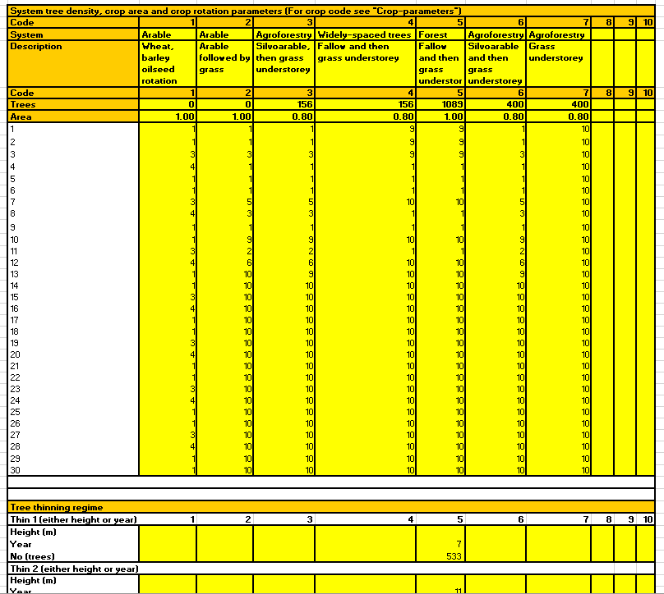

Figure 4. Appearance of data entry tables for crop rotation and tree thinning regime (if required) on the Management worksheet

Up to five separate tree thinning events can be defined based either on current tree height (as modelled within Yield-SAFE) or the rotation year. The user selects how the thinning events will be defined (height or year) using the ‘Thinning code’ entered in the ‘Summary of simulation options’ section of the Management worksheet. In the ‘Tree thinning regime’ (shown at the bottom of Figure 4) a user must specify either the height or the year – not both – and define the number of trees affected by the thinning event.

Tree-parameters worksheet
An example of the appearance of the Tree-parameters worksheet is shown in Figure 5. A list of the parameters contained on the Tree-parameters worksheet, together with a brief description and their units, is provided in Table 2.

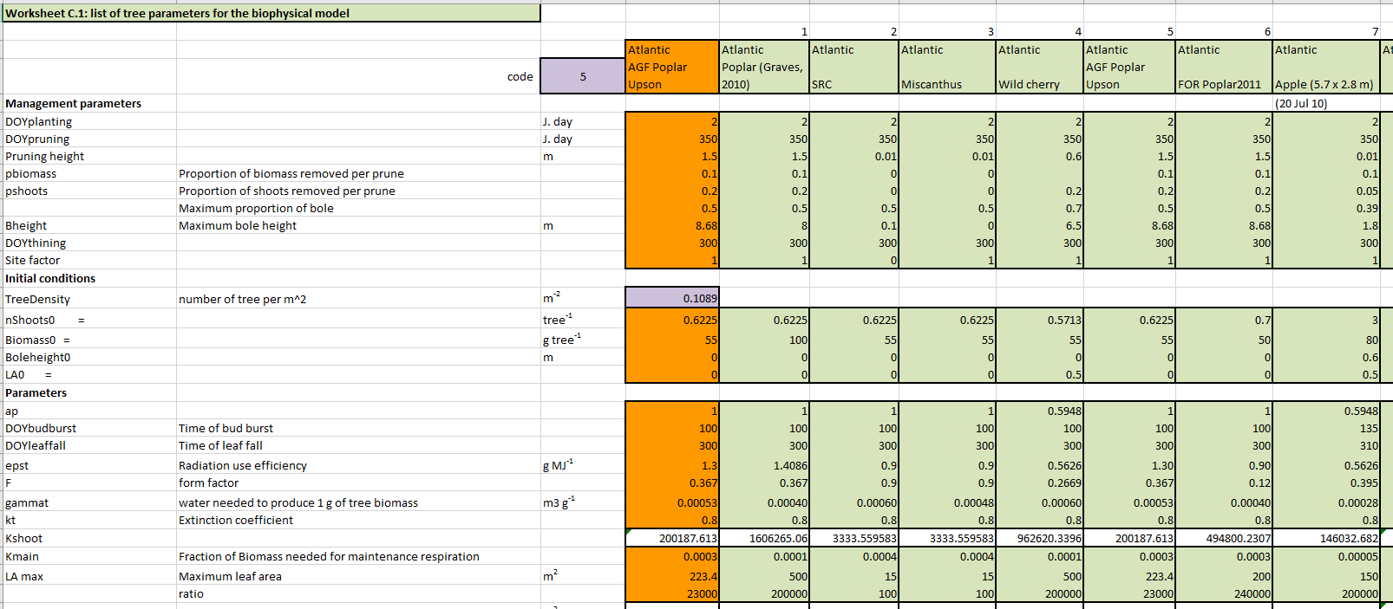
Figure 5. Example appearance of Tree-parameters worksheet

Table 2. List of tree parameters
Tree parameters
Management parameters
DOY_{planting} | Day of year of planting | Day of year
DOY_{pruning} | Day of year of pruning | Day of year
H_{prune} | Increment of prune height | m
π_{b} | Proportion of the tree biomass pruned
π_{s} | Proportion of the shoots pruned
B_{height} | Maximum height of the bole | m
DOY_{thinning} | Day of year of thinning
Initial conditions
ρ_{t} | Tree density | tree m⁻²
N_{shoots0} | Initial number of shoots | Shoots tree⁻¹
B_{to} | Initial biomass of tree | g tree⁻¹
B_{heighto} | Initial bole height of tree | m
LA_{o} | Initial leaf area of the tree | m² tree⁻¹
Parameters
ap | power function to describe tree height/diameter relationship
DOY_{budburst} | Day of year of budburst | Day of year
DOY_{leaffall} | Day of year of leaf fall | Day of year
ε_{t} | Above-ground dry matter to intercepted radiation coefficient | g MJ⁻¹
F | Form factor for the tree
γ_{t} | Water needed to produce 1 g of above-ground biomass | m³ g⁻¹
k_{t} | Radiation extinction coefficient
K_{shoot} | Calculated value
K_{Main} | Maintenance coefficient (fraction of biomass)
$$LA_{tree}^{max}$$ | Maximum leaf area of an individual tree | m² tree⁻¹
$LA_{tree}^{max}$ratio | Ratio between $LA_{ss}^{max}$and $n_{Shoots}^{max}$
$$LA_{ss}^{max}$$ | Calculated maximum leaf area for a single shoot | m² shoot⁻¹
$$n_{Shoots}^{max}$$ | Calculated maximum number of shoots | Shoots tree⁻¹
π_{branch} | Proportion of the above-ground biomass that forms branches
π_{timber} | Proportion of the above-ground biomass that forms timber
ρ_{timber} | Density of dry timber | g m⁻³
pFcrit_{c} | Critical pF value for tree growth | log(cm)
PWP_{t} | Permanent wilting point for the tree | log(cm)
$$σ_{height}$$ | Ratio of tree height to tree diameter for a free growing tree
$$\frac{dσ_{height}}{∂ρ_{t}}$$ | The change in $σ_{height}$ with density | (tree m⁻²)⁻¹
$$σ_{canopy}$$ | Ratio of canopy width (C_{width}) to canopy depth (C_{depth}) i.e. (C_{width}/C_{depth})
τ_{t} | Time constant representing the number after bud-burst at each the leaf area reached 63.2% of its maximum leaf area (See Note C3) | day
 | Wood moisture content
a | Light extinction "a" value
b | Light extinction "b" value
π_{S R} | Ratio of structural roots to aboveground biomass (See note C5)
r | Length of fine root per gram of structural root (See note C5) | m g⁻¹
kr | Extinction coefficient determining the interception of water per unit of root length
DOY_{fruitset} | DOY fruit set | Day of year
π_{bf} | Proportion of biomass to fruit

Crop-parameters worksheet
An example of the appearance of the Crop-parameters worksheet is shown in Figure 6. The parameters used for the crop component of the Yield-SAFE model are outlined in Table 3.

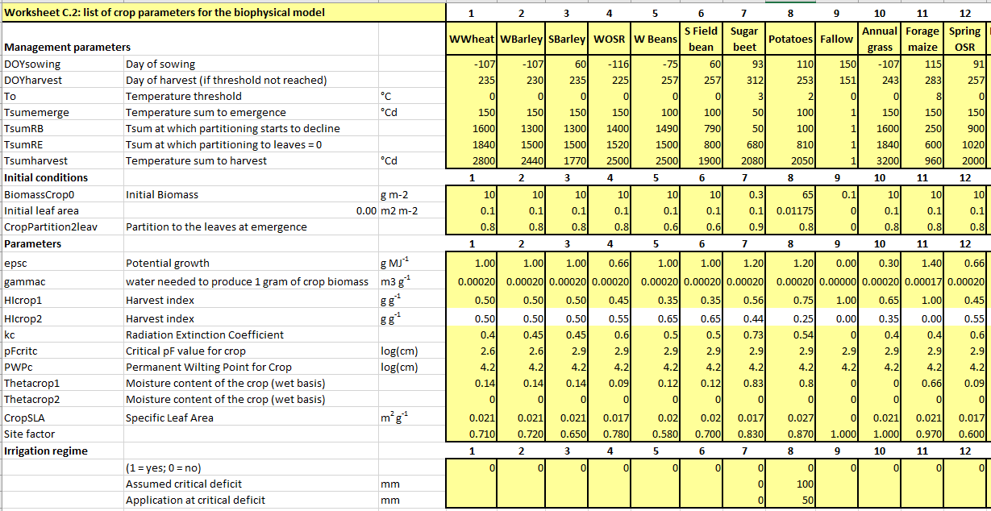
Figure 6. Example appearance of Crop-parameters worksheet

Table 3. List of crop parameters
Crop parameters
Management parameters
DOY_{sowing} | Day of year of sowing | Day of year
DOY_{harvest} | Day of harvest (if T_{sumharvest} not reached) | Day of year
T₀ | Temperature threshold | °C
T_{sumEmerge} | T_{sum} to plant emergence | °C d
T_{sum}R_{B} | T_{sum} at which partitioning to leaves starts to reduce | °C d
T_{sum}R_{E} | T_{sum} at which partitioning to leaves =0 | °C d
T_{sumharvest} | Temperature sum till harvest | °C d
Initial conditions
B_{cropo} | Initial above-ground biomass of crop | g (m² crop area)⁻¹
LA0 | Initial leaf area | m² m⁻²
p_{lo} | Initial partitioning factor of above-ground biomass to the leaves
Parameters
ε_{c} | Above-ground dry matter to intercepted shortwave radiation coefficient | g MJ⁻¹
γ_{c} | Water need to produce 1 g above-ground biomass -regional | m³ g⁻¹
HI_{crop1} | Harvest index for first crop component
HI_{crop2} | Harvest index for second crop component
k_{c} | Radiation extinction coefficient for crop
pFcrit_{c} | Critical pF value for crop growth | log(cm)
PWP_{c} | Permanent wilting point for the crop | log(cm)
θ_{crop1} | Water content (wet basis) of first crop component
θ_{crop2} | Water content (wet basis) of second crop component
s_{c} | Specific leaf area | m² g⁻¹
Irrigation Regime
Flag | (1 = yes; 0 = no)
 | Assumed critical deficit | mm
 | Application at critical deficit | mm
Notes:
- The initial leaf area need not be the same as initial biomass x initial partitioning to leaf coefficient / specific leaf area.
- It is possible to add harvest indices for two crop components i.e., grain and straw.
- An option (θ_{crop1}) has been added to account for the water content of a crop.

Crop-manager worksheet
The Crop-manager worksheet (example appearance shown in Figure 7) provides a yearly summary of the production data modelled by Yield-SAFE.

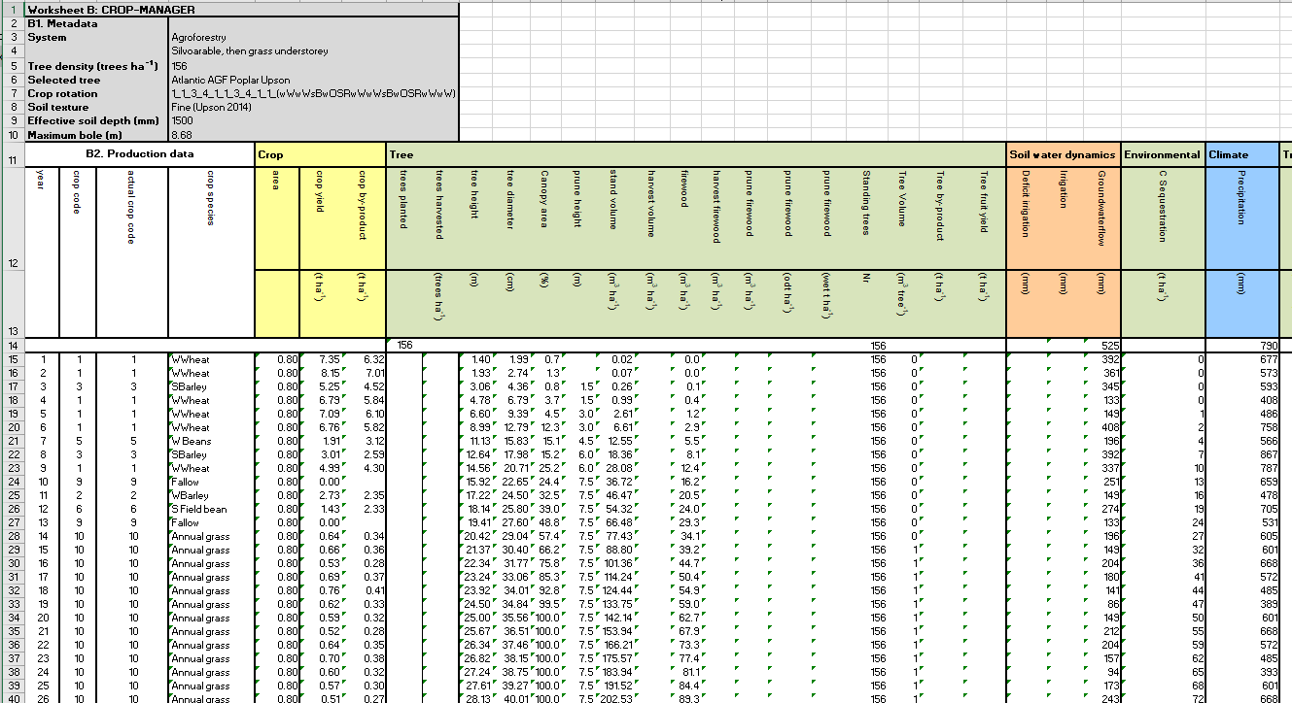

Figure 7. Example appearance of Crop-manager worksheet

The first section of this worksheet provides the following summary data for the tree/crop system defined on the Management worksheet:

- System description
- Tree density (trees/ha)
- Selected tree
- Crop rotation
- Soil texture
- Effective soil depth (mm)
- Maximum bole (m)

A list of the parameters currently output on the Crop-manager worksheet for each rotation year is shown in Table 4.

Table 4. Parameters currently output on the Crop-manager for each rotation year

Parameter | Description | Unit
Year | Year of rotation
Crop code | The code for the crop grown that year
Actual crop code | Currently the same as ‘crop code’
Crop species | Identity of the crop species
Area | The fraction of the land area covered by the crop
Crop yield | Yield of crop | t ha⁻¹
Crop by-product | Yield of by-product e.g. straw | t ha⁻¹
Trees planted | Number of trees originally planted – this value is only inputted once
Trees harvested | Number of trees that have been harvested that year | trees ha⁻¹
Tree height | The tree height reached | m
Tree diameter | The tree diameter at breast-height (dbh) reached | cm
Canopy area | Proportion of the ground covered by the tree canopy | %
Prune height | Height of pruning | m
Stand volume | Total volume of timber (standing and harvested timber) | m³ ha⁻¹
Harvest volume | Volume of harvested timber Harvested timber | m³ ha⁻¹
Firewood | Volume of the timber that is branchwood (firewood) | m³ ha⁻¹
Harvest firewood | The volume of the branchwood (firewood) that has been harvested | m³ ha⁻¹
Prune firewood | Total volume of pruned and harvested branchwood (firewood) | m³ ha⁻¹
Prune firewood | Total volume of pruned and harvested branchwood (firewood) | odt ha⁻¹
Prune firewood | Total volume of pruned and harvested branchwood (firewood) | wet t ha⁻¹
Standing trees | Number of trees still standing
Tree Volume | Volume of a tree. | m³ tree⁻¹
Tree by-product | Total mass of pruned and harvested branchwood (firewood). | t ha⁻¹
Tree fruit yield | Tree fruit yield. | t ha⁻¹
Deficit irrigation | Total critical deficit irrigation. | mm
Irrigation | Total overhead irrigation application. | mm
Groundwaterflow | Total water flow to groundwater. | mm
C Sequestration | Total mass of carbon sequestered. | t ha⁻¹
Precipitation | Total precipitation | mm
Total timber volume | Total amount of timber generated up to date (i.e., sum of current stand volume and all harvested wood) | m³ ha⁻¹
Tree water use | Total tree water use | mm yr⁻¹
Crop water use | Total crop water use | mm yr⁻¹
Soil evaporation | Total soil evaporation | mm yr⁻¹

Soil-parameters worksheet
An example of the appearance of the Soil-parameters worksheet is shown in Figure 8. The list of soil parameters included in the Yield-SAFE model are described in Table 5. The worksheet also includes an “irrigation parameters” (Table 6) and “environmental parameters” (Table 7) section.

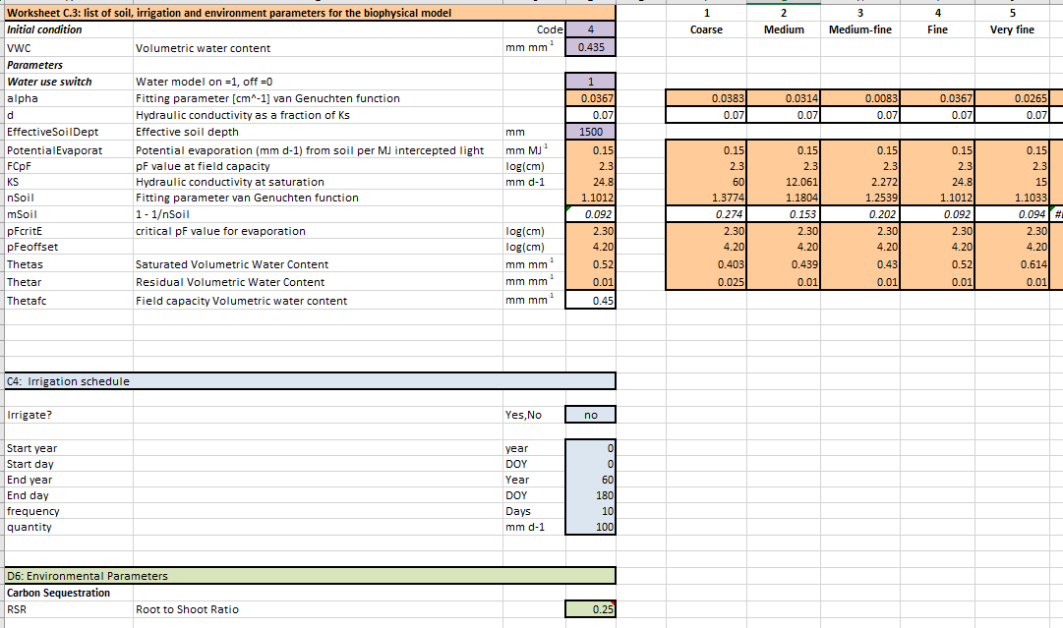
Figure 8. Example appearance of Soil-parameters worksheet

Table 5. List of soil parameters
Soil parameter | Description | Unit
$$α$$ | van Genuchten parameter | cm⁻¹
$$δ$$ | Hydraulic conductivity as a fraction of K_{s}
D | Effective soil depth | mm
$$∂_{eva}$$ | Potential evaporation per unit energy | mm MJ⁻¹
FC | Field capacity pF value
K_{s} | Hydraulic conductivity at saturation | mm d⁻¹
n | van Genuchten parameter
pFcrit_{E} | Critical pF value for evaporation | log(cm)
$$pF_{offset}^{E}$$ | pF where soil evaporation is 0 (comparable to permanent wilting point) | log(cm)
$$θ_{s}$$ | Saturated volumetric water content | mm mm⁻¹
$$θ_{r}$$ | Residual volumetric water content | mm mm⁻¹

Table 6. List of irrigation parameters
Parameter | Description | Unit
 | Irrigation model switch (yes/no)
Year_{Irrstart} | Year for starting irrigation
DOY_{Irrstart} | Day of year for starting irrigation
Year_{Irrend} | Year for finishing irrigation
DOY_{Irrend} | Day of year for finishing irrigation
Irr_{int} | Interval between irrigation events | d
Irr_{amount} | Amount of irrigation | mm d⁻¹

Table 7. List of environmental parameters
Parameter | Description | Units
Root to shoot ratio | Root to shoot ratio
Soil OM | % of organic matter in soil | 0-1
Depth of soil OM | Depth until the OM is present | m
Atmospheric deposition |  | kg ha⁻¹
N in organic fertilizer |  | kg ha⁻¹
N in mineral fertilizer |  | kg ha⁻¹
Bulk density |  | kg m⁻³
OM | Organic matter in soil | kg ha⁻¹
Beta | Recovery factor

Yield-SAFE worksheet
The Yield-SAFE worksheet (Figure 9) modifies the tree, crop and soil data on a daily basis. Each row in the worksheet represents a single day. The general flow of the calculations is from left to right. This worksheet comprises five sections.
- Date and meteorological data: daily meteorological data for the specific period examined.
- Tree growth calculations: tree growth calculations based on a single tree.
- Crop dynamics: crop variables expressed relative to the cropped area.
- Soil water dynamics: soil water content, evaporation and water uptake
- Environmental assessment: calculation of root biomass and carbon and CO₂ sequestration
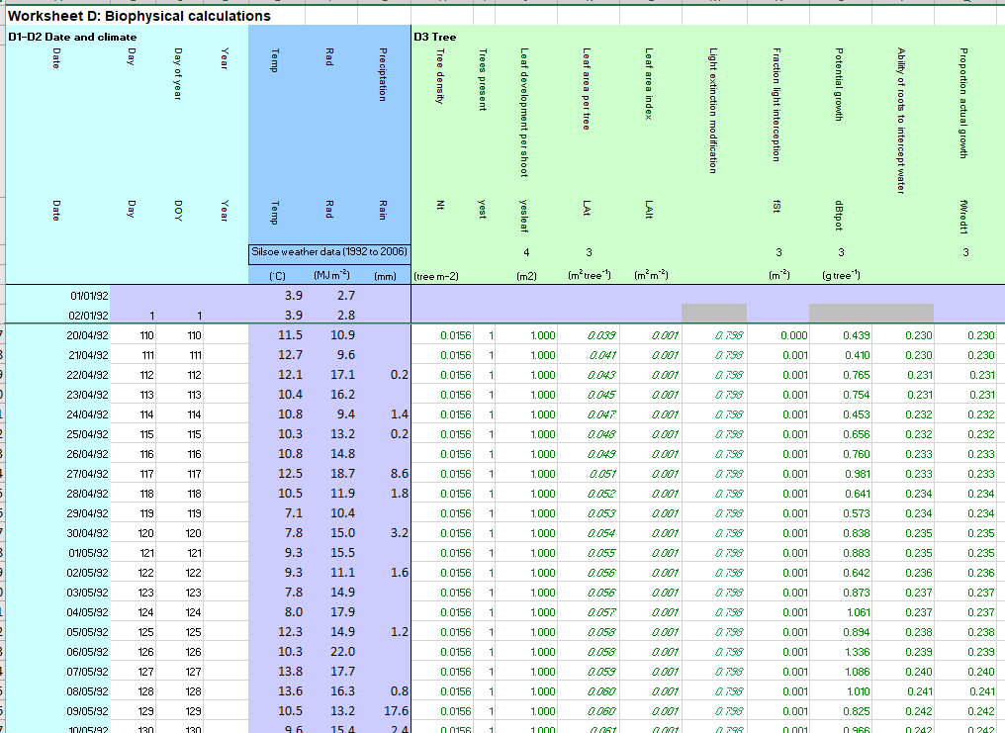
Figure 9. Example appearance of the Yield-SAFE worksheet

Date and meteorological data
The first section of the Yield-SAFE worksheet contains the daily meteorological data for the specific period examined (Table 8).

Table 8. Date and meteorological parameters on the Yield-SAFE worksheet
 | Inputs | Unit
I | Daily incoming total shortwave radiation | MJ m⁻²
P | Daily precipitation | mm³ (mm² tree area)⁻¹
T | Mean temperature at 150 cm above soil surface | °C

Tree growth calculations
Daily calculations are completed to provide daily values for a range of tree state variables (Table 9).

Table 9. List of tree state variables
Symbol | Description | Units
$$ρ_{t}$$ | Tree density | Trees m⁻²
B_{t} | Biomass of tree | g tree⁻¹
CanopyArea | Proportion of the ground covered by tree canopy | %
C_{Depth} | Depth of tree canopy | m
C_{Width} | Maximum tree canopy width | m
dbh | Diameter at breast height | m
H | Tree height | m
H_{prune} | Height of pruning | m
LA_{ss} | Leaf area per single shoot | m² shoot⁻¹
LA_{t} | Leaf area per tree | m² tree⁻¹
n_{Shoots} | Number of shoots per tree | Shoots tree⁻¹
V | Volume of timber | m³ tree⁻¹

Crop dynamics
In this part all crop state variables are expressed relative to the cropped area (Table 10). Typically, in a silvoarable system there is a proportion of the tree area, typically at the base of the trees, that is not cropped (1-Ar_{ct}). In this analysis, the two proportions are analysed separately.

Table 10. List of crop state variables
Symbol | Description | Units
B_{crop} | Crop biomass | g (crop area)⁻¹
LAI_{crop} | Leaf area of crop | m² (m² crop area)⁻¹
p_{l} | Partitioning to leaves
T_{sum} | Thermal time above base temperature | °C d
Y_{crop} | Crop yield | g (crop area)⁻¹

Soil water dynamics

The soil water state variables include the soil water potential (Table 11) and flows of water to the tree and crop components.

Table 11. List of soil water state variables
Symbol | Description | Unit
pF | log (Ψ) | log (cm)
$$θ$$ | Soil water content | mm mm⁻¹
Ψ | Soil water potential | cm head of water
P | Rainfall | mm³ (mm² tree area)⁻¹ d⁻¹
W_{irr} | Irrigation | mm³ (mm² tree area)⁻¹ d⁻¹
R | Runoff | mm³ (mm² tree area)⁻¹ d⁻¹
F_{gw} | Flux to groundwater | mm³ (mm² tree area)⁻¹ d⁻¹
F_{t} | Flux to trees | mm³ (mm² tree area)⁻¹ d⁻¹
F_{c} | Flux to crops | mm³ (mm² tree area)⁻¹ d⁻¹
E_{Act} | Actual evaporation flux | mm³ (mm² tree area)⁻¹ d⁻¹

Environmental assessment
The parameters calculated in the final section of the Yield-SAFE worksheet are shown in Table 12.

Table 12. Environmental assessment parameters on the Yield-SAFE worksheet
Description | Unit
Root biomass | g tree⁻¹
Carbon sequestered | t C ha⁻¹
CO₂ sequestered | t CO₂ ha⁻¹

Bio-graph worksheet
The seventh worksheet includes a graphical representation of selected state variables on a daily basis for the duration of the tree rotation selected in cell F10 (Figure 10). The plotted meteorological graphs are mean temperature, daily solar radiation, and daily rainfall. The crop data includes the presence or absence of the crop, the crop leaf area index, the crop biomass, and the crop yield. The tree data includes the stand volume and the tree height.

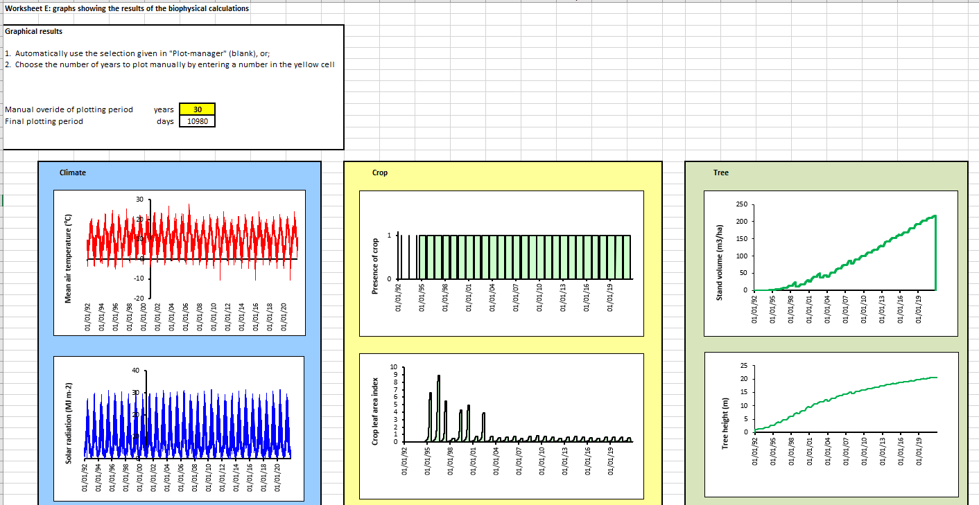
Figure 10. Example appearance of Bio-graph worksheet

Acknowledgements
The Yield-SAFE model was developed as part of the collaborative EU research project called “SAFE: Silvoarable Agroforestry for Europe”. Support for SAFE was provided by the Quality of Life Programme of the European Union (contract number QLK5-CT-2001-00560). The Yield-SAFE v2 model was modified by Matt Upson through his PhD (Upson 2014) which received support from Cranfield University, Forest Research, and the Scottish Forestry Trust. The process of creating a default publicly available version of the model has been enabled through the BioForce project funded by the UK Department for Energy Security and Net Zero.

References
Burgess, P.J., Graves, A.R., Metselaar, K., Stappers, R., Keesman, K., Palma, J., Mayus, M., and van der Werf, W. (2004) Description of the Plot-SAFE version 0.3 model. Cranfield University. 52 pp.
Burgess, P.J., Graves, A.R., Upson, M., Wiltshire, K., Giannitsopoulos, M., Metselaar, K., Stappers, R., Keesman, K., Palma, J., Pilbeam, D.J., van der Werf, W. (2023) Yield-SAFE Description and Calibration Guide. Cranfield, Bedfordshire, UK, Cranfield University. 46 pp
Dupraz, C., Wolz, K.J., Lecomte, I., Talbot, G., Vincent, G., Mulia, R., Bussière, F., Ozier-Lafontaine, H., Andrianarisoa, S., Jackson, N., Lawson, G., Dones, N., Sinoquet, H., Lusiana, B., van Noordwijk, M. (2019) Hi-sAFe: A 3D agroforestry model for integrating dynamic tree–crop interactions. Sustainability, 11, 2293. https://doi.org/10.3390/su11082293
García de Jalón, S., Graves, A., Palma, J.H.N., Williams, A., Upson, M.A., Burgess, P.J. (2018) Modelling and valuing the environmental impacts of arable, forestry and agroforestry systems: a case study. Agroforestry Systems 92:1059–1073. https://doi.org/10.1007/s10457-017-0128-z
Giannitsopoulos, M., Graves, A.R, Burgess, P.J., Crous-Duran, J., Moreno, G., Herzog, F., Palma, J.H.N., Kay, S., García de Jalón, S. (2020) Whole system valuation of arable, agroforestry and tree-only systems at three case study sites in Europe. Journal of Cleaner Production 269, 122283. https://doi.org/10.1016/j.jclepro.2020.122283
Graves, A.R., Burgess, P.J., Palma, J., Keesman, K., van der Werf, W., Dupraz, C., van Keulen, H., Herzog, F., Mayus, M. (2010) Implementation and calibration of the parameter-sparse Yield-SAFE model to predict production and land equivalent ratio in mixed tree and crop systems under two contrasting production situations in Europe. Ecological Modelling 221, 1744-1756. https://doi.org/10.1016/j.ecolmodel.2010.03.008
Graves, A.R., Burgess, P.J., Liagre, F., Terreaux, J-P., Borrel, T, Dupraz, C., Palma, J., Herzog, F. (2011) Farm-SAFE: the process of developing a plot- and farm-scale model of arable, forestry and silvoarable economics. Agroforestry Systems 81, 93-108.
Palma, J.H.N., Crous-Duran, J., Graves, A.R., Garcia de Jalon, S., Upson, M., Oliveira, T.S., Paulo, J.A., Ferreiro-Domínguez, N., Moreno, G., Burgess, P.J. (2018) Integrating belowground carbon dynamics into Yield-SAFE, a parameter sparse agroforestry model. Agroforestry Systems 92, 1047–1057. https://doi.org/10.1007/s10457-017-0123-4
Upson, M.A. (2014) The Carbon Storage Benefits of Agroforestry and Farm Woodlands. Unpublished PhD thesis. Bedfordshire, UK: Cranfield University. https://dspace.lib.cranfield.ac.uk/handle/1826/9298
van der Werf, W., Keesman, K., Burgess, P., Graves, A., Pilbeam, D., Incoll, L.D., Metselaar, K., Mayus, M., Stappers, R., van Keulen, H., Palma, J. Dupraz, C. (2007) Yield-SAFE: A parameter-sparse, process-based dynamic model for predicting resource capture, growth, and production in agroforestry systems. Ecological Engineering 29, 419–433. https://doi.org/10.1016/j.ecoleng.2006.09.017

