Coupling green hydrogen production to community benefits: a pathway to social acceptance?
Joel A. Gordonª, Nazmiye Balta-Ozkan^{a*}, Anwar Haq^{b} Seyed Ali Nabaviª
a School of Water, Energy and Environment, Cranfield University, Bedford, UK
b Newcastle Business School, Northumbria University, London, UK

Table 1 provides full details of the survey questions pertaining to each construct and its respective indicators (see Figure 1), as well as the scales employed, in addition to the supporting literature for deriving each item. The presented framework is referred to in the text as the Domestic Hydrogen acceptance Model (DHAM).
Figure 1 is presented in the main manuscript as Figure 2, while Table 1 is presented in Supplementary Materials as Table S3. In total, 13 Supplementary Notes are provided to support the analysis. Figure 1 is presented below for contextual purposes.
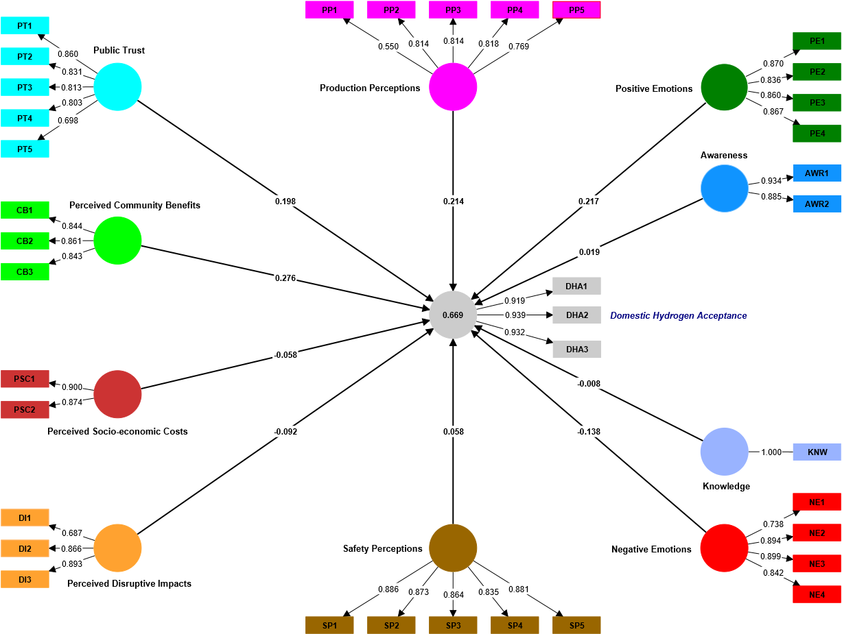

Figure 1. Structural model path coefficients.

Table 1. Questionnaire details and literature sources.

Construct | Indicator | Question items and framing | Scale | Supporting literature
Awareness (AWR)ª | AWR1 | There are a range of low-carbon energy technologies that may provide an alternative to natural gas for heating and cooking purposes.  - Are you aware of these technology options? | 1–5:  Unaware–Extremely aware | [1–6]
Awareness (AWR)ª | AWR2 | - Are you aware that hydrogen may provide a potential low-carbon option for home heating and cooking? | 1–5:  Unaware–Extremely aware | [1–6]
Knowledge (KNW)^{b} | KNW | - How much do you know about hydrogen fuel? | 1–5:  Nothing–Significant amount | [1,3,7–11]
Public trust  (ST) |  | How much trust do you have in the following stakeholders when it comes to supporting a cost-effective, efficient, and fair transition to hydrogen homes?
 | ST1 | - Gas Distribution Network Operators | 0–10:  No trust–Total trust | [8–10,12–14]
 | ST2 | - Renewable energy producers | 0–10:  No trust–Total trust | [8–10,12–14]
 | ST3 | - Financial institutions | 0–10:  No trust–Total trust | [8–10,12–14]
 | ST4 | - The Office of Gas and Electricity Markets (Ofgem) | 0–10:  No trust–Total trust | [8–10,12–14]
 | ST5 | - The media | 0–10:  No trust–Total trust | [8–10,12–14]
Safety Perceptions (SP) |  | Please evaluate your current safety perceptions of hydrogen compared to natural gas for the following: | 0–10:  Less safe–More safe | [1,2,5,8,9,15–18]
Safety Perceptions (SP) | SP1 | - Hydrogen boilers | 0–10:  Less safe–More safe | [1,2,5,8,9,15–18]
Safety Perceptions (SP) | SP2 | - Hydrogen hobs | 0–10:  Less safe–More safe | [1,2,5,8,9,15–18]
Safety Perceptions (SP) | SP3 | - Hydrogen pipelines (i.e. transport/transmission) | 0–10:  Less safe–More safe | [1,2,5,8,9,15–18]
Safety Perceptions (SP) | SP4 | - Underground storage of hydrogen gas | 0–10:  Less safe–More safe | [1,2,5,8,9,15–18]
Safety Perceptions (SP) | SP5 | - Overall, how do you perceive the safety level of hydrogen compared to natural gas in terms of production, storage, transportation, and domestic use? | 0–10:  Less safe–More safe | [1,2,5,8,9,15–18]
Production Perceptions  (PP) | PP1 | - What is your attitude towards the UK government supporting blue hydrogen production in the short-term (i.e. up to 2030)? | 0–10:  Opposed–Supportive | [7–9,19–21]
Production Perceptions  (PP) | PP2 | - What is your attitude towards the UK government supporting blue hydrogen production over the long-term (i.e. after 2030)? | 0–10:  Opposed–Supportive | [7–9,19–21]
Production Perceptions  (PP) | PP3 | - What is your attitude towards the UK government supporting green hydrogen production in the short-term (i.e. up to 2030)? | 0–10:  Opposed–Supportive | [7–9,19–21]
Production Perceptions  (PP) | PP4 | - What is your attitude towards the UK government supporting green hydrogen production over the long-term (i.e. after 2030)? | 0–10:  Opposed–Supportive | [7–9,19–21]
 | PP5 | - How do you feel about the government's twin-track strategy? (i.e. with a role for blue and green hydrogen) |  | [7–9,19–21]
Disruptive Impacts (DI) | DI1 | - How concerned are you about noise, traffic, and other potential inconvenience from changes to infrastructure and other hydrogen-related activities at street level? | 1–5:  Not at all concerned–Extremely concerned | [8,9,13,14,22]
Disruptive Impacts (DI) | DI2 | - How concerned are you about being temporarily disconnected from the gas grid for up to 3 days in summer: (i.e. during the switchover period for hydrogen homes)? | 1–5:  Not at all concerned–Extremely concerned | [8,9,13,14,22]
Disruptive Impacts (DI) | DI3 | - How concerned are you about disruption from engineers and technicians working within your home during the switchover period: (i.e. up to 3 days)? | 1–5:  Not at all concerned–Extremely concerned | [8,9,13,14,22]
Perceived Costs (PC) |  | To what extent do you agree or disagree with the following statements: | 1–5:  Strongly disagree–Strongly agree | [6,14,17,23–25]
Perceived Costs (PC) | PC1 | - Switching from natural gas to hydrogen will have a negative impact on UK energy security (i.e. reliability of energy supply) | 1–5:  Strongly disagree–Strongly agree | [6,14,17,23–25]
Perceived Costs (PC) | PC2 | - Switching from natural gas to hydrogen will lead to higher levels of fuel poverty across the UK | 1–5:  Strongly disagree–Strongly agree | [6,14,17,23–25]
Community Benefits (CB) | CB1 | - What is your expectation for hydrogen homes delivering economic benefits such as job opportunities and income security? | 0–10:  Low–High expectation | [11,13,14,26–28]
Community Benefits (CB) | CB2 | - What is your expectation for hydrogen homes delivering social benefits such as reduced levels of fuel poverty and improved health? | 0–10:  Low–High expectation | [11,13,14,26–28]
Community Benefits (CB) | CB3 | - What is your expectation for hydrogen homes delivering environmental benefits such lower carbon emissions and better air quality? | 0–10:  Low–High expectation | [11,13,14,26–28]
Positive Emotions (PE) | PE1 | - How satisfied do you feel about the prospect of using a hydrogen boiler and hydrogen hob within your home? | 1–5:  No feeling–Very strong feeling | [3,15,29–32]
Positive Emotions (PE) | PE2 | - How calm do you feel about the prospect of using a hydrogen boiler and hydrogen hob within your home? | 1–5:  No feeling–Very strong feeling | [3,15,29–32]
Positive Emotions (PE) | PE3 | - How confident do you feel about the prospect of using a hydrogen boiler and hydrogen hob within your home? | 1–5:  No feeling–Very strong feeling | [3,15,29–32]
Positive Emotions (PE) | PE4 | - How optimistic do you feel about the prospect of using a hydrogen boiler and hydrogen hob within your home? | 1–5:  No feeling–Very strong feeling | [3,15,29–32]
Negative Emotions (NE) | NE1 | - How discontent do you feel about the prospect of using a hydrogen boiler and hydrogen hob within your home? | 1–5:  No feeling–Very strong feeling | [3,15,29–32]
Negative Emotions (NE) | NE2 | - How worried do you feel about the prospect of using a hydrogen boiler and hydrogen hob within your home? | 1–5:  No feeling–Very strong feeling | [3,15,29–32]
Negative Emotions (NE) | NE3 | - How fearful do you feel about the prospect of using a hydrogen boiler and hydrogen hob within your home? | 1–5:  No feeling–Very strong feeling | [3,15,29–32]
Negative Emotions (NE) | NE4 | - How pessimistic do you feel about the prospect of using a hydrogen boiler and hydrogen hob within your home? | 1–5:  No feeling–Very strong feeling | [3,15,29–32]
Domestic Hydrogen Acceptance  (DHA) |  | Please evaluate your current level of support or opposition for the following:
Domestic Hydrogen Acceptance  (DHA) | DHA1 | - Domestic hydrogen becoming a critical part of the UK’s energy future | 0–10:  Opposed–Supportive | [23,33–35]
Domestic Hydrogen Acceptance  (DHA) | DHA2 | - Hydrogen replacing natural gas in your local area before 2030 | 0–10:  Opposed–Supportive | [23,33–35]
Domestic Hydrogen Acceptance  (DHA) | DHA3 | - Switching your home to both hydrogen heating and hydrogen cooking before 2030 | 0–10:  Opposed–Supportive | [23,33–35]

ª For the Awareness scale, the following options were given:

- No, I was unaware before today
- Yes, I’m slightly aware
- Yes, I’m somewhat aware
- Yes, I’m very aware
- Yes, I’m extremely aware

^{b} For the Knowledge scale, the following options were given:

- I know nothing about hydrogen fuel but may have heard something about it in the past
- I know a little about hydrogen fuel and understand some basic details
- I know a moderate amount about hydrogen fuel and can explain some basic information about it
- I know a lot about hydrogen fuel and feel confident explaining information about it
- I know a significant amount about hydrogen fuel and feel very confident explaining information about it

References
[1] D. Apostolou, S.N. Welcher, Prospects of the hydrogen-based mobility in the private vehicle market. A social perspective in Denmark, Int J Hydrogen Energy. 46 (2021) 6885–6900.
[2] S. Hienuki, Y. Hirayama, T. Shibutani, J. Sakamoto, J. Nakayama, A. Miyake, How knowledge about or experience with hydrogen fueling stations improves their public acceptance, Sustainability. 11 (2019) 6339.
[3] N.M.A. Huijts, The emotional dimensions of energy projects: Anger, fear, joy and pride about the first hydrogen fuel station in the Netherlands, Energy Res Soc Sci. 44 (2018) 138–145.
[4] L.L. Lozano, B. Bharadwaj, A. de Sales, A. Kambo, P. Ashworth, Societal acceptance of hydrogen for domestic and export applications in Australia, Int J Hydrogen Energy. 47 (2022) 28806–28818.
[5] K. Ono, K. Tsunemi, Identification of public acceptance factors with risk perception scales on hydrogen fueling stations in Japan, Int J Hydrogen Energy. 42 (2017) 10697–10707.
[6] J. Yap, B. McLellan, Evaluating the attitudes of Japanese society towards the hydrogen economy: A comparative study of recent and past community surveys, Int J Hydrogen Energy. (2023) In Press.
[7] J.A. Gordon, N. Balta-Ozkan, S.A. Nabavi, Gauging public perceptions of blue and green hydrogen futures: Is the twin-track approach compatible with hydrogen acceptance?, Int J Hydrogen Energy. (2023) In Press.
[8] L.L. Lozano, B. Bharadwaj, A. de Sales, A. Kambo, P. Ashworth, Societal acceptance of hydrogen for domestic and export applications in Australia, Int J Hydrogen Energy. 47 (2022) 28806–28818.
[9] V. Martin, P. Ashworth, S. Petrova, B. Wade, K. Witt, E. Clarke, Public perceptions of hydrogen: 2021 national survey results, Future Fuels CRC, 2021. https://espace.library.uq.edu.au/view/UQ:f25a2cc
[10] P. Bögel, C. Oltra, R. Sala, M. Lores, P. Upham, E. Dütschke, U. Schneider, P. Wiemann, The role of attitudes in technology acceptance management: Reflections on the case of hydrogen fuel cells in Europe, J Clean Prod. 188 (2018) 125–135.
[11] S.K. Kar, R. Bansal, S. Harichandan, An empirical study on intention to use hydrogen fuel cell vehicles in India, Int J Hydrogen Energy. 47 (2022) 19999–20015.
[12] F.N.H. Montijn-Dorgelo, C.J.H. Midden, The role of negative associations and trust in risk perception of new hydrogen systems, J Risk Res. 11 (2008) 659–671.
[13] C. Oltra, E. Dütschke, R. Sala, U. Schneider, P. Upham, The public acceptance of hydrogen fuel cell applications in Europe, Rev Int Sociol. 75 (2017) e076.
[14] J.A. Gordon, N. Balta-Ozkan, S.A. Nabavi, Price promises, trust deficits and energy justice: Public perceptions of hydrogen homes, Renewable & Sustainable Energy Reviews. 188 (2023) 113810.
[15] S. Harichandan, S.K. Kar, R. Bansal, S.K. Mishra, Achieving sustainable development goals through adoption of hydrogen fuel cell vehicles in India: An empirical analysis, Int J Hydrogen Energy. 48 (2023) 4845–4859.
[16] J.A. Gordon, N. Balta-Ozkan, A. Nabavi, Divergent consumer preferences and visions for cooking and heating technologies in the United Kingdom: Make our homes clean, safe, warm and smart!, Energy Res Soc Sci. 104 (2023) 103204.
[17] M. Scott, G. Powells, Towards a new social science research agenda for hydrogen transitions: Social practices, energy justice, and place attachment, Energy Res Soc Sci. 61 (2020) 101346.
[18] M. Scott, G. Powells, Sensing hydrogen transitions in homes through social practices: Cooking, heating, and the decomposition of demand, Int J Hydrogen Energy. 45 (2020) 3870–3882.
[19] R. Zimmer, J. Welke, Let’s go green with hydrogen! the general public’s perspective, Int J Hydrogen Energy. 37 (2012) 17502–17508.
[20] H.L. Bentsen, J.K. Skiple, T. Gregersen, E. Derempouka, T. Skjold, In the green? Perceptions of hydrogen production methods among the Norwegian public, Energy Res Soc Sci. 97 (2023) 102985.
[21] C. Smith, C. Bucke, D. van der Horst, Green hydrogen powering sustainable festivals: Public perceptions of generators, production and ownership, Int J Hydrogen Energy. 48 (2023) 8370–8385.
[22] D. Gray, H. Snodin, A. Bullen, Exploring the evidence on potential issues associated with trialling hydrogen heating in communities: A literature review and focus group study, Department for Business, Energy & Industrial Strategy: BEIS Research Paper Number 2020/018, 2019. https://www.gov.uk/government/publications/exploring-the-evidence-on-issues-associated-with-trialling-hydrogen-heating
[23] M.D. Scovell, Explaining hydrogen energy technology acceptance: A critical review, Int J Hydrogen Energy. 47 (2022) 10441–10459.
[24] K. Beasy, S. Lodewyckx, P. Mattila, Industry perceptions and community perspectives on advancing a hydrogen economy in Australia, Int J Hydrogen Energy. 48 (2023) 8386–8397.
[25] K.J. Dillman, J. Heinonen, A ‘just’ hydrogen economy: A normative energy justice assessment of the hydrogen economy, Renewable and Sustainable Energy Reviews. 167 (2022) 112648.
[26] HM Government, UK Hydrogen Strategy, 2021. https://www.gov.uk/government/publications/uk-hydrogen-strategy.
[27] P. Emmerich, A.G. Hülemeier, D. Jendryczko, M.J. Baumann, M. Weil, D. Baur, Public acceptance of emerging energy technologies in context of the German energy transition, Energy Policy. 142 (2020) 111516.
[28] N.P. Dumbrell, S.A. Wheeler, A. Zuo, D. Adamson, Public willingness to make trade-offs in the development of a hydrogen industry in Australia, Energy Policy. 165 (2022) 112987.
[29] M. Martiskainen, B.K. Sovacool, Mixed feelings: A review and research agenda for emotions in sustainability transitions, Environ Innov Soc Transit. 40 (2021) 609–624.
[30] N.M.A. Huijts, C.J.H. Midden, A.L. Meijnders, Social acceptance of carbon dioxide storage, Energy Policy. 35 (2007) 2780–2789.
[31] N. Contzen, A. V. Handreke, G. Perlaviciute, L. Steg, Emotions towards a mandatory adoption of renewable energy innovations: The role of psychological reactance and egoistic and biospheric values, Energy Res Soc Sci. 80 (2021) 102232.
[32] N. Contzen, G. Perlaviciute, P. Sadat-Razavi, L. Steg, Emotions toward sustainable innovations: A matter of value congruence, Front Psychol. 12 (2021).
[33] J. Van Alstine, C. Bastin, Establishing the UK hydrogen corridor: Socio-economic, environmental, and regulatory issues, University of Leeds, 2019. https://eprints.whiterose.ac.uk/163121/
[34] J. Gordon, N. Balta-Ozkan, S.A. Nabavi, Homes of the future: Unpacking public perceptions to power the domestic hydrogen transition, Renewable and Sustainable Energy Reviews. 164 (2022) 112481.
[35] J.A. Gordon, N. Balta-Ozkan, S.A. Nabavi, Beyond the triangle of renewable energy acceptance: The five dimensions of domestic hydrogen acceptance, Appl Energy. 324 (2022) 119715.

