Mapping Report
Condition
Acquire Date | 6/18/2018 11:21:50 AM | Voltage | 50 kV
Scan Size | 12.180, 5.550 mm | Current | 1000 uA
Image size | 406 x 185 pixel | Filter | OFF
Pixel size | 30 um/pixel | Collimator | 0.2x0.2mm
Time per pixel | 50.00 ms
Frame Accmu. counts | 1
Mapping Total Time | 63.8 min

Sample image
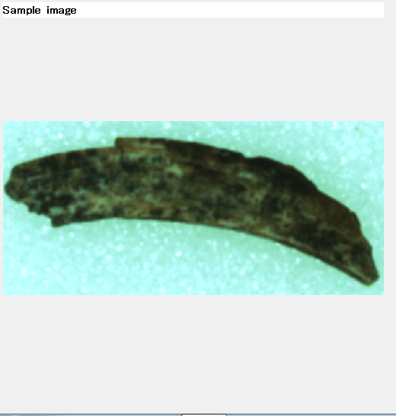
Ca-Ka
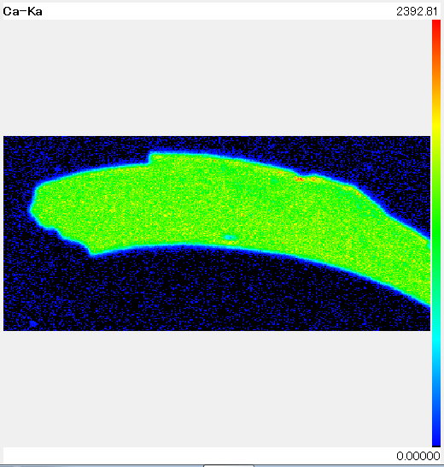

P-Ka
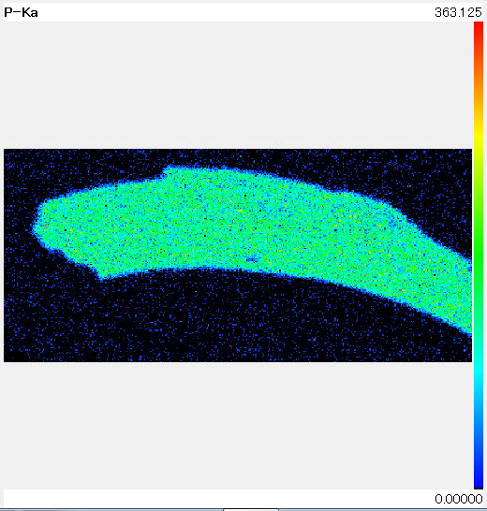
Fe-Ka
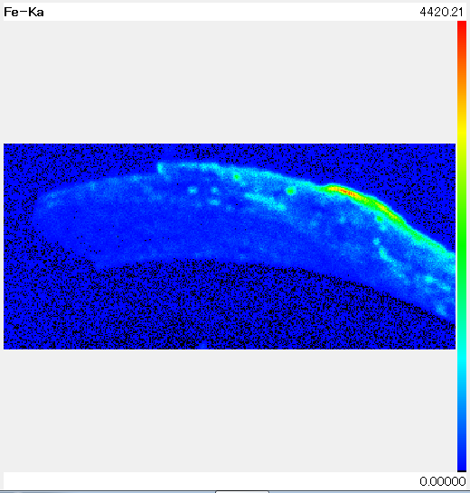

Mn-Ka
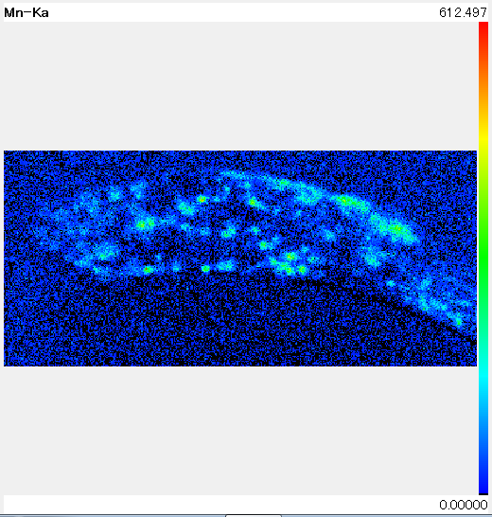
Sr-Ka
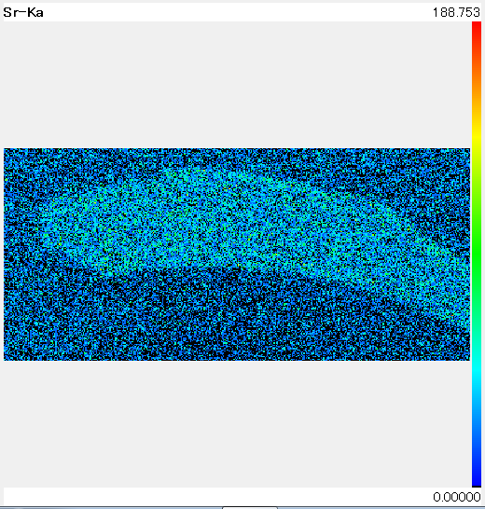

Zn-Ka
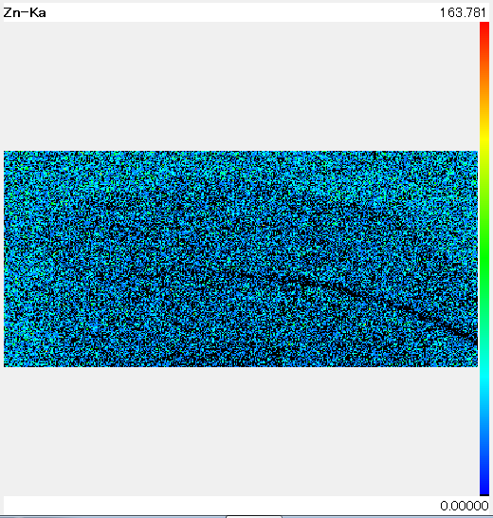
K-Ka
