CRANFIELD UNIVERSITY

MOHAMED JUBAIR MOHAMED RAFI

METHODOLOGIES FOR LARGE SCALE PERSONALISATION OF CONSUMER PRODUCTS DESIGN AND MANUFACTURE

SCHOOL OF AEROSPACE, TRANSPORT, AND MANUFACTURING
MSc Aerospace Manufacturing

MSc
Academic Year: 2016 - 2017

Supervisor: Prof. Harris Makatsoris & Mr. Samet Isaev
September 2017

CURES/ETHICS APPROVAL REFERENCE: CURES/3137/2017

CRANFIELD UNIVERSITY

School of Aerospace, Transport, and Manufacturing
MSc Aerospace Manufacturing

MSc

Academic Year 2016 - 2017

MOHAMED JUBAIR MOHAMED RAFI

Methodologies for Large Scale Personalisation of Consumer Products Design and Manufacture

Supervisor: Prof. Harris Makatsoris & Mr. Samet Isaev
September 2017

This thesis is submitted in partial fulfillment of the requirements for the degree of MSc - Aerospace Manufacturing
(NB. This section can be removed if the award of the degree is based solely on examination of the thesis)

© Cranfield University 2017. All rights reserved. No part of this publication may be reproduced without the written permission of the copyright owner.

ABSTRACT
In today’s manufacturing environment, consumer as co-creator & meeting consumer’s preferences & needs is the greatest challenges encountered by manufacturing industries. For a successful New Product Development (NPD), the product should not only meet the consumers’ preferences but also be manufactured sustainably and economically. Today’s consumer loves to have an exclusive products or service which satisfy their needs and this leads to increase in demand for personalised consumer products. Currently, most manufacturing sectors follow closed-system in which the consumers are not involved in the manufacturing process but consumers wish to get actively involved in NPD process rather than just doing surveys and questionnaires. To address these issues, Open Innovation (OI) process (i.e. consumer as co-creator) must be embraced by industries. Present tools for OI are not effective to bring consumer in loops. Therefore, the Cranfield’s prof. Harris research team within the ‘Sustainable Manufacturing Systems Centre’ found alternative methods for effective consumer engagement and translation of end user needs into a product by using novel technologies developed by the group.

This project explores a novel methodology for design and manufacture of consumer-driven personalised Energy Drinks (ED) using novel technologies developed by the research group. Initially, a novel online crowdsourcing OI platform named ‘Preference Marketplace’ is used to identify consumer’s preferences & sensory attributes for the formulation of ED and then followed by manufacturing of consumer-preferred ED using a novel automated continuous flow manufacturing reactor for sensory evaluation. By combining the two technologies, it is now possible to produce an economical and sustainable on-demand formulated liquid food products that meet consumer needs.

Keywords:
Open innovation (OI), co-creation, web-based co-creation, prediction market, oscillatory baffle reactor, closed system, OI food industry, re-distributed manufacturing, new product development, OI tools, energy drinks, caffeine, taurine, B vitamins, sugar, drinks formulation, orange drink formulation, soft drinks, sensory attributes, preference marketplace, continuous flow reactor

ACKNOWLEDGEMENTS
This research has been fully funded and supported by Cranfield University. Author thanks, Prof. Harris Makatsoris and his research team for their support, expert advice, encouragement, comments, and feedbacks on the progress of the project, as well as Mr. Samet Isaev for his invaluable support and help throughout this project. This project would have been impossible without all the participants and friends who helped to finish this project successfully and I thank them all for their help.

TABLE OF CONTENTS
ABSTRACT i
ACKNOWLEDGEMENTS ii
LIST OF FIGURES iv
LIST OF TABLES vi
LIST OF ABBREVIATIONS vii
1 Introduction 1
1.1 Project aim and objectives 3
1.2 Project Constraints 3
1.3 Structure of the report 3
2 Literature Review 5
2.1 Mass personalisation of consumer products 5
2.1.1 Demand for personalised products 6
2.1.2 Personalisation in food and beverage industry 7
2.2 Open Innovation (OI) in Food Industry (FI) 8
2.2.1 Co-Creation process 10
2.2.2 Technologies associated with OI 12
2.3 Energy drinks (ED) 17
2.3.1 Ingredients 18
2.4 Research gap 21
3 Research Methodology 23
3.1 Project planning 24
3.2 Online survey – Using PM 25
3.3 Experimental workshop 28
4 Results and validation 33
4.1 ‘Preference Marketplace’ analysis 33
4.1.1 Energy drink customisation using novel platform 38
4.2 Sensory evaluation by consumer panel 39
4.3 Validation 42
5 Conclusion & further work 43
6 References 44
7 Appendices 53

LIST OF FIGURES
Figure 1: Consumer’s interest in personalised products by categories and age groups 7
Figure 2: Comparison of received & co-creation views 9
Figure 3: Conceptual framework of consumer Co-Creation 10
Figure 4: A scenario of using the internet to support information flow in NPD 13
Figure 5: OI web portal process 14
Figure 6: Basic configuration of an OBFR 15
Figure 7: Visualisation of flow in an oscillatory baffled tube 16
Figure 8: Research Methodology of this project 23
Figure 9: Four sensory market created in PM 25
Figure 10: Sweet sensory attribute trading window in PM 27
Figure 11: Sensory attributes of Taste market in PM 27
Figure 12: Novel continuous flow reactor 29
Figure 13: Pumps to suck and feed the ingredients into the reactor 29
Figure 14: Software to control reactor 30
Figure 15: Different combination of ED samples 31
Figure 16: Markets created for workshop 31
Figure 17: PM results - Taste 34
Figure 18: PM results – Flavour 35
Figure 19: PM results - Caffeine content 36
Figure 20: PM results – Variant 37
Figure 21: Samples selected for sensory evaluation 39
Figure 22: Consumer’s preference of ED in different sensory profiles 41
Figure 23: Sensory Evaluation workshop 42

Figure_Apx 1: Online survey email invitation 53
Figure_Apx 2: New account creation page- PM 54
Figure_Apx 3: Login Page- PM 54
Figure_Apx 4: Profile page - PM 55
Figure_Apx 5: Leader board - ranking based on their share value 55
Figure_Apx 6: Four sensory markets in PM 56
Figure_Apx 7: Sensory attributes of taste sensory group- PM 56
Figure_Apx 8: Sweet taste attributes trading page in PM 57
Figure_Apx 9: Bitter taste attribute trading page in PM 57
Figure_Apx 10: Sour taste trading page in PM 58
Figure_Apx 11: Different flavour attributes of flavour sensory group 58
Figure_Apx 12: Diff. flavour in flavour sensory group contd. 59
Figure_Apx 13: Orange flavour trading page 59
Figure_Apx 14: Berry flavour trading page 60
Figure_Apx 15: Mango flavour trading page 60
Figure_Apx 16: Apple flavour trading page 61
Figure_Apx 17: Lemon flavour trading page 61
Figure_Apx 18: Grape flavour trading page 62
Figure_Apx 19: Caramel flavour trading page 62
Figure_Apx 20: Sensory attributes of variant of ED in PM 63
Figure_Apx 21: Carbonated drink trading page 63
Figure_Apx 22: Non-carbonated ED trading page 64
Figure_Apx 23: Sensory attributes of caffeine content in ED 64
Figure_Apx 24: 60 mg caffeine content trading page 65
Figure_Apx 25: 80 mg caffeine content trading page 65
Figure_Apx 26: 90 mg trading page 66
Figure_Apx 27: 100 mg caffeine trading page 66
Figure_Apx 28: Consent form to participate in sensory evaluation 67
Figure_Apx 29: Software to control the reactor and pumps 68
Figure_Apx 30: Script to control the pumps and mixing condition 68
Figure_Apx 31: Reactor calculation of various parameters 69
Figure_Apx 32: Reactor baffle disk 69
Figure_Apx 33: Magnetic stirrer 70
Figure_Apx 34: Weighing machine 71
Figure_Apx 35: UV/VIS spectrometer to measure colour intensity 72
Figure_Apx 36: HANNA instruments pH 211 Microprocessor (pH meter) 72
Figure_Apx 37: Mango flavour concentration 73
Figure_Apx 38: Caffeine, taurine, B vitamins concentration solution 73
Figure_Apx 39: Sucrose and glucose concentration solution 74
Figure_Apx 40: Sensory evaluation workshop 1 74
Figure_Apx 41: Sensory evaluation workshop 2 75
Figure_Apx 42: Sample B colour intensity test 75
Figure_Apx 43: Sample C colour intensity test 76

LIST OF TABLES
Table 1: Concept of Co-creation 11
Table 2: ED products with caffeine content & other ingredients 18
Table 3: Taurine content foodstuff 19
Table 4: Ingredients for formulation of ED 24
Table 5: Sensory descriptors for PM 26
Table 6: Most consumers preferred sensory attributes from PM 28
Table 7: Summary of most preferred attributes from PM 38
Table 8: Physical properties of workshop samples 39
Table 9: Final formulation description of samples 40

Table_Apx 1: Physical properties measurement of samples 77

LIST OF ABBREVIATIONS
NPD  OI | New Product Development  Open Innovation
PM | Preference Marketplace
ED | Energy Drinks
FED | Flavoured Energy Drinks
R&D | Research & Development
F&BI | Food & Beverage Industry
FI | Food Industry
OBFR | Oscillatory Baffle Flow Reactor
mg | Milligram
Oz | Ounce

Introduction
Nowadays, for a manufacturing company needs to be successful, its new products should be able to meet their customer’s preferences and desires. Meeting every consumer’s need is one of the greatest challenge facing by every manufacturing sectors and it has become a huge concern for them (R. MOSKOWITZ & SAGUY, 2013). Therefore, to address this issue, the companies must produce goods which meet consumer needs and to do so the mass customisation of products is the only way. Customisation or personalisation is defined as the development of new product or service that meet the specific consumer needs (Vlasic & Kesic, 2007). Personalisation can be done in many products such as electronic devices, apparels, shoes, foods, beverages, cars, bicycle, cosmetics, newspapers etc., and some companies such as priceline.com & dealtime.com let their customers fix their own price for a product and they will search a seller who agrees to sell at that price (Wind & Rangaswamy, 2001). Personalisation of mass consumer products is not an easy task, it requires lots of information and modern technologies and most company have failed to be successful in mass personalisation of products.
For a successful New Product Development (NPD), the product should not only meet the consumer's preference but also produced in an economical and sustainable way (Jreissat, et al., 2017). NPD is not only about the product, it is also about whole manufacturing & distribution network (Tsimiklis, et al., 2015). To answer those manufacturing requirements the industries should be responsive and adaptable, this opens the door for Open Innovation (OI) approach to keep the consumers in the loop for the whole manufacturing process (Tsimiklis, et al., 2015). According to Chesbrough, (2006) open innovation is defined as “the use of purposive inflows & outflows of knowledge to accelerate internal innovation, and expand the market for external use of innovation, respectively”. In simple words, Open innovation process will make the consumers to co-create their products with the company and this will make a huge difference in the manufacturing sector. For example, in Nike company, the consumers are involved in designing of their own shoes and discussing their new designs & ideas through the company’s online community platform (Fuller, et al., 2006). OI could rapidly identify the requirements and preferences of the consumers and it is also flexible (Jreissat, et al., 2017).
Currently, in the traditional manufacturing process, the consumers are kept out from design and manufacture process. At the most, the consumer engagement is based on the surveys and questionnaires. Whilst this approach may suitable for certain small scale and slow-moving industries but it’s not useful for a large scale and fast-moving industries. The current methods, technology, and tools are not effective or attractive to bring the customers in the loop, therefore, OI needs an effective technology to be successfully implemented within the industries.
To address these challenges, Cranfield’s Prof. Harris Makatsoris research team, explored an alternative and effective tool for an effective consumer engagement and translation of end user needs into products and actionable process specification. The group has developed over the years a novel online crowd-sourcing platform named ‘Preference Marketplace’ (PM) that includes incentive and game mechanism to reveal the information from consumers to identify the most promising ideas and attributes for a NPD. Then follows is the trialling of these product ideas into a product using a novel production platform which is also developed by the same group (Jreissat, et al., 2017). By combining the two, it is now possible to produce on-demand goods that meet the specific consumer needs.
This research project focuses on studying of how this technology and model based methodology will be an effective tool for consumer engagement in NPD process. Consumer-driven liquid food formulation such as flavoured Energy Drinks (ED) has been selected to test the ability of the proposed methodology comprising online crowd-sourcing platform i.e. PM and computer-driven manufacturing device. It also discusses the target sensory attributes for the formulation of ED obtained from consumer groups via PM and its manufacturing process using novel platform and prototype of energy drinks for sensory evaluation analyse by a consumer group.

Project aim and objectives
The aim of the project is to develop and trial methodology that employs those novel technologies (i.e. PM and novel manufacturing platform), for the design and continuous manufacturing of consumer-driven beverage formulation such as Flavoured Energy Drinks (FED).
The objectives of the project are:
- Design an experimental plan to test and validate the performance of the proposed methodology.
- Conduct an online survey to engage more consumers using the novel online crowd-sourcing platform ‘Preference Marketplace’ to elucidate preferences for the target product from a consumer group.
- Analyse the results and translate the preferences into a product by using the novel manufacturing equipment.
- Conduct sensory evaluation workshop to validate the performance of end products and whether it meets the consumers need.

Project Constraints
The main constraints are the gathering of information for the formulation of energy drinks due to lack of literature. Due to time constraints, we’re unable to formulate ED in various flavour except the most consumer preferred mango flavour. Furthermore, the methodology and technology are novel, so, not much referencing are made for the technologies used in this project. Moreover, students were busy with their project work, therefore, only limited number of participants were joined in the sensory evaluation workshop to taste the drinks.

Structure of the report
In chapter 1, discusses the introductions for challenges faced by manufacturing industries, need for mass consumer products personalisation, role of the consumer in OI and novel methodology to address those issues. In chapter 2, literature review concentrates on the need for OI, effective way for consumer engagement in co-creation, ingredients for the formulation of energy drinks and technologies. What then follows is the research methodology proposed to carry out the project & detailed discussion of how online workshop was conducted using PM & formulation of ED using novel continuous manufacturing platform and sensory evaluation as in chapter 3. In chapter 4, results of the online survey and experimental workshop are discussed in detail. Finally, the conclusion of the project and further work is mentioned in chapter 5.

Literature Review
In this section, a comprehensive literature review is done for the following concepts such as mass personalisation, demand for personalised products, personalisation in food and beverage industry, OI and co-creation process, technologies associated with OI and finally energy drinks ingredients.

Mass personalisation of consumer products
In this modern world, consumers have more selections of products and services than earlier but they are not satisfied with the products or services provided by the companies (C. K. PRAHALAD & RAMASWAMY, 2004). For a successful New Product Development (NPD), the product should not only meet the consumer’s requirements but also be manufactured as sustainably and cost-effectively too (Jreissat, et al., 2017). In addition to this, the good communication and relationship between the customers and providers are essential in NPD (D. Hoyer, et al., 2010; Fogt Jacobsen, et al., 2014) and it is also important to understand consumer’s perceptions and needs during the early stage of the NPD will increases the chance of new product’s success (Banović, et al., 2016). Every consumer has their own preferences and needs; hence, meeting their expectation with a new product has turned out to be a more complex task and this has become one of the greatest challenge facing by the industries (Kajtaz, et al., 2015). Furthermore, the reduced lifecycle of new products, increases in new products & services, globalisation, increase in demand for innovative products and huge pressure from competitors are some of the other challenges encounter by the industries (Mourtzis D. & Doukas M., 2014). To address these challenges, the industry should start doing the mass personalisation of consumer products.
Adomavicius & Tuzhilin, (2005) defines that “Personalisation is the ability to provide product and services tailored to individuals based on knowledge about their preferences and behaviours”. S.Fogliatto, et al., (2012) states that the concept of personalisation was first proposed and developed by Davis, (1989). In recent times, the importance of mass personalisation has been greatly valued by the industries. The concept of mass personalisation is gradually increasing its attention in global market and it is becoming a vital strategy for the companies which has a goal to provide better products to their customers and sustain in this competitive business world (Franke & Schreier, 2008). Implementing mass personalisation has some constraints such as technology, knowledge, environmental issues, government policy, etc; Moreover, some of the other challenges are consumers expect high quality, high variety, short delivery time and affordable products (Mourtzis, et al., 2014). All these constraints to be addressed for a successful implementation of personalisation.

Demand for personalised products
The consumer becomes more selective in products they use and want an exclusive product which fulfills their needs (Maulana & Rufaidah, 2014). At present, consumer products standards are mainly focused on its functionality, aesthetics, user-friendly, low cost, safety, quality, etc. but currently, smarter or personalised products are most preferred by consumers, this leads to high demand (Kajtaz, et al., 2015). In recent times, lots of private companies and agencies are conducting surveys regarding personalisation & its impact on the consumers. The results of the surveys are quite astonishing. One of the independent market research agency conducted an online survey of more than 1000 people over 16 years old about their view on personalisation (Deloitte, 2015). This survey reveals some quite interesting facts about personalisation. More than 70% of consumers in the US and UK like to must have some type of customised products and young age peoples are more attracted to personalised products (Hong, 2014). People under 40 years old are more interested in personalised products or services i.e. 43% of people around 16-24 years and 46% of people between 25-30 years old are very much interested in buying personalised products; one in five customers are willing to pay more and 48% are willing to wait longer for personalised products (Deloitte LLP, 2015). Figure 1 clearly shows the category wise personalised products interest among different age groups of UK people.
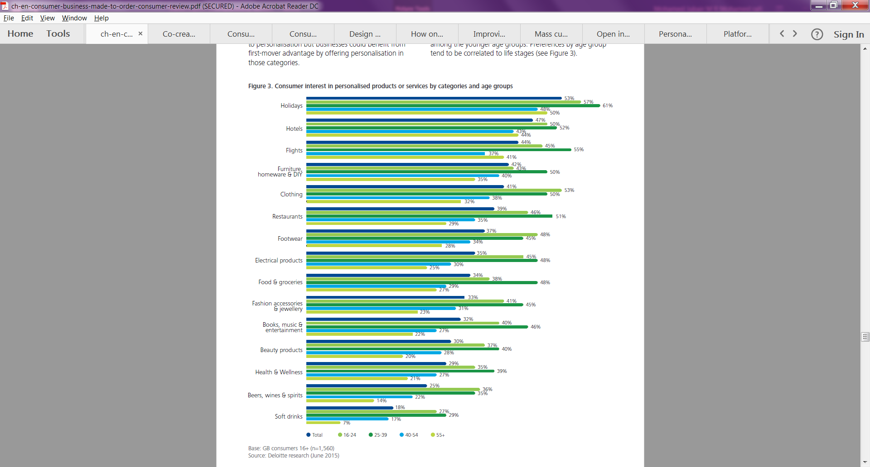
Figure 1: Consumer’s interest in personalised products by categories and age groups (Deloitte, 2015)

Personalisation in food and beverage industry
Personalisation in Food and Beverage Industry (F&BI) is gradually increasing. Like other personalised products, consumers are like to consume more customised food and beverage products which can be clearly seen in figure 2. FI is viewed as traditional industry and it is conservative with the level of investment in research (Bigliardi & Galati, 2013). However, to stay competitive, the Food Industries (FI) should start searching technologies & investing in research sector to develop and innovate new products (De Pelsmaeker, et al., 2015). Current technologies in production, packaging, and services are reactive nature and old; to be more efficient there is a need for novel technologies for faster production, flexibility, quality, time consumption, less labour, less waste and better services (Rodgers, 2007). Some of the other benefits receiving from new technologies are safer, healthier and nutritional foods with less energy, water, waste and hazards (Rollin, et al., 2011). The report states that yearly avg.35,000 new food & beverage products are reaching UK retailers but 80% of them are failing to meet up with the consumer's expectations, this emphasises the need for personalised food and beverage products (Tsimiklis, et al., 2015). Personalisation in food products have few challenges as other personalised products such as poor quality, duplication, lack of innovation & consumer input (Costa, et al., 2004). The key stages in formulation of consumer-oriented food products are, identifying consumer’s current & future need, idea development, product development to support the idea and marketing the products (Costa, et al., 2004). To address these issues and challenges Saguy & Sirotinskaya, (2014) suggests that OI is the best possible way to understand and satisfy the consumers’ need. OI will keep the consumers in the loop and it rapidly respond to consumer’s demand and it is flexible (Jreissat, et al., 2017).

Open Innovation (OI) in Food Industry (FI)
Food & beverage industry is the largest manufacturing sector in EU and it is contributing largely to its economy and employments (Bigliardi & Galati, 2013). As per UK Cabinet Office, (2008) & DEFRA, (2016) the UK food & drinks sector contributed £110bn or 6.6% to UK’s GDP in 2016 and it also employs 3.5 million people. In the US food sectors generate gross revenue of $360 billion per year and globally it is $1.3 trillion per year (Rodgers, 2007). In the next fifty years FI going to face the biggest challenge ever i.e. to meet up a global demand it must produce more food than ever in the history of humanity (Keating, et al., 2010). Two other primary challenges faced by FI is the ability to identify the different market segments and consumer’s need; secondly, ability to respond rapidly to those needs (Tsimiklis, et al., 2015). To stay competitive, FI should develop new products cherished by customers and at the same time, a new product must be profitable within the certain time frame (Fogt Jacobsen, et al., 2014).
To address all the above-mentioned challenges & problems, FI should embrace an OI model. By adopting OI, industries could proactively engage the future challenges and responds quickly to consumers’ demands (Saguy & Sirotinskaya, 2014). In 2003, Henry Chesbrough first coined the concept and modern definition of OI (Lichtenthaler, 2008). Chesbrough, (2003) defines OI as “valuable ideas come from inside or outside the firm and go to the market from inside or outside the firm as well”. FI has been following closed innovation system (i.e. driven by internal capabilities) for many years but it’s a time to be innovative and responsive to meet up with the future demands (Kratzer, et al., 2017). Closed innovation is entirely relying on internal R&D sector, this is not adequate to be competitive in the global market and this rise the era of open innovation model (Çubukcua & Gümü, 2015). OI has already implemented in other sectors such as IT, telecom, biotech, software, and pharmaceuticals industry and it is gradually being implemented in food sectors. Open innovation model is based on co-creation approach in which the customers could co-create a new product along with the company in a various way & involved in NPD process (Enkel, et al., 2009). The term co-creation refers to that the consumers collaborate with industry to develop new product as seen in figure 2.
Figure 2: Comparison of received & co-creation views (Durugbo & Pawar, 2014)

Co-Creation process
Consumers as co-creator of mass personalised consumer products are the biggest challenge facing the manufacturing industries (Jreissat, et al., 2017). Placing consumer in the loop is not an easy task for an organisation and the process should not affect the performance objectives such as quality, speed, dependability, flexibility, and cost of the organizations (Tsimiklis, et al., 2015). A decade ago co-creation is not possible but thanks to the technological development that has helped the consumers to contribute more in NPD and this has provided them with a customer empowerment (D. Hoyer, et al., 2010). Co-creation blurs the gap between providers and consumers and a consumer is transferring from consumer to creator (Humphreys & Grayson, 2008). Some examples of companies successfully implemented co-creations are Microsoft, IKEA, Dell, Sony, Cisco, Disney, Coca-Cola, Toyota Scion, Aloft, Mazda and eBay (Tollo, et al., 2012).
Figure 3: Conceptual framework of consumer Co-Creation (D. Hoyer, et al., 2010)
Figure 3 shows some consequences of the co-creation and outcomes. Two primary advantages for the firm after successfully implementing co-creation are 1) it increases effectiveness (e.g. enhance product value, variety, innovation and meet consumers need) and efficiency (e.g. reduce operational cost, labour cost, increase productivity) (Prahalad & Ramaswamy, 2000).
Table 1: Concept of Co-creation (C. K. PRAHALAD & RAMASWAMY, 2004)
Moreover, other advantages of implementing co-creation process are an increase in product creativity, decrease in risk of product failures, reduce R&D cost immensely, coping with consumers demand and decrease in time to market the products (Banović, et al., 2016). From Table 1, it’s easy to understand the concepts of co-creation.
According to Prahalad & Ramaswam, (2000) co-creation process has a direct impact on the firms and products success. Like every model co-creation too has many challenges as equal as benefits. Some challenges are (D. Hoyer, et al., 2010): incentive cost for better ideas from customers, difficulty in selecting some potential ideas from heaps of consumers, managing expectations, relationship between the firm and consumers, managing negative comments since post-launch, reduced control over strategic planning & objectives by firms, selection of consumers, managing consumers involvement and novel technologies. If the industries find a ‘win-win’ scenario for customer-supplier then co-creation process will have greater impact (Durugbo & Pawar, 2014). Despite these challenges, the organisation and consumers are willing to be a part of co-creation system and consumers wish to actively engage in the NPD process (Jreissat, et al., 2017). Co-creation process would be more effective using the online platform and novel technologies (Jreissat, et al., 2017). Currently, there are lots of online platforms or web portal tools are used by consumers to contribute their vision and ideas (Kwon, et al., 2017). In this project, formulation of FED is produced by co-creation process using the online platform and novel continuous manufacturing device and these are detailly explained in the forthcoming sections.

Technologies associated with OI

Web based platform
Developments in social media, Web 2.0 and online crowd sourcing platforms are some of the new forms of methodological innovation and enabling consumers to share their personal, social, and scientific knowledge worldwide and it helps to engage thousands of peoples at same time for data aggregation, social filtering, participation and sharing of data (Raford, 2015). The web plays a significant role in co-creation because the web gives easy access to many consumers worldwide to involve in NPD to share their ideas and knowledge (Zwass, 2010). Co-creation using the web based platform is an upcoming trend and it is also defined as crowd sourcing since the organisation uses consumer to improve a product or services and find a new solution (Lorenzo-Romero, et al., 2014). Howe, (2006) defines crowd-sourcing as “it is an act of a company or institution taking a function once performed by employees and outsourcing it to an undefined network of people in the form of an open call. the crucial prerequisites are the use of open call format and a large network of potential labour” (Howe, 2006). Some benefits such as rewards, bonus and incentives must be provided to motivate the consumers to participate in co-creation process (Fuller, et al., 2006). Online crowdsourcing platforms speed up the NPD process, cost & time effective, easy way of gathering information from consumers and aids an organisation to access those innovative ideas to improve a new product (Tsimiklis, et al., 2015). Figure 4 shows the speed of flow of information using the internet in new product development cycle.
Figure 4: A scenario of using the internet to support information flow in NPD (Tsimiklis, et al., 2015)
Generally, OI web portal consists of 2 sections such as organisation and innovator section as shown in figure 5.
Figure 5: OI web portal process (Çubukcua & Gümü, 2015)
In innovator section, the organisation would define the challenge (i.e. a solution for problems or need of innovative ideas) and they should also define who needs to participate, rules, rewards, how long a challenge remains open etc.; in organisation section, the consumer would access a challenge and provide a solution or ideas for the respective challenge and submit for evaluation. Finally, the organisation evaluates the ideas and provide rewards for best ideas (Çubukcua & Gümü, 2015).
Web based platform is seeming to be quite effective, and it engages large consumers to actively involved in the manufacturing process and it addresses some of the challenges related to OI (Jreissat, et al., 2017).

Continuous Oscillatory Baffle Flow Reactors (OBFR)
A novel continuous manufacturing device was developed to formulate any liquid beverage products and it is developed based on OBFR (Jreissat, et al., 2017). OBFR is a continuous plug flow reactor used for continuous production of long reaction process; it is fitted with orifice baffle plates in horizontal stack for producing oscillatory motion and a piston is used to oscillates the fluid in high velocity at least twice the speed of net flow velocity through the tube for achieving uniform mixing condition (STONESTREET & HARVEY, 2002). When fluid interacts with baffle plates placed at an equal distance creates the oscillatory or vortex motion which improves the fluid mixing (Makatsoris, et al., 2013). Applying oscillatory flow enhances the heat and mass transfer, low shear and it generates excellent and controllable fluid mixing which is essential for optimum products (Stephens & Mackley, 2002). Unlike tubular flow reactor, where a high velocity is required and minimum Reynolds number is maintained for uniform condition and in OBFR mixing is independent to net flow (Phan & Harvey, 2010). Figure 6 explains the configuration of OBFR, the fluid is feed near the starting point of the tube and piston is used to produce oscillation motion, the liquid passes through the baffle tube stacked horizontally and exits at the outlet of the reactor; all this occurs at specified amplitude and frequency (STONESTREET & HARVEY, 2002).
Figure 6: Basic configuration of an OBFR (STONESTREET & HARVEY, 2002)
Operating condition of OBFR is shown in Figure 7, (figure 7a and 7b) explains the tube in which oscillatory motion is imposed, from (figure 7c) it is understood that there is no effect when using smooth tube, whereas (figure 7d) shows the moderate oscillatory flow in baffle tube and vortices can be seen and (figure 7e) shows the flow becomes turbulent it is due to effect of high oscillatory motion.
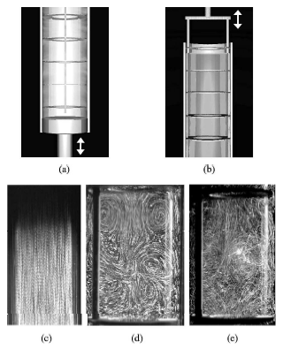
Figure 7: Visualisation of flow in an oscillatory baffled tube (NI, et al., 2003)
The key feature of baffle flow reactor is it can be operated at high velocity with greater control & these baffle has maximum mixing condition and minimum frictional loss (NI, et al., 2003). This reactor is efficient, low cost and minimum time required for completion of the whole process (Jreissat, et al., 2017).
Now integrating both online crowd-sourcing platform and OBFR, it is now possible to rapidly co-create the consumer driven products such as formulated drinks.

Energy drinks (ED)
Fluids are an essential content for humans but it can be taken in other forms than water, appropriate fluid intake leads to an optimal health (Attila & Çakir, 2011). The current younger generation is obsessed with their fitness and prevention of obesity, so exercise is making a resurgence in numerous countries this has seeded the emergence of sports & energy drinks (Higgins, et al., 2010). Initially, sports drinks were produced to provide sufficient carbohydrates and electrolytes for muscle growth and aid performance but later it was replaced by ED (Higgins, et al., 2010). Sports drinks are different from ED, sports drinks are non-caffeinated drinks provides hydration & small amount of carbohydrates, replacing electrolytes, maintaining endurance and performance whereas ED is caffeinated non-alcoholic drinks contains carbohydrates, calories, nutrients, B-vitamins and other stimulants (Campbell, et al., 2013; Meadows-Oliver & Ryan-Krause, 2007).
According to published research, ED is very popular among adolescents, younger generation and athletes (K, et al., 2004). Survey shows that more than half of the students in US, EU and few other countries consuming at least one ED per month (Giles, et al., 2012) and the reasons for consumption of ED are it uphold alertness while driving & studying, decrease fatigue, increase energy & endurance and counteracts sleep (Peacock, et al., 2013).
Energy drinks are a multibillion dollar industry had a tremendous growth over a past two decades (McCrory, et al., 2017) and this sector comprises 42.4% of overall beverage market globally and has generated a total revenue of $11.8 billion US dollars by the end of 2008 and it was expected to reach $16.4 billion by the end of 2013 (Bunting, et al., 2013). Nearly 500 new ED brands were introduced in 2006 and stats reported that over 7million people have consumed an ED (Meadows-Oliver & Ryan-Krause, 2007). In 1962, a Japanese company, Taisho Pharmaceuticals, launched one of the first energy drink named ‘Lipovitan D’ which contains caffeine, ginseng, taurine, B vitamins and other stimulants (Heckman, et al., 2010). Although energy drinks are launched in 1960’s in Europe and Asia, since the launch of ‘Red Bull’ in 1987 in Austria and 1997 in the US sparked the trend towards caffeinated energy drinks all over the world (Reissig, et al., 2009).

Ingredients
Primary ingredients of energy drinks are caffeine, taurine, B-vitamins, sugars and may include glucuronolactone, ginseng, guarana, electrolytes and other herbal extracts (Peacock, et al., 2013; Hardy, et al., 2016; Attila & Çakir, 2011).

Caffeine
Caffeine (1,3,7-trimethyl xanthine) is one of the most consumed psychoactive (stimulant) substance in the world and it is present in many foods, beverages (i.e. tea, coffee, cola), dietary supplements, drugs and some plant species (Neves & Caldas, 2017). Despite the other ingredients, caffeine is the core ingredient in ED due to its stimulatory effect (Peacock, et al., 2013). Some studies show that it enhances the mood & alertness, athletic performance enhancement, reduce negative side effects associated with sleep loss and weight loss (Heckman, et al., 2010).
Table 2: ED products with caffeine content & other ingredients (Babu, et al., 2007)
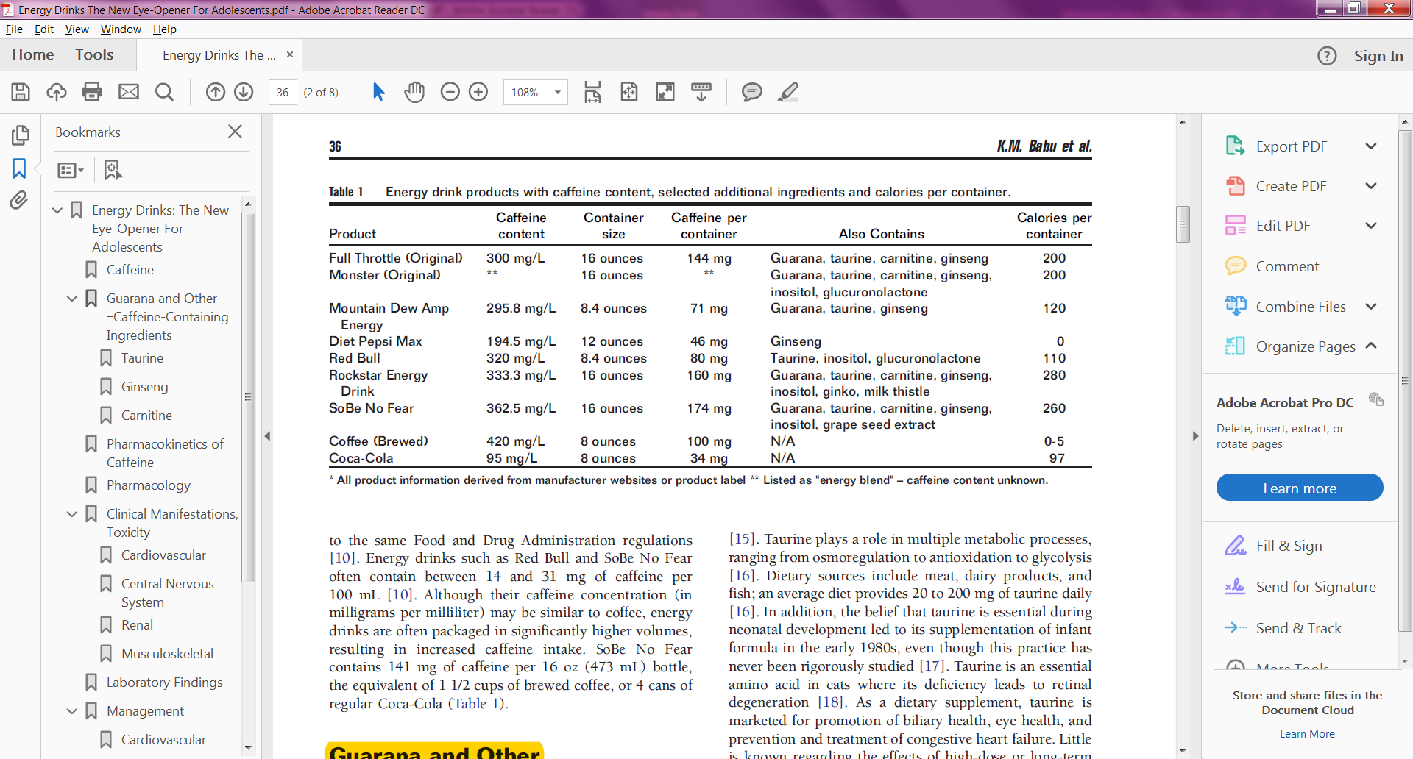
Average caffeine content in most ED brands ranges from 70-200 mg/16oz (Higgins, et al., 2010) and in comparison, brewed coffee contains 56-100 mg/100 ml, instant coffee and tea contains 20-73 mg/ 100 ml, colas has 9-19 mg/100 ml and chocolate has 5-20 mg/100 g (Babu, et al., 2007). Safer limit of consumption of caffeine is up to 400 mg/day, if exceeding so, it may have serious health effects and overdose may cause potential death (Wikoff, et al., 2017). Table 2 shows the popular ED brand’s caffeine content, additional ingredients and calories per container.

Taurine
Taurine (2-aminoethane sulfonic acid) is the sulphur containing most abundant free amino acid naturally found in human & animal tissues and human dietary (Higgins, et al., 2010). This amino acid derived from methionine and cysteine and it is found naturally in a nutritional source such as dairy products, meat & fish; an average daily intake of taurine from dietary sources ranges from 20 mg to 200 mg (Babu, et al., 2007). Table 3 shows that taurine contains food.
Table 3: Taurine content foodstuff (SuppVersity, 2010)
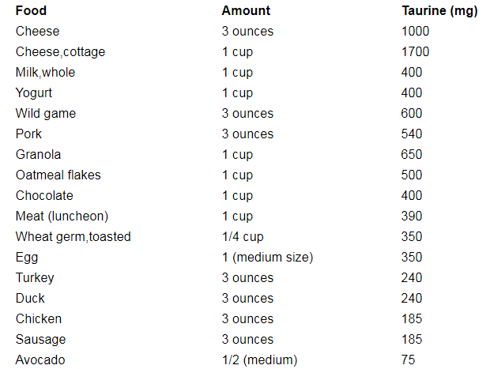
In mammals, the roles of taurine are cellular membrane stabilisation, anti-oxidation, calcium homeostasis maintenance for retinal & nervous function, cardiac, skeletal muscle, growth modulation, osmoregulation, glycolysis & glycogenesis stimulation (REDMOND, et al., 1998; Salze & Davis, 2015). A large amount of taurine is used in ED and the average concentration of taurine found in commercially available energy drinks are 3180 mg/L which is equivalent to 753 mg per 8 oz. (Heckman, et al., 2010). The European Food Safety Authority states that, Observed Safe Level (OSL) of taurine per day is predicted to be 100 mg per kg body weight (EFSA, 2012). However, taurine found in ED is in very small quantity and cannot cause any beneficial effects or adverse health effects (Higgins, et al., 2010).

B vitamins
The B vitamins include thiamine, riboflavin, niacin, pantothenic acid, pyridoxine hydrochloride, biotin, inositol, & cyanocobalamin, are the eight water soluble vitamins essential for many enzymatic reactions that are involved in energy production, proper cell function & protein metabolism (Amendola, et al., 2004). Insufficient vitamins in long term can cause health effects and decreased performance; however, research shows that excessive consumption of vitamins than Recommended Daily Allowance (RDA) has never shown any improvement in performance and it also has no adverse effects; RDA for every vitamin may differ for different age groups (Brouns, 1993). ED contains a large amount of sugar, so, these vitamins are essential to convert sugar into energy and this is the extra energy that ED can provide (Higgins, et al., 2010). Moreover, research claimed that a lot of B vitamins consumption would improve mental alertness and focus & enhance mood (Navarro-Pascual-Ahuir, et al., 2016). The specific function of each B vitamins is as follows (Higgins, et al., 2010): B1 (thiamine) essential for oxidation & carbohydrate metabolism; B2 (riboflavin) required for respiratory chains and coenzyme in energy metabolism involving fats, proteins & carbohydrates; B3 (niacin) plays major role in energy production in cells; B5 (pantothenic acid) & B7 (biotin) is coenzyme required for fatty acid oxidation; B6 (pyridoxine hydrochloride) involved in protein & red blood cell metabolism which is important for immune system; B8 (Inositol) plays a major role in liver process fats & function of muscles & nerves; B12 (cyanocobalamin) is needed for DNA production and red blood cells formation. B vitamins are incorporated in energy drinks and most common vitamins incorporated in ED are Vitamin B2 (riboflavin), B3 (niacin), B6 (pyridoxine) and B12 (Heckman, et al., 2010).

Sugars
Sugars including sucrose, glucose, and fructose are basic substance for providing energy in the body which is naturally present in fruits and vegetables; glucose is the main carbohydrate source required by the body for cellular metabolism and energy production & conserve muscle glycogen (Higgins, et al., 2010). Drinks containing caffeine and glycose could improve attention, enhance energy performance and reduce fatigue (Kennedy & Scholey, 2004). Natural sweeteners are extracted from honey, tree sap, fruits, roots and leaves and they give natural sweetness and taste; artificially synthesised sweeteners such as aspartame, saccharin, acesulfame-K, cyclamate, neo hesperidin DC, sucralose, steviol glycosides are low in calories and very small quantity is enough for intense sweet flavour (Edwards, et al., 2016). Recent studies show that sugar intake of adults is higher than RDA and thus it leads to globally 13% and 39% of them are obese and overweight respectively (Edwards, et al., 2016). World Health Organisation (WHO) recommends maximum consumption of sugar per day is 6 teaspoons for adults and for children just 3 teaspoons (Beaglehole, 2015). ED contain sugars either in the form of sucrose, glucose and fructose or sweetener. The average amount of sugar per 500ml can of ED is 54 g which is equivalent to ¼ cups (Higgins, et al., 2010).
Other than these primary ingredients some preservatives, acidity regulator, a colouring agent, and flavouring are added in energy drinks.

Research gap
The following research gaps have been identified:
- There is lack of literature regarding the formulation of energy drinks. However, some literature of orange drinks formulation is adapted for ED formulation and this project becomes a novel methodology for the formulation of ED.
- The technologies and methodology applied for this project are novel and it is developed in Cranfield. Hence, there is lack of literature regarding these technologies. But these technologies are developed based on online crowd sourcing tool and OBFR, so this has been explained in the literature review. Application and working principle of these novel technologies are explained in the methodology chapter.

Research Methodology
In this project, various literature has been studied and importance of OI & co-creation has understood and ingredients for the formulation of ED has been identified. The research methodology to carry out this project is adopted from a methodology developed by Prof. Harris research team from Cranfield University and methodology using novel technologies has been explained by them in a literature named ‘Consumer Driven New Product Development in Future Re-Distributed Models of Sustainable Production & Consumption’ (Jreissat, et al., 2017) and this has been adapted for formulation of ED. Research methodology for this thesis is shown in figure 8.

Figure 8: Research Methodology of this project based on Jreissat, et al., (2017)
In the first phase, the extensive literature review was done to understand the mass personalisation, OI, and co-creation which is the background of this project. Ingredients to formulated ED has also been identified through literature. Experimental planning was designed to conduct an online survey and sensory evaluation workshop. In the second phase, an online survey using novel crowd-sourcing tool named ‘Preference marketplace’ was done to understand the preferences and needs of the consumers for the formulation of ED. Different markets and sensory attributes were created in PM and players could select most preferred sensory attributes by the trading method. At the end of the survey, high priced attributes are taken for the formulation of ED. In the final phase, based upon the selected attributes various samples were formulated by using novel manufacturing platform and sensory evaluation was conducted. In sensory evaluation workshop, participants were asked to taste the given samples and give feedbacks for validation. From feedbacks, could know whether the samples were satisfied the consumer's expectation and preferences.

Project planning
In the initial phase, comprehensive research is done to identify the ingredients of ED, formulation process and understanding of web based tools and OBFR. From the literature review, various ingredients were identified and for this project, only the primary ingredients were used and table 4 describes the selected ingredients for ED.
Table 4: Ingredients for formulation of ED
Description
Water, Caffeine 0.03%, Taurine 0.4%, B vitamins 20%, sugars or natural sweetener, citric acid, fruit concentration for flavouring, natural colouring: beta-carotene
The stimulant such as caffeine and taurine were used in less quantity based upon safer consumption limit. This does not have any adverse effects. Caffeine amount per can is chosen by consumers from an online survey. All the ingredients used in this project is certified food grade materials which are consumable and could use for food products.

Online survey – Using PM
In the second phase, an online survey was conducted using the novel online consumer interface platform, ’Preference Marketplace’. PM is developed based on stock market (Spann & Skiera, 2003) and prediction market, to identify the promising ideas by trading those attributes using virtual currency (Wolfers & Zitzewitz, 2004). Prediction market or virtual stock market allows consumers to predict and bet on the outcome of future events, this proved to be the potential tool for aggregating information from people (Pfeiffer & Almenberg, 2010).
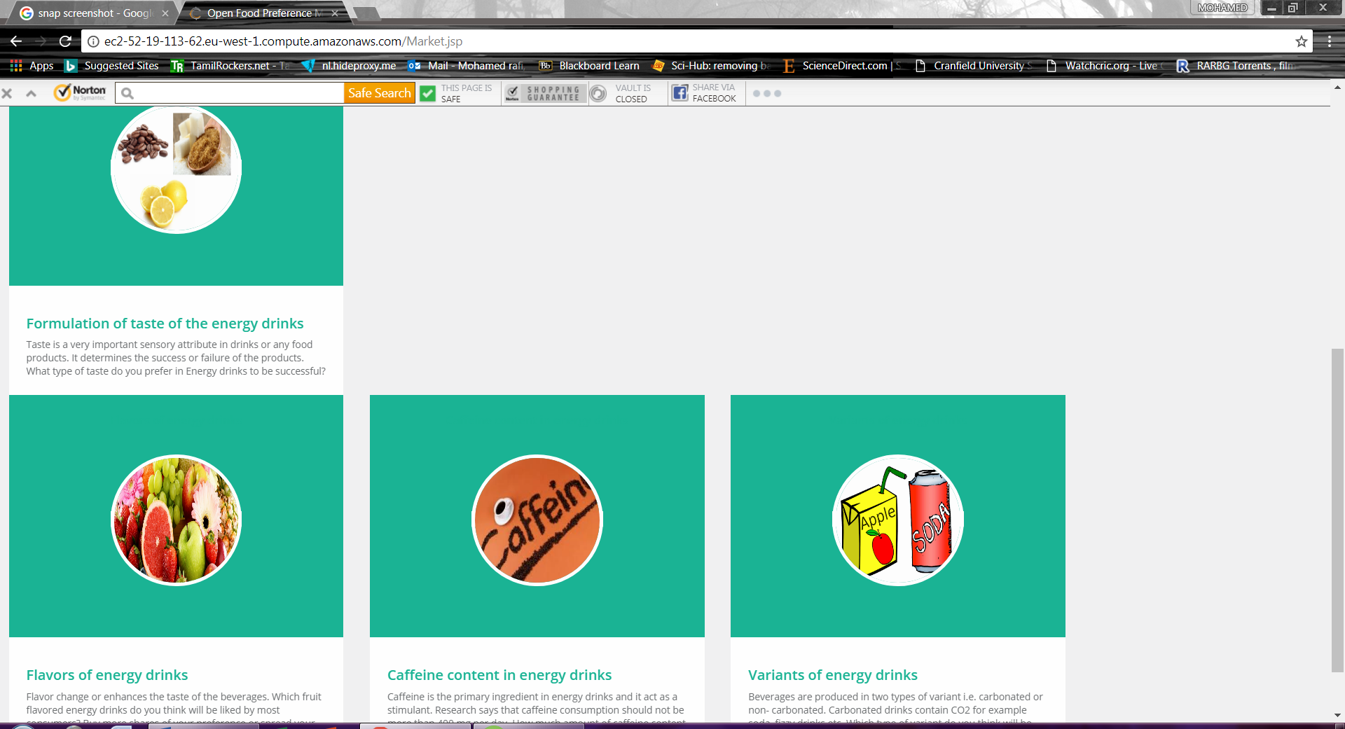
Figure 9: Four sensory market created in PM
PM was developed using a game like mechanics for effective consumer engagement and the primary goal of the PM is to identify the preferences and needs of the consumers (Jreissat, et al., 2017). For online survey, initially, basic sensory markets for ED such as taste, flavour, caffeine content and variant of ED were identified & developed as shown in Figure 9. Description and symbolic picture for each market and attributes were created for consumers understanding.
Table 5: Sensory descriptors for PM
Markets (challenges) | Sensory Attributes
Taste | Sweet |  |  |  | Bitter |  |  |  |  | Sour
Flavours | Pomegranate | Orange |  | Cherry & Berry |  | Mango |  | Apple | Caramel |  |  | Grape | Lemon
Caffeine Content | 60 mg / 250 ml |  | 80 mg/ 250 ml |  |  |  | 90 mg/ 250 ml |  |  |  | 100 mg/ 250 ml
Variant | Carbonated drink |  |  |  |  |  | Non-carbonated drink

Each market has various sensory descriptors. Four markets and a group of sensory attributes for each market were created as shown in Table 5. Stock prices of each attribute define the preferences of the respective attribute and it also represents the percentage of consumer’s preferences. For e.g. if the price of the sweet attribute is 57 bite coins then it represents 57% consumer prefers the sweet taste. Participants from different country, age, & gender were invited to join in the survey and create their profile in PM.
The aim of the game was to increase the initial profit and participants should buy or sell the shares of the attribute based on their preference. Participants can pick a market and select the quantity of the share to buy or sell their preferred attributes as shown in (Figure 10). To avoid manipulation and large price changes, quantity of shares is restricted to max. 50 per transaction. Share value of each attribute changes depending up on the demand or investment of other players. The survey was opened for one week and each day the changes in share value were monitored. At the end of the survey, the high stock priced attributes from each market were used to manufacture the ED using novel continuous flow reactor. Figure 11 shows the sensory attributes of taste profile market.
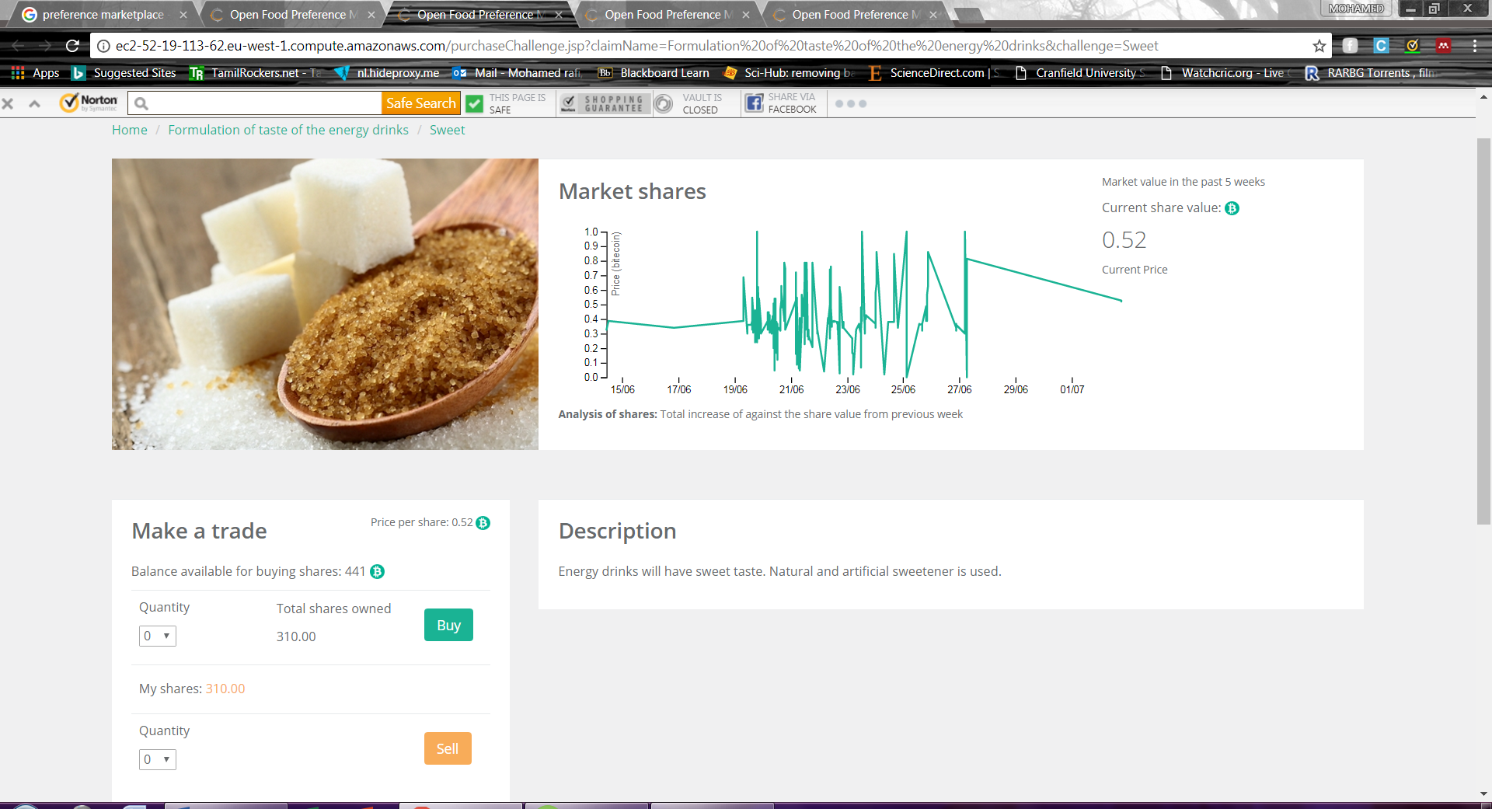
Figure 10: Sweet sensory attribute trading window in PM

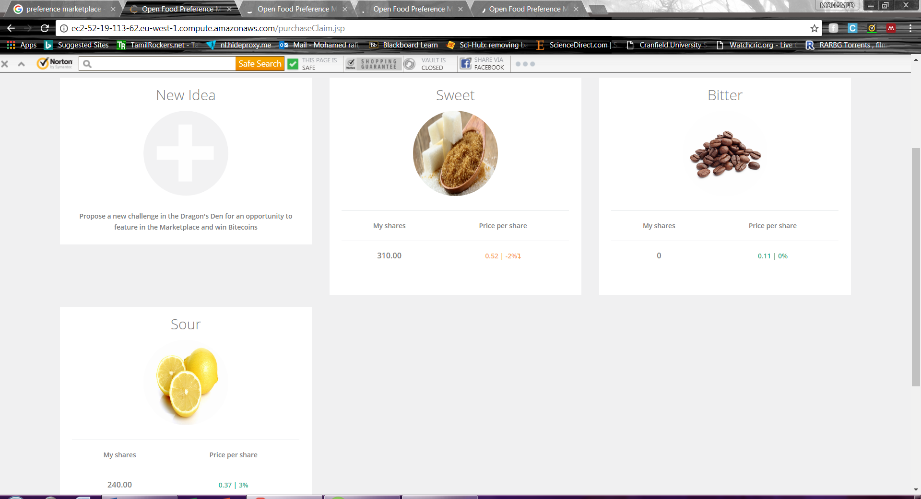
Figure 11: Sensory attributes of Taste market in PM
Most preferred sensory attributes chosen from PM is shown in Table 6 are used for manufacturing of samples for experimental workshop.
Table 6: Most consumers preferred sensory attributes from PM
Market | Sensory Attributes’ preference percentage
Taste | Sweet (61%)
Flavour | Mango (42%)
Caffeine content | 80 mg per 250 ml (50%)
Variant | Non-carbonated (65%)

Experimental workshop
In the final phase, attributes selected from PM has been used to manufacture ED. A novel continuous flow reactor was used to formulate and manufacture energy drinks and this reactor is developed based on OBFR; novel platform is very effective than batch process production and some advantages are cost effective, less lead time, greater mixing conditions, flexibility, reformulate at any time of the process and high performance (Jreissat, et al., 2017). This device is a computer driven automatic platform which produces a product in a continuous flow. A novel continuous flow reactor is shown in Figure 12. It consists of a computer driven controller, mixing section consisting of OBFR and oscillation mechanism. Baffle disk stacked closely together horizontally creates oscillation flow which enhances the greater mixing condition of the ingredients in highly controllable manner.
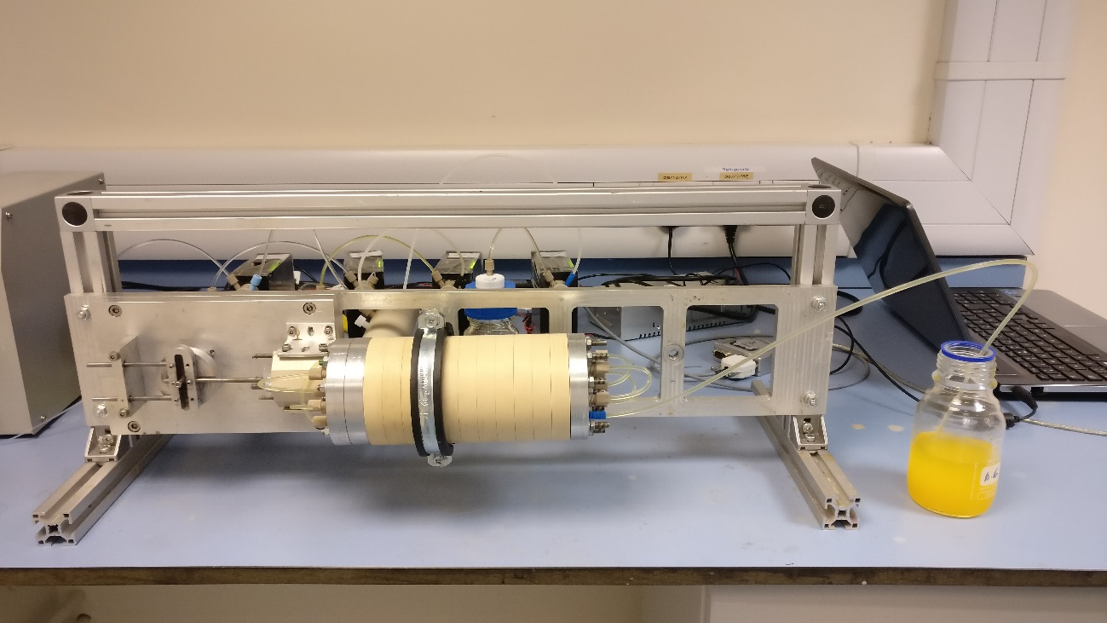
Figure 12: Novel continuous flow reactor
Pumps shown in figure 13 used to suck and feed the ingredients into the reactor using tubes. Each pump feeds different ingredients, in pump 1 concentration of caffeine, taurine and B vitamins solutions were pumped into the reactor and in pump 2 & pump 3 feeds sugar solution & concentration mango juice for flavouring respectively and in pump 4 distilled water was pumped. All this is controlled by software shown in figure 14.
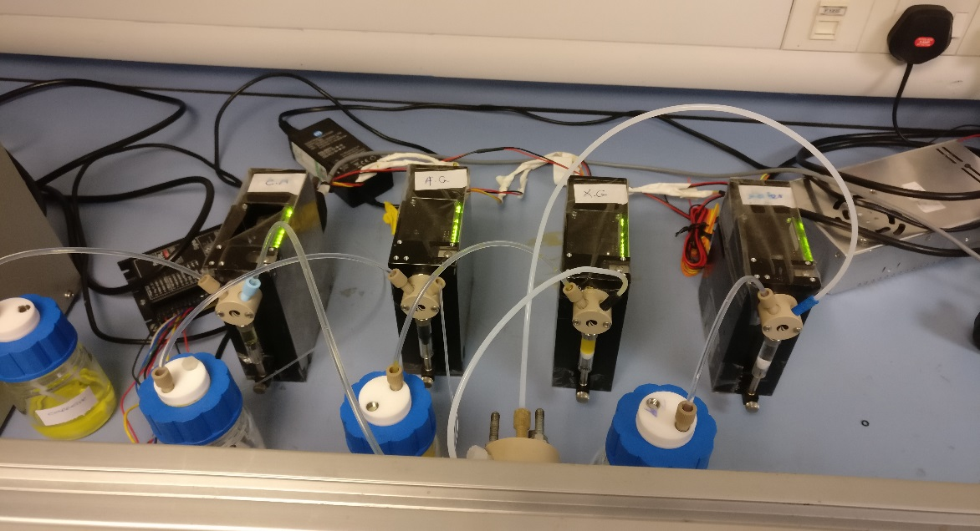
Figure 13: Pumps to suck and feed the ingredients into the reactor
The software controls amplitude, frequency, speed and various parameters. The formulation can be changed at any point of the process and once the input is provided, the reactor continuously manufactures a drink without any interference.
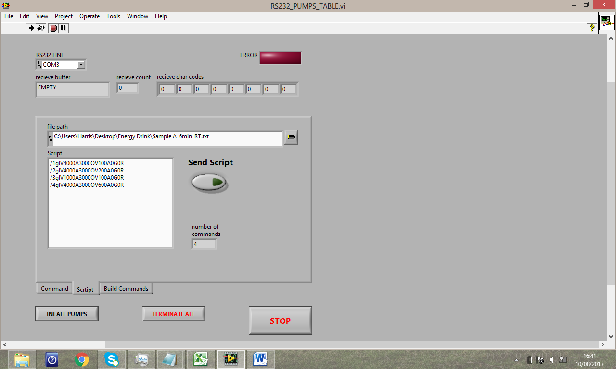
Figure 14: Software to control reactor
For the experimental workshop, various formulation of samples was manufactured and tested by our research group. To find out the best-formulated drink to satisfy the consumer’s needs and to achieve effective results, different samples were produced by changing the sensory parameters & attributes such as residence time, sugar level, mango flavour concentration, using sweetener instead of sugar and adding colouring agent. Total 15 samples were manufactured by trying different combination and residence time. From that 4 best tasting samples were selected for sensory evaluation. Two samples were made with low concentration flavour and sugar and another two were formulated using sweetener instead of sugar and adding colouring agent. Figure 15 shows the different samples produced. Physical properties such as pH and colour intensity were measured for each sample & this is measured using a device respectively is HANNA Instruments pH 211 Microprocessor (pH meter) and UV/VIS spectrometer (in nm units).
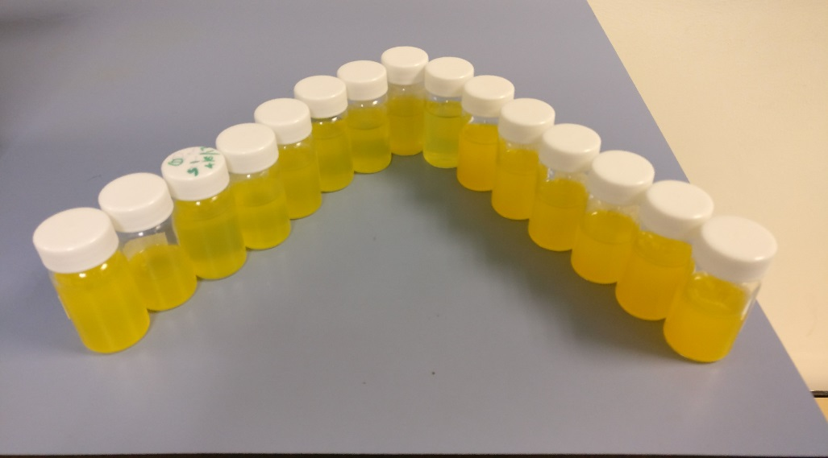
Figure 15: Different combination of ED samples
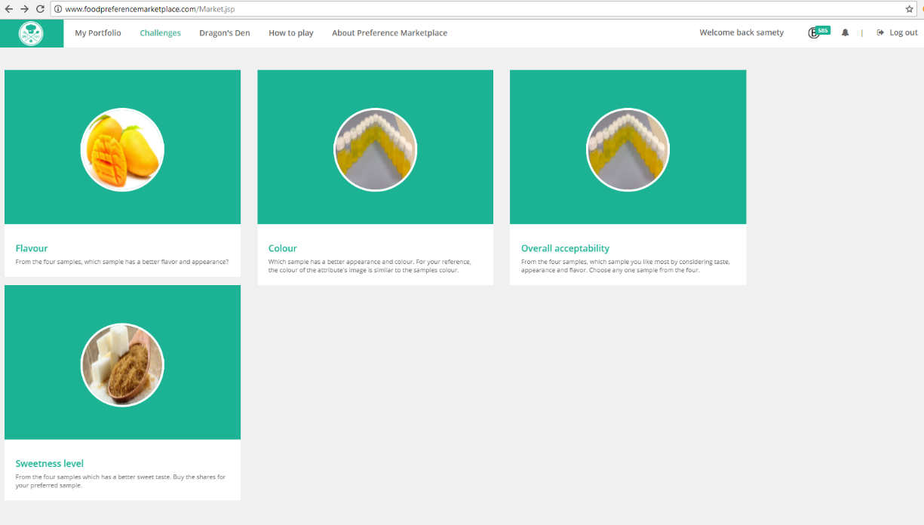
Figure 16: Markets created for workshop
Sensory evaluation was conducted to taste and evaluate the sensory attributes of the manufactured ED using data gathered from PM. Untrained participants from different countries and age group were invited for the evaluation. All the participants were asked to sign the consent form before starting the session and small presentation about the project was presented. The participants were informed to evaluate the samples based on colour, sweetness, taste, flavour, smell, and texture. Assessors were asked to enter their preferences and feedbacks in PM by buying or selling their preferred samples before and after tasting. The markets created for the sensory evaluation workshop is shown in (figure 16). Participants were asked to select best samples for each category such as colour, taste, flavour and overall acceptability and buy their preferred samples’ shares in PM. At the end, the samples with high share value were their preferred sample in each category. From their feedback, validation of the experiment was done.

Results and validation
Data of PM, physical properties, experimental design, sensory evaluation & participants panel all these were integrated to form an effective co-creation model to develop a consumer driven NPD.

‘Preference Marketplace’ analysis
In today’s manufacturing environment, most of the industries are flowing closed system where they keep consumer out of the NPD process. However, to meet the demand, be competitive and understand the consumers’ needs it is very important to embrace an OI (Jreissat, et al., 2017). Currently, at the most, the customer's engagement is by questionnaires but they wish to actively be involved in NPD. So, to address these issues co-creation is one of the best possible solutions and the first phase of co-creation model is aggregating information from consumers.
PM is a better tool than another kind of surveys because of its information finding model and incentives to motivate the consumers. For the development of new ED products, sensory attributes such as taste, flavour, caffeine content and variant of ED were created in PM. Total of 65 participants which includes 42 males and 23 females from different countries and age groups participated over a 7 days gaming period. Final price of each attribute represents the percentage of consumer preferences. The initial price of each attribute was defined when creating markets. Participants buy or sell the preferred attributes during PM and play anytime during the gaming period. Results of each sensory markets and attributes were discussed below.
Results of taste preference are shown in Figure 17. In PM three different taste was created in taste market. As you can see in the graph (fig.17) consumers prefer sweet taste for the ED from the start of the survey. On the first day, the stock price of sweet taste was 57 Bite coins that mean 57% people prefer the sweet taste. Sweet taste had the highest preference over the gaming period and in the middle of the gaming period, some people bought lots of shares in sour taste this resulted in a drop in the share value of the sweet taste. But again, at the end, the sweet taste leads in the stock price. On third day total 61% of people preferred sweet taste which is the highest percentage of preference over the gaming period which shows that sweet taste was preferred by most people.

Figure 17: PM results - Taste
The sour taste is next to the sweet taste and 38% of people prefer sour taste over sweet and bitter. The reason for the reasonable amount of sour taste because there are some beverages in citric flavour and the sour-sweet combo is preferred by some people. The results also show that bitter is the lowest percentage of people’s preference. The highest bitter value was the 30 bite coins which represent 30% of people. But over the gaming period, the preference of bitter taste was around 20 bite coins i.e. 20% consumers. As a summary, over a one-week gaming period, the preferences for taste attributes were 61% of participants prefer the sweet taste and 38% and 30% of participants prefers sour and bitter taste respectively.
For flavouring of ED, flavours such as cherry & berry, apple, mango, grape, lemon, pomegranate, orange, and caramel were created in PM. The consumer’s preference of the flavours is shown in Figure 18.

Figure 18: PM results – Flavour
As we see, it is understood that mango flavour had more preference from participants over another flavour because there are no energy drinks in mango flavour at present. Thus, consumers wish to taste some new novelty flavour, this is the reason for the more preferences of another new flavour, pomegranate as well. Mango flavour was most preferred by 42% of consumer panel i.e. 42 bite coins. From the beginning, mango flavour was a clear winner in the flavour attributes. Second most preferred flavour next to mango was the most commonly consuming orange flavour, which was preferred by 30% participants. However, third most preferred was another new flavour pomegranate with 25% of preference from participants. Other than mango, orange, and pomegranate, there was no strong agreement on the participants for a specific flavour. All the remaining flavours were closely packed throughout the survey.
Four different amounts (60 mg, 80 mg, 90 mg & 100 mg) of caffeine content per 250 ml ED were proposed to participants. At the end of the game, the caffeine content of 60 mg and 80 mg were most preferred over another amount as shown in Figure 19.

Figure 19: PM results - Caffeine content
Consumers were aware of the effects and risk of caffeine content. This is the main reason for the most preferences of lower caffeine content over higher amount despite all are safer limit to consume. Over 40% of participants preferred the lower amount of caffeine. There was no much differences or preference between 60 mg & 80 mg of caffeine, where 50% and 45% of participants prefer 80 mg and 60 mg respectively. In contrast, around 20% of people preferred the high amount of caffeine in their ED. More the amount of caffeine is less the preference for the higher caffeine attributes. Bite coins for 90 mg & 100 mg were 24 and 22 which represent 24% & 22% of participants preference respectively. The results summarise that participants want less caffeine content in their drinks.
There are 2 types of soft drinks i.e. carbonated drinks e.g. soda, sparkling water, and noncarbonated drinks e.g. fruit juices. These two types of the variant were created for PM to identify their preferences as shown in Figure 20.

Figure 20: PM results – Variant
Consumer panel was not so preferred of any specific variant which can be seen in result. The preferences were continuously changing every day over the period. But the price of the noncarbonated attribute was 65 bite coins on the beginning of the game which represents 65% of people preferred. Whereas carbonated attribute price was fluctuating but the highest price was 61 bite coins. Even at the end of the game non-carbonated variant had a slight edge over carbonated drinks which was quite surprising. Because most successful commercial ED is carbonated drinks, however, consumer panel prefer non-carbonated energy drink.

Energy drink customisation using novel platform
According to PM’s results, the sensory attributes for the formulation of energy drinks were identified as shown in Table 7.
Table 7: Summary of most preferred attributes from PM
Market | Sensory attributes (% preferred)
Taste | Sweet (61%)
Flavour | Mango (42%)
Caffeine amount | 80 mg per 250 mL (50%)
Variant | Non-carbonated (65%)

From the selected attributes, mango flavoured non-carbonated energy drink with a sweet taste and 80 mg caffeine per can was formulated using computer driven automatic continuous flow reactor. Total 15 samples were formulated based on this attributes by trying different combination and proportion of ingredients such as sweetness, mango concentration, etc. All the samples were formulated according to this manufacturing process conditions: 4.00 mm oscillatory amplitude, the frequency was 1.07 Hz, 9.99 ml/min net flow rate and residence time between 5 to 7 min. Out of all the samples, 4 samples were selected for sensory evaluation workshop as shown in Figure 21.
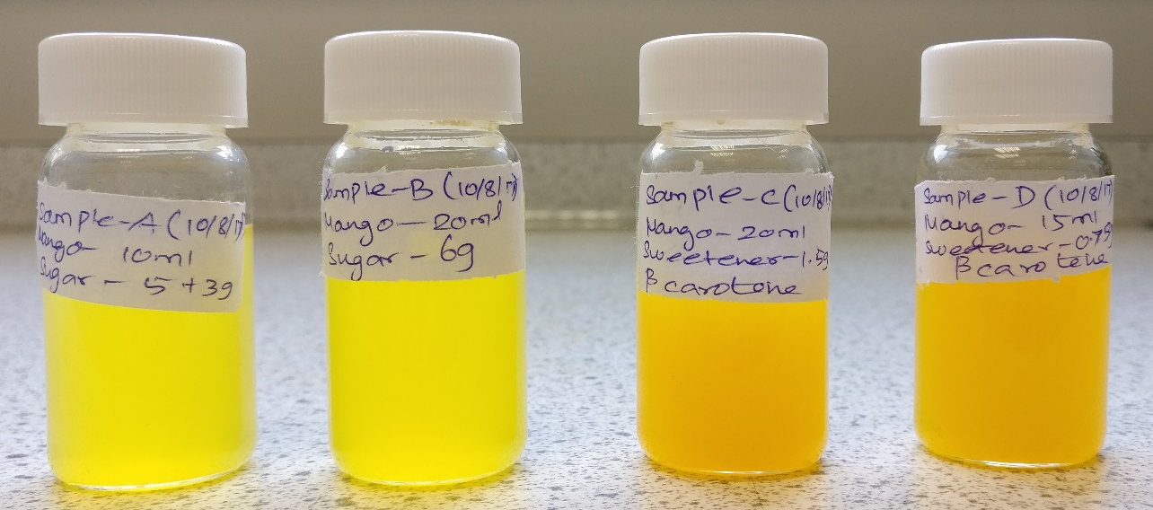
Figure 21: Samples selected for sensory evaluation

Sensory evaluation by consumer panel
For sensory evaluation workshop, participants from a different country, gender, and age were invited. Total 16 untrained participants were participated in the workshop and tasted the samples. The physical properties of samples are shown in Table 8. And final formulation & proportion of ingredients are shown in Table 9.
Table 8: Physical properties of workshop samples
Samples | Residence time in min | pH | Colour intensity in nm unite
Sample A | 6 | 3.14 | 587.545
Sample B | 5 | 3.36 | 588.292
Sample C | 5 | 3.20 | 602.72
Sample D | 6 | 3.15 | 601.58

Table 9: Final formulation description of samples
Samples | Final formulation ingredients per 100 ml
Sample A | Caffeine 30 mg, Taurine 400 mg, B vitamins 200 mg, sucrose 5 g, glucose 3 g, mango concentration 10%, water, citric acid
Sample B | Caffeine 30 mg, Taurine 400 mg, B vitamins 200 mg, sucrose 3.5 g, glucose 2.5 g, mango concentration 15%, water, citric acid
Sample C | Caffeine 30 mg, Taurine 400 mg, B vitamins 200 mg, natural sweetener 1.5 g, mango concentration 20%, water, citric acid, beta-carotene (colouring agent)
Sample D | Caffeine 30 mg, Taurine 400 mg, B vitamins 200 mg, natural sweetener 0.75 g, mango concentration 15%, water, citric acid, beta-carotene (colouring agent)

Four samples were made using this proportion and participants were asked to assess the samples based on sensory descriptors such as colour, smell, taste, flavour and overall acceptability. All these preferences were entered in PM. At the end of the workshop, the high stock priced samples in each sensory market are the samples liked by the participants.
Initially, participants were asked to give their preference in PM before tasting the samples just by reading the description of each sample and pictorial representation. It was to understand the consumer's general preferences of mango flavoured drinks before tasting. After some time, participants were asked to taste the samples and assess it. Water was given to participants before tasting each sample to evaluate effectively. Consumer’s preference of samples in each sensory profile as shown in Figure 22.

Figure 22: Consumer’s preference of ED in different sensory profiles
It shows that (fig. 22), in sweetness level, sample B has most preference & this clearly shows that they want mild sweetness drink. High sugar level samples were not much founded by participants. Similarly, consumers prefer medium concentration of mango flavour in ED which represents that they don’t want a drink which tastes like a mango juice instead of ED. Sample B was the most preferred samples in all sensory profile except the colour. In colour evaluation, sample C attracted the participants because of its vibrant colour. pH level of all the samples was almost similar so consumers were not able to effectively identify the most preferred samples in acidity sensory market. Consumer panel selected sample B as the best product over all the samples, which is clearly shown in overall acceptability. 53% of participants accepted sample B as their best sample. Therefore, sample B satisfy the participant's expectation and needs in almost every sensory profile.

Validation

Figure 23: Sensory Evaluation workshop
Validation of the formulated samples was done by the participant's evaluation. All the participants gave a positive feedback and all the samples satisfied their expectation and they also felt that the formulated drinks were equivalence to commercially available ED. It was well formulated with the proper proportion of ingredients using the continuous flow reactor. The primary purpose of energy drinks is their physical & mental stimulation, but only 10ml quantity of each sample was provided to every individual. Hence, they were not able to assess the stimulant properties of the drinks. From their evaluation, it was understood that participants need mild-sweet tasting, less mango flavoured and more vibrant coloured noncarbonated energy drinks. Participants in the workshop for tasting and analysing samples as shown in figure 23.

Conclusion & further work
In this project, a methodology for manufacturing of consumer driven ED formulation using novel technologies was explicitly presented. The novel technology comprises of an online crowdsourcing co-creation tool, ‘Preference Marketplace’ used to aggregate the preferences of consumers. Then follows the translation of those preferences into a consumer preferred product using a novel continuous flow reactor to produce energy drinks rapidly and efficiently. From evaluation of this methodology and technologies by the consumers, it's understood that PM is an efficient, flexible, scalable and feasible crowdsourcing tool for elucidating information from consumers. On the other hand, novel manufacturing reactor could manufacture drinks efficiently as an industrial manufacturing process. It also responds to consumers preference and manufactures a beverage rapidly. The reactor is cost & time effective, high mixing performance and low energy requirements. By combining the two novel technologies, it is now possible to allow the consumer to effectively engage in co-creation process of producing a consumer-driven new product along with an NPD team.
In the future, deployment and cost model of this technology should be investigated. Integration of PM with other technologies and various industries could be another exploration to be done in the future. Furthermore, we should also study the large-scale production and implementation of these technologies in industries to determine its efficiency and flexibility.

References
Adomavicius, G. & Tuzhilin, A., 2005. Personalization Technologies: A PROCESS-ORIENTED PERSPECTIVE. COMMUNICATIONS OF THE ACM, 48(10), pp. 83-90.
Amendola, C. et al., 2004. Multivariate statistical analysis comparing sport and energy drinks. Innovative Food Science and Emerging Technologies, Volume 5, pp. 263-267.
Attila, S. & Çakir, B., 2011. Energy-drink consumption in college students and associated factors. Nutrition, Volume 27, p. 316–322.
Babu, K. M., Church, R. J. & Lewander, W., 2007. Energy Drinks: The New Eye-Opener For Adolescents. Clin Ped Emerg Med, Volume 9, pp. 35-42.
Banović, M., Krystallis, A., Guerrero, L. & J. Reinders, M., 2016. Consumers as co-creators of new product ideas: An application of projective and creative research techniques. Food Research International, Volume 87, p. 211–223.
Beaglehole, R. H., 2015. Dentists and sugary drinks. JADA, 146(2), pp. 73-74.
Bigliardi, B. & Galati, F., 2013. Innovation trends in the food industry: the case of functional foods. Trends in Food Science & Technology, Volume 31, pp. 118-129.
Brouns, F., 1993. Nutritional needs of athletes. New York: John Wiley & Sons.
Bunting, H., Baggett, A. & Grigor, J., 2013. Adolescent and young adult perceptions of caffeinated energy drinks. A qualitative approach. Appetite, Volume 65, p. 132–138.
C. K. PRAHALAD & RAMASWAMY, V., 2004. CO-CREATION EXPERIENCES: THE NEXT PRACTICE IN VALUE CREATION. JOURNAL OF INTERACTIVE MARKETING, 18(3), pp. 5-14.
Campbell, B. et al., 2013. International Society of Sports Nutrition position stand: energy drinks. Journal of the International Society of Sports Nutrition, 10(1), pp. 1-16.
Chesbrough, H., 2003. Open innovation: The new imperative for creating and profiting from technology. Cambridge: MA: Harvard Business School Publishing..
Chesbrough, H., 2006. Open business models: How to thrive in the new innovation landscape. Boston: Harvard Business School Press.
Costa, A., Dekkerb, M. & Jongenb, W., 2004. An overview of means-end theory: potential application in consumer-oriented food product design. Trends in Food Science & Technology, Volume 15, p. 403–415.
Çubukcua, A. & Gümü, B., 2015. Systematic Design of an Open Innovation Tool. Procedia - Social and Behavioral Sciences, Volume 195, p. 2859 – 2867.
D. Hoyer, W. et al., 2010. Consumer Cocreation in New Product Development. Journal of Service Research, 13(3), pp. 283-296.
Davis, S., 1989. From future perfect: mass customizing. Planning Review, 17(2), pp. 16-21.
De Pelsmaeker, S. et al., 2015. Consumer-driven product development and improvement combined with sensory analysis: A case-study for European filled chocolates. Food Quality and Preference, Volume 41, pp. 20-29.
DEFRA, 2016. Food Statistics Pocketbook. London: s.n.
Deloitte LLP, 2015. Making it personal – One in three consumers wants personalised products. [Online]
Available at: https://www2.deloitte.com/uk/en/pages/press-releases/articles/one-in-three-consumers-wants-personalised-products.html
[Accessed 17 August 2017].
Deloitte, 2015. Made-to-Order: The rise of mass personalisation, London: The Deloitte Consumer Review.
Durugbo, C. & Pawar, K., 2014. A unified model of the co-creation process. Expert Systems with Applications, Volume 41, p. 4373–4387.
Edwards, C. H. et al., 2016. The role of sugars and sweeteners in food, diet and health: Alternatives for the future. Trends in Food Science & Technology, Volume 56, pp. 158-166.
EFSA, 2012. Scientific opinion on the safety and efficacy of taurine as a feed additive for all animal species. EFSA Journal, 10(6), pp. 2736-2752.
Enkel, E., Gassmann, O. & Chesbrough, H., 2009. Open R&D and open innovation: exploring the phenomenon. R & D Management, Volume 39, pp. 311-316.
Fogt Jacobsen, L. et al., 2014. Improving internal communication between marketing and technology functions for successful new food product development. Trends in Food Science & Technology, Volume xx, pp. 1-9.
Franke, N. & Schreier, M., 2008. Product uniqueness as a driver of customer utility in mass customization. Market Lett, Volume 19, p. 93–107.
Fuller, J., Bartl, M. & Ernst, H., 2006. Community based innovation: How to integrate members of virtual communities into new product development. Electron Commerce Res, Volume 6, pp. 57-73.
Fuller, J., Bartl, M. & Ernst, H., 2006. Community based innovation: How to integrate members of virtual communities into new product development. Electron Commerce Res, Volume 6, pp. 57-73.
Giles, G. E. et al., 2012. Differential cognitive effects of energy drink ingredients: Caffeine, taurine, and glucose. Pharmacology, Biochemistry and Behavior, Volume 102, pp. 569-577.
Hardy, R., Kliemann, N., Evansen, T. & Brand, J., 2016. Relationship Between Energy Drink Consumption and Nutrition Knowledge in Student-Athletes. Journal of Nutrition Education and Behavior, pp. 1-8.
Heckman, M., Sherry, K. & Mejia, E. G. d., 2010. Energy Drinks: An Assessment of Their Market Size, Consumer Demographics, Ingredient Profile, Functionality, and Regulations in the United States. COMPREHENSIVE REVIEWS IN FOOD SCIENCE AND FOOD SAFETY, Volume 9, pp. 303-317.
Higgins, J. P., Tuttle, T. D. & Higgins, C. L., 2010. Energy Beverages: Content and Safety. Mayo Clin Proc., 85(11), pp. 1033-1041.
Hong, P., 2014. 70% Of Consumers Want More Personalized Shopping Experiences. [Online]
Available at: https://www.linkdex.com/en-us/inked/70-of-consumers-want-more-personalized-shopping-experiences/
[Accessed 17 August 2017].
Howe, C., 2006. Crowdsourcing: why the power of the crowd is driving the future of business. New York: Random House.
Humphreys, A. & Grayson, K., 2008. The Intersecting Roles of Consumer and Producer: A Critical Perspective on Co-production, Co-creation and Prosumption. Sociology Compass, Volume 2, pp. 963-980.
Jreissat, M., Isaev, S., Moreno, M. & Makatsoris, C., 2017. Consumer Driven New Product Development in Future Re-Distributed Models of Sustainable Production and Consumption. Procedia CIRP, Volume 63, pp. 698-703.
Kajtaz, M. et al., 2015. An Approach for Personalised Product Development. Procedia Technology, Volume 20, pp. 191-198.
Keating, B. A. et al., 2010. Eco-efficient Agriculture: Concepts, Challenges and Opportunities. Crop Science, 50(1), pp. 109-119.
Kennedy, D. O. & Scholey, A. B., 2004. A glucose-caffeine ‘energy drink’ ameliorates subjective and performance deficits during prolonged cognitive demand. Appetite, Volume 42, pp. 331-333.
K, F., W, K., J, H. & L, K., 2004. Nutritional supplement use among college athletes and their sources of information. Int J Sport NutrExerc Metab, Volume 14, pp. 104-120.
Kratzer, J., Meissner, D. & Roud, V., 2017. Open innovation and company culture: Internal openness makes the difference. Technological Forecasting & Social Change, Volume 119, p. 128–138.
Kwon, S., Ha, S. & Kowal, C., 2017. How online self-customization creates identification: Antecedents and consequences of consumer-customized product identification and the role of product involvement. Computers in Human Behavior, Volume 75, pp. 1-13.
Lichtenthaler, U., 2008. Open innovation in practice: an analysis of strategic approaches to technology transactions. IEEE Transactions on Engineering Management, 55(1), pp. 148-157.
Lorenzo-Romero, C., Constantinides, E. & Brünink, L. A., 2014. Co-Creation: Customer Integration in Social Media Based Product and Service Development. Procedia - Social and Behavioral Sciences, Volume 148, pp. 383-396.
Makatsoris, C., Paramonov, L. & Alsharif, R., 2013. A modular flow reactor. GB/Middlesex, Patent No. WO 2013/050764 A1.
Maulana, M. R. S. & Rufaidah, P., 2014. Co-creation of small-medium enterprises. Procedia - Social and Behavioral Sciences, Volume 115, p. 198 – 206.
McCrory, C. et al., 2017. Perceptions and Knowledge of Caffeinated Energy Drinks: Results of Focus Groups With Canadian Youth. Journal of Nutrition Education and Behavior, Volume 49, pp. 304-311.
Meadows-Oliver, M. & Ryan-Krause, P., 2007. Powering Up With Sports and Energy drinks. J Pediatr Health Care, Volume 21, pp. 413-416.
Mourtzis D. & Doukas M., 2014. Design and planning of manufacturing networks for mass customisation and personalisation: Challenges and Outlook. Procedia CIRP, Volume 19, p. 1 – 13.
Mourtzis, D., Doukas, M., Psarommatis, F. & Giannoulis, C., 2014. A web-based platform for mass customisation and personalisation. CIRP Journal of Manufacturing Science and Technology, Volume 7, p. 112–128.
Navarro-Pascual-Ahuir, M., Lerma-García, M. J., Simo-Alfonso, E. F. & Herrero-Martínez, J. M., 2016. Determination of water-soluble vitamins in energy and sport drinks by micellar electrokinetic capillary chromatography. Food Control, Volume 63, pp. 110-116.
Neves, D. B. d. J. & Caldas, E. D., 2017. Determination of caffeine and identification of undeclared substances in dietary supplements and caffeine dietary exposure assessment. Food and Chemical Toxicology, Volume 105, pp. 194-202.
NI, X. et al., 2003. MIXING THROUGH OSCILLATIONS AND PULSATIONS- A GUIDE TO ACHIEVING PROCESS ENHANCEMENTS IN THE CHEMICAL AND PROCESS INDUSTRIES. Trans IChemE, Volume 81, pp. 373-383.
Peacock, A., Martin, F. H. & Carr, A., 2013. Energy drink ingredients. Contribution of caffeine and taurine to performance outcomes. Appetite, Volume 64, pp. 1-4.
Pfeiffer, T. & Almenberg, J., 2010. Prediction markets and their potential role in biomedical research- A review. Biosystems, Volume 102, pp. 71-76.
Phan, A. N. & Harvey, A., 2010. Development and evaluation of novel designs of continuous mesoscale oscillatory baffled reactors. Chemical Engineering Journal, Volume 159, pp. 212-219.
Prahalad, C. K. & Ramaswamy, V., 2000. Co-opting Customer Competence. Harvard Business Review, Volume 78, pp. 79-87.
R. MOSKOWITZ, H. & SAGUY, S., 2013. Reinventing the Role of Consumer Research in Today’s Open Innovation Ecosystem. Critical Reviews in Food Science and Nutrition, Volume 53, pp. 682-693.
Raford, N., 2015. Online foresight platforms: Evidence for their impact on scenario planning & strategic foresight. Technological Forecasting & Social Change, Volume 97, pp. 65-76.
REDMOND, H. P., STAPLETON, P. P., NEARY, P. & BOUCHIER-HAYES, D., 1998. Immunonutrition: The Role of Taurine. Nutrition, 14(7/8), pp. 599-604.
Reissig, C. J., Strain, E. C. & Griffiths, R. R., 2009. Caffeinated energy drinks—A growing problem. Drug and Alcohol Dependence, Volume 99, pp. 1-10.
Rodgers, S., 2007. Innovation in food service technology and its strategic role. Hospitality Management, Volume 26, pp. 899-912.
Rollin, F., Kennedy, J. & Wills, J., 2011. Consumers and new food technologies. Trends in Food Science & Technology, Volume 22, pp. 99-111.
S.Fogliatto, F., J.C.daSilveira, G. & DenisBorenstein, 2012. The mass customization decade: An updated review of the literature. Int. J. Production Economics, Volume 138, p. 14–25.
Saguy, I. S. & Sirotinskaya, V., 2014. Challenges in exploiting open innovation’s full potential in the food industry with a focus on small and medium enterprises (SMEs). Trends in Food Science & Technology, Volume 38, pp. 136-148.
Salze, G. P. & Davis, D. A., 2015. Taurine: a critical nutrient for future fish feeds. Aquaculture, Volume 437, pp. 215-229.
Spann, M. & Skiera, B., 2003. Internet-based virtual stock market for business forecastin. Management science, 49(10), pp. 1310-1326.
Stephens, G. & Mackley, M., 2002. Heat transfer performance for batch oscillatory flow mixing. Experimental Thermal and Fluid Science, Volume 25, pp. 583-594.
STONESTREET, P. & HARVEY, A. P., 2002. A MIXING-BASED DESIGN METHODOLOGY FOR CONTINUOUS OSCILLATORY FLOW REACTORS. Trans IChemE, Volume 80, pp. 31-44.
SuppVersity, 2010. Taurine Content of Selected Foods: Taurine Deficiency Very Unlikely on a Normal Diet. [Online]
Available at: http://suppversity.blogspot.co.uk/2010/08/taurine-from-foods-can-i-be-taurine.html
[Accessed 21 August 2017].
Tollo, G. D., Tanev, S., Davide, D. M. & Ma, Z., 2012. Neural networks to model the innovativeness perception of co-creative firms. Expert Systems with Applications, Volume 39, p. 12719–12726.
Tsimiklis, P. et al., 2015. A Consumer-Centric Open Innovation Framework for Food and Packaging Manufacturing. International Journal of Knowledge and Systems Science, 6(3), pp. 52-69.
UK CabinetOffice, 2008. Food Maters: Towards a strategy for the 21st Century, s.l.: s.n.
Vlasic, G. & Kesic, T., 2007. Analysis of Consumers’ Attitudes toward Interactivity and Relationship Personalization as Contemporary Developments in Interactive Marketing Communication. Journal of Marketing Communications, 13(2), pp. 109-129.
Wikoff, D. et al., 2017. Systematic review of the potential adverse effects of caffeine consumption in healthy adults, pregnant women, adolescents, and children. Food and Chemical Toxicology, Volume xxx, pp. 1-64.
Wind, J. & Rangaswamy, A., 2001. CUSTOMERIZATION: THE NEXT REVOLUTION IN MASS CUSTOMIZATION. JOURNAL OF INTERACTIVE MARKETING, Volume 15, pp. 13-18.
Wolfers, J. & Zitzewitz, E., 2004. Prediction Markets. Journal of economic perspectives, Volume 18, pp. 107-126.
Zwass, V., 2010. Co-Creation: Toward a Taxonomy and an Integrated Research Perspective. International Journal of Electronic Commerce, 15(1), pp. 11-48.

Appendices

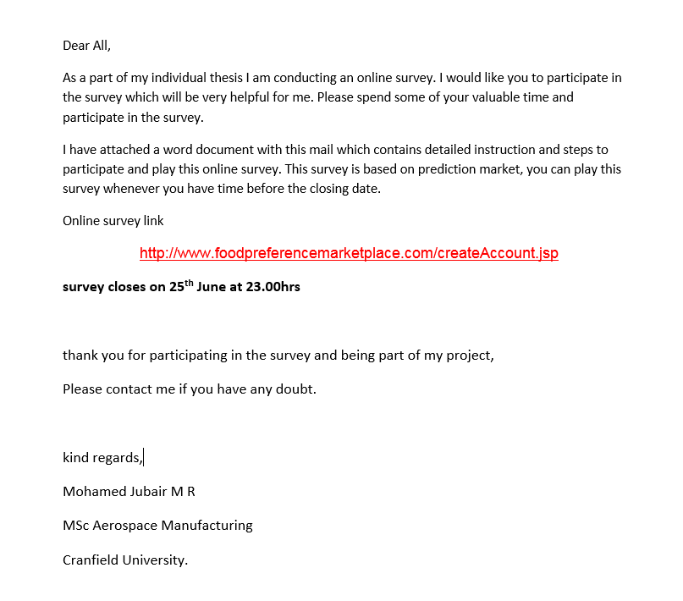
Figure_Apx 1: Online survey email invitation


Figure_Apx 2: New account creation page- PM

Figure_Apx 3: Login Page- PM


Figure_Apx 4: Profile page - PM


Figure_Apx 5: Leader board - ranking based on their share value
Figure_Apx 6: Four sensory markets in PM
Figure_Apx 7: Sensory attributes of taste sensory group- PM
Figure_Apx 8: Sweet taste attributes trading page in PM
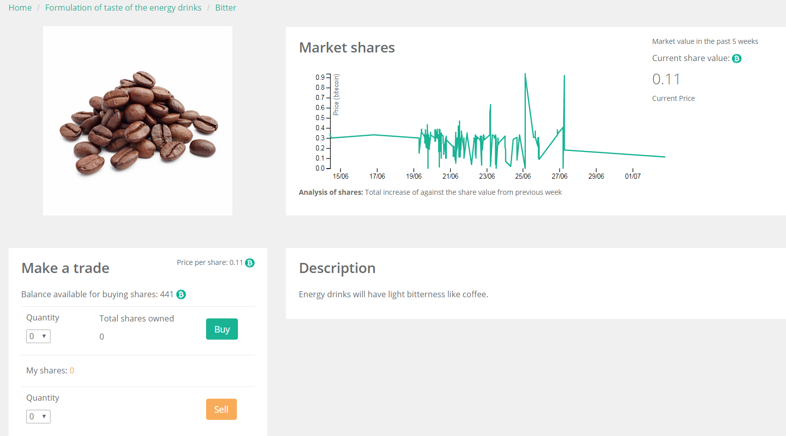
Figure_Apx 9: Bitter taste attribute trading page in PM
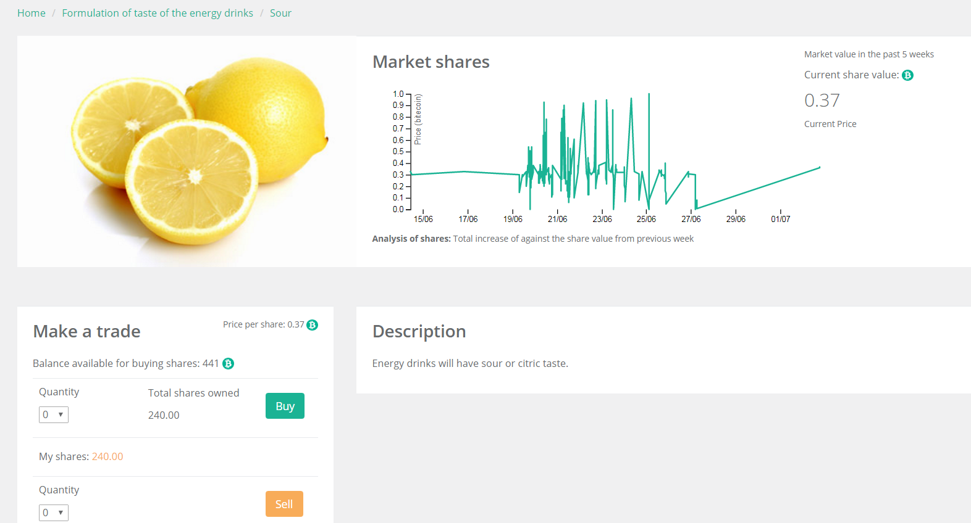
Figure_Apx 10: Sour taste trading page in PM
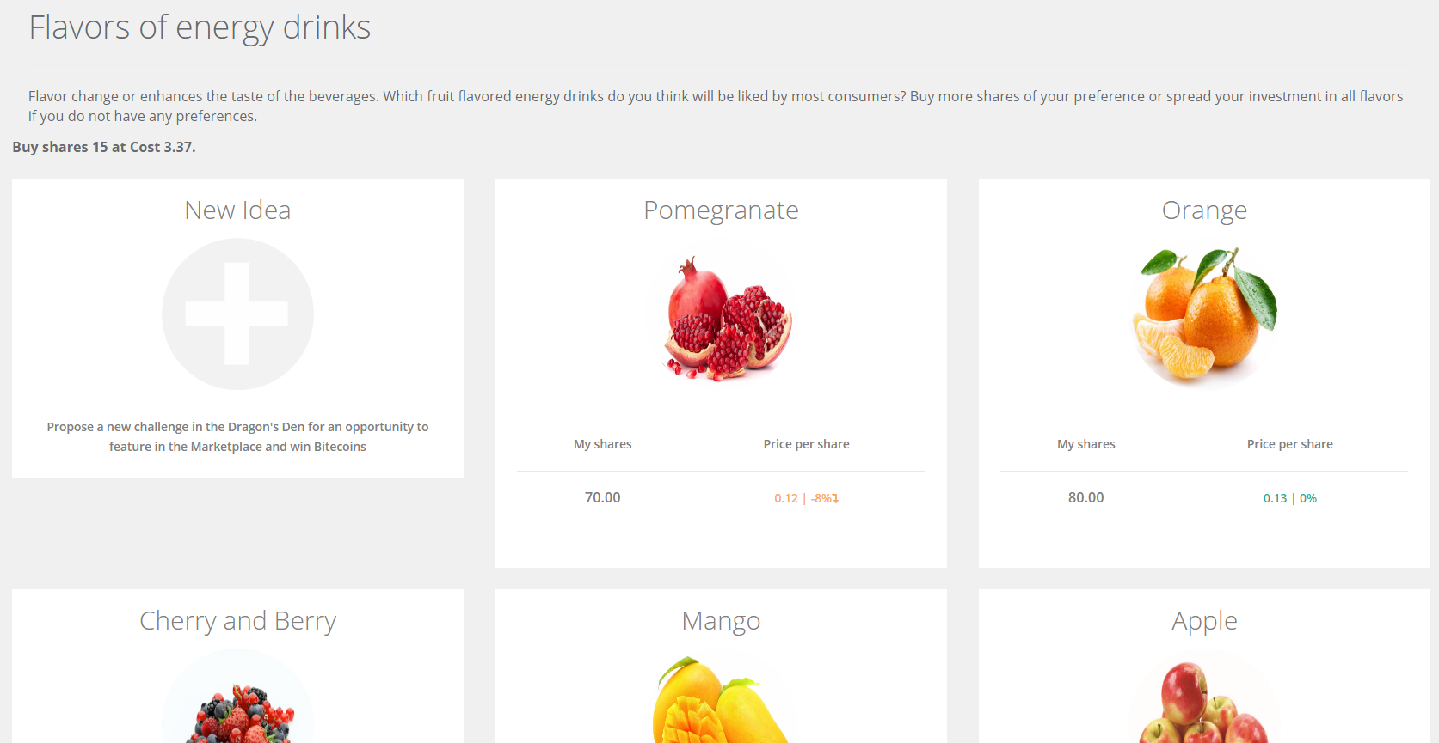
Figure_Apx 11: Different flavour attributes of flavour sensory group

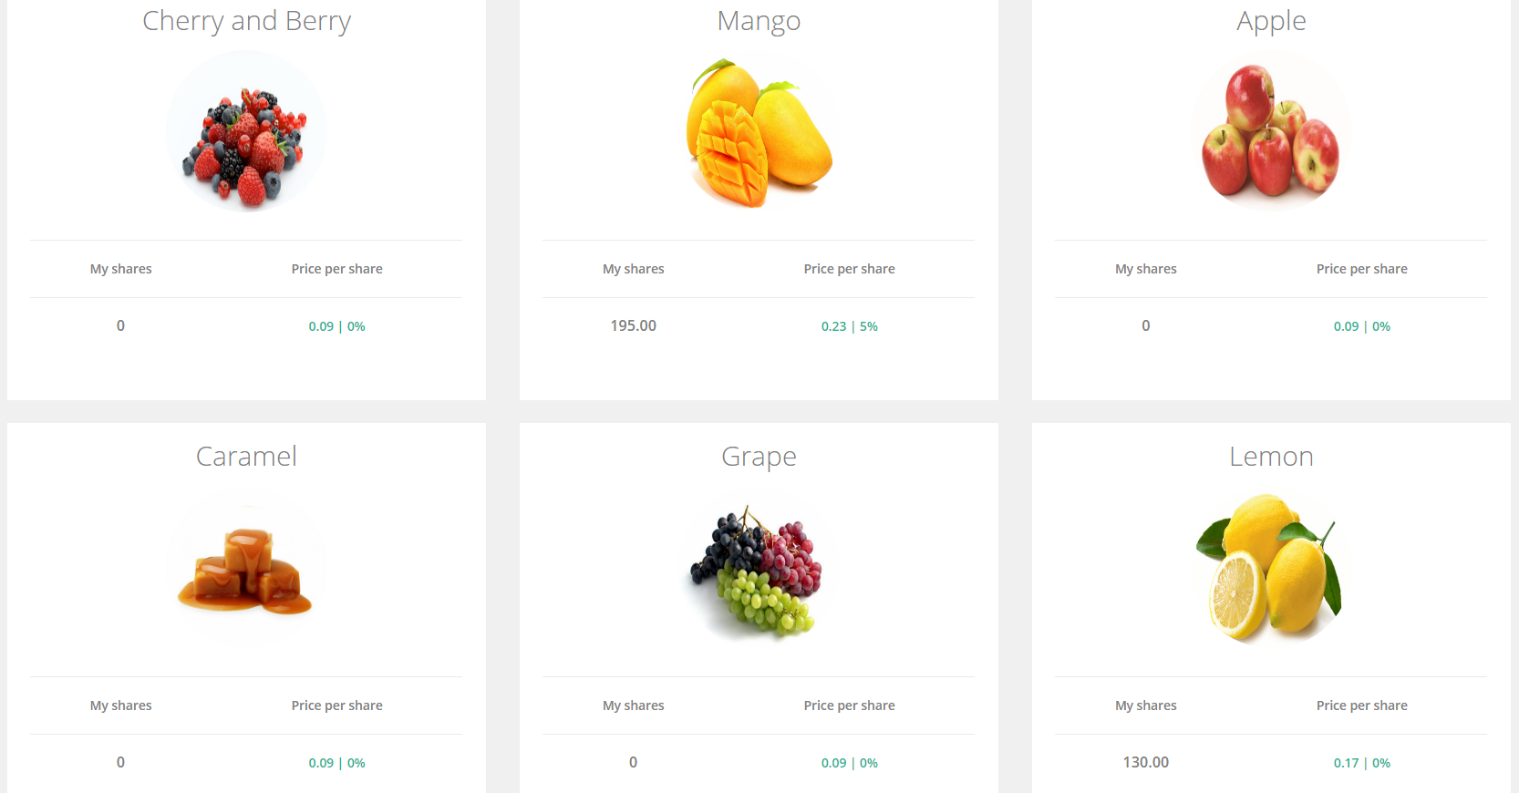
Figure_Apx 12: Diff. flavour in flavour sensory group contd.
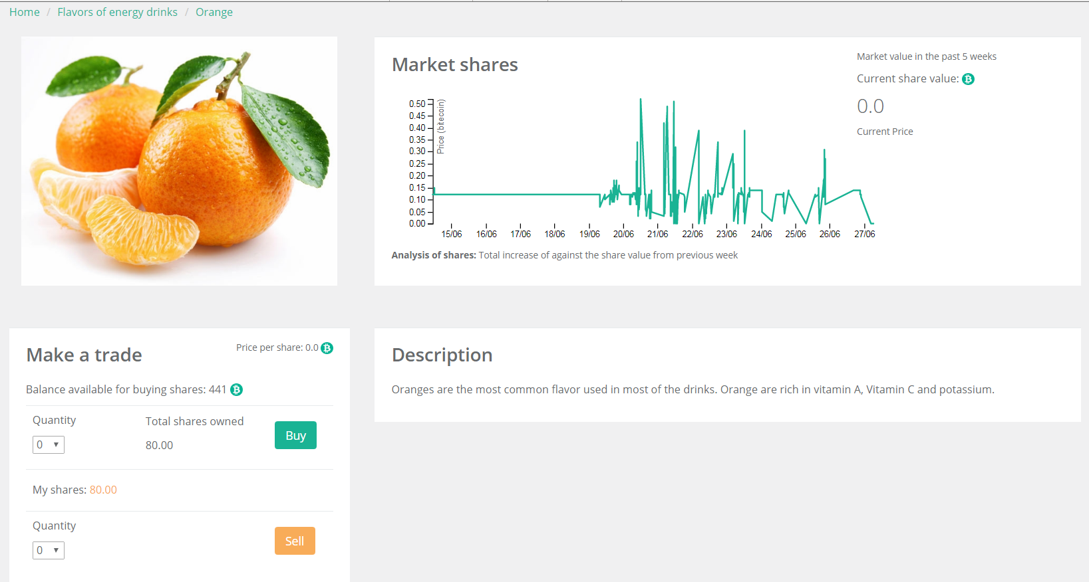
Figure_Apx 13: Orange flavour trading page
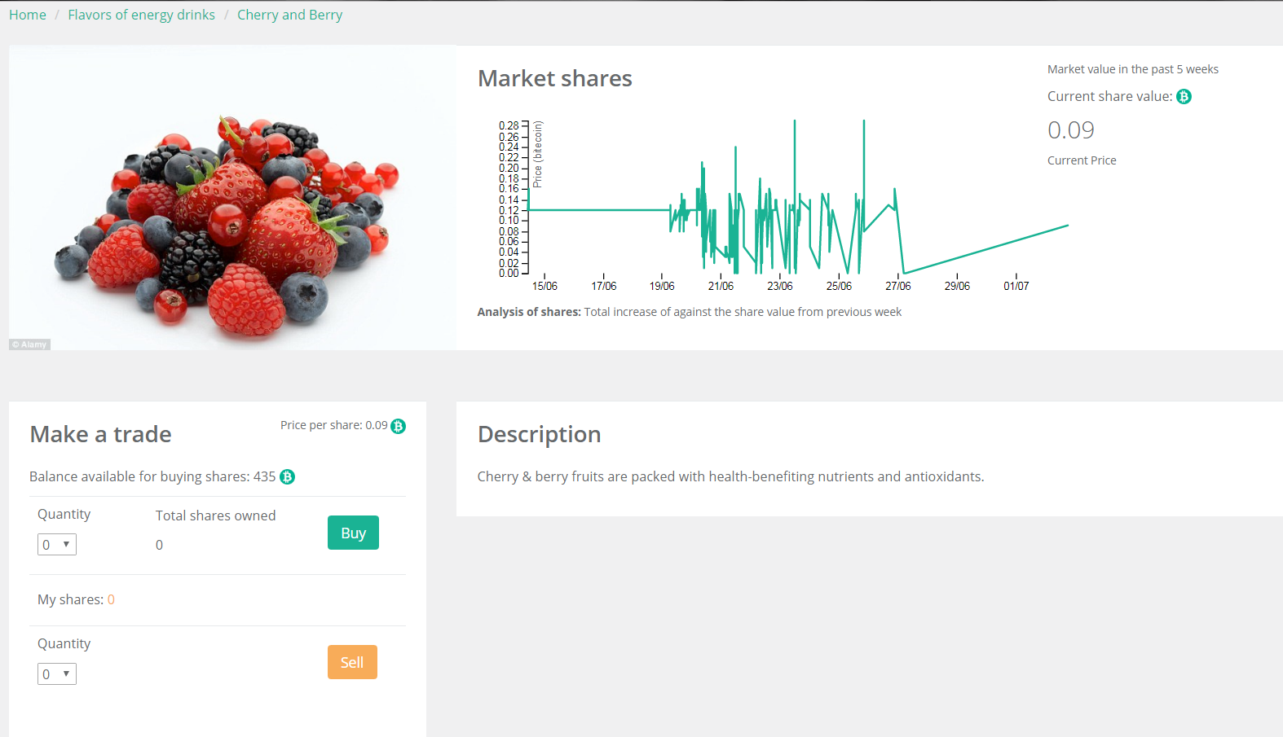
Figure_Apx 14: Berry flavour trading page
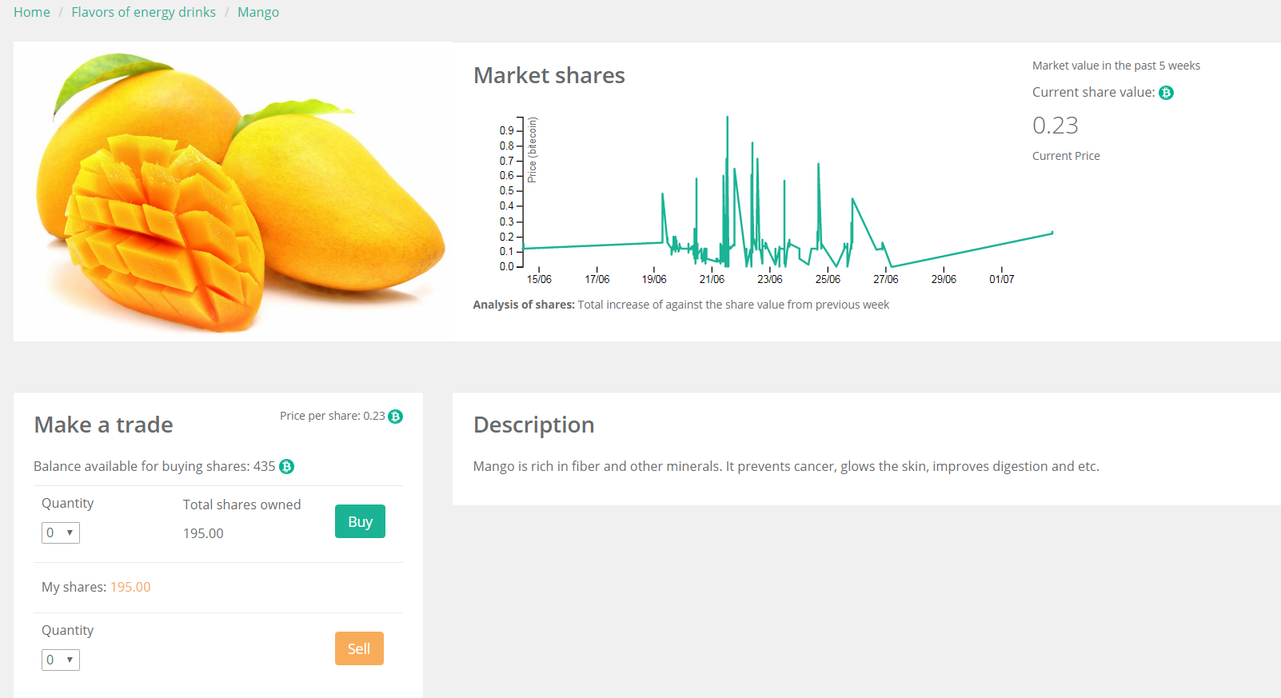
Figure_Apx 15: Mango flavour trading page
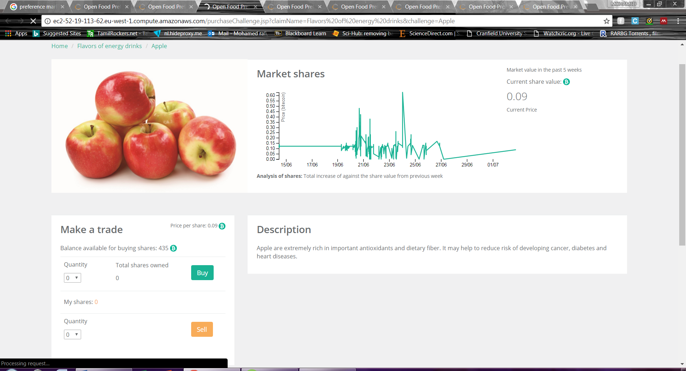
Figure_Apx 16: Apple flavour trading page
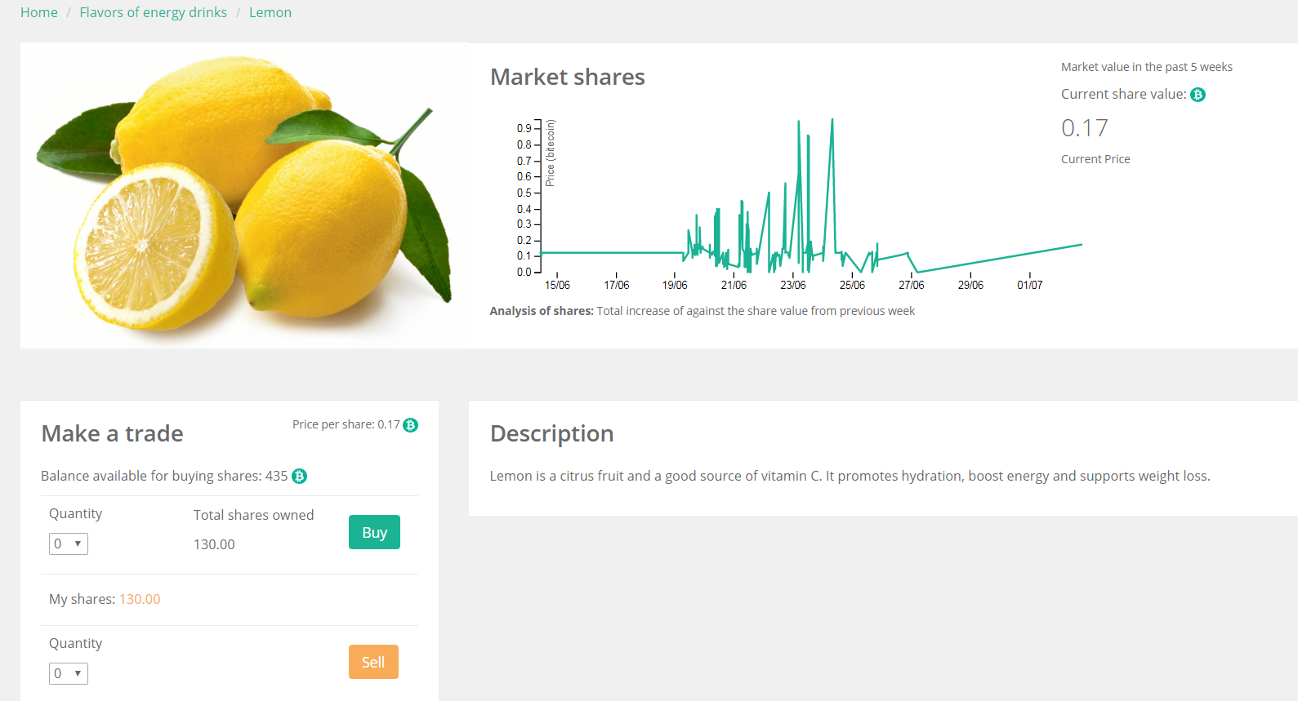
Figure_Apx 17: Lemon flavour trading page
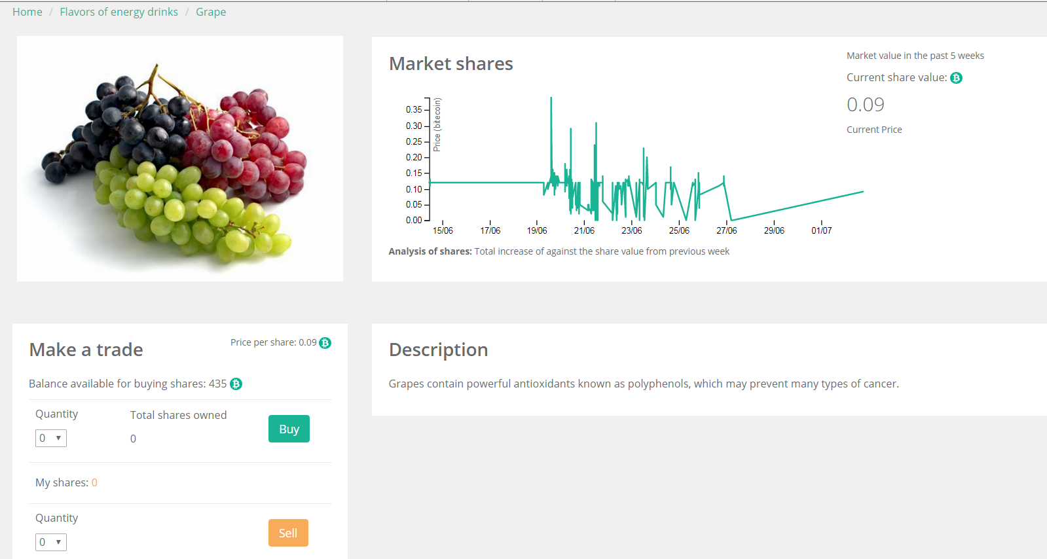
Figure_Apx 18: Grape flavour trading page
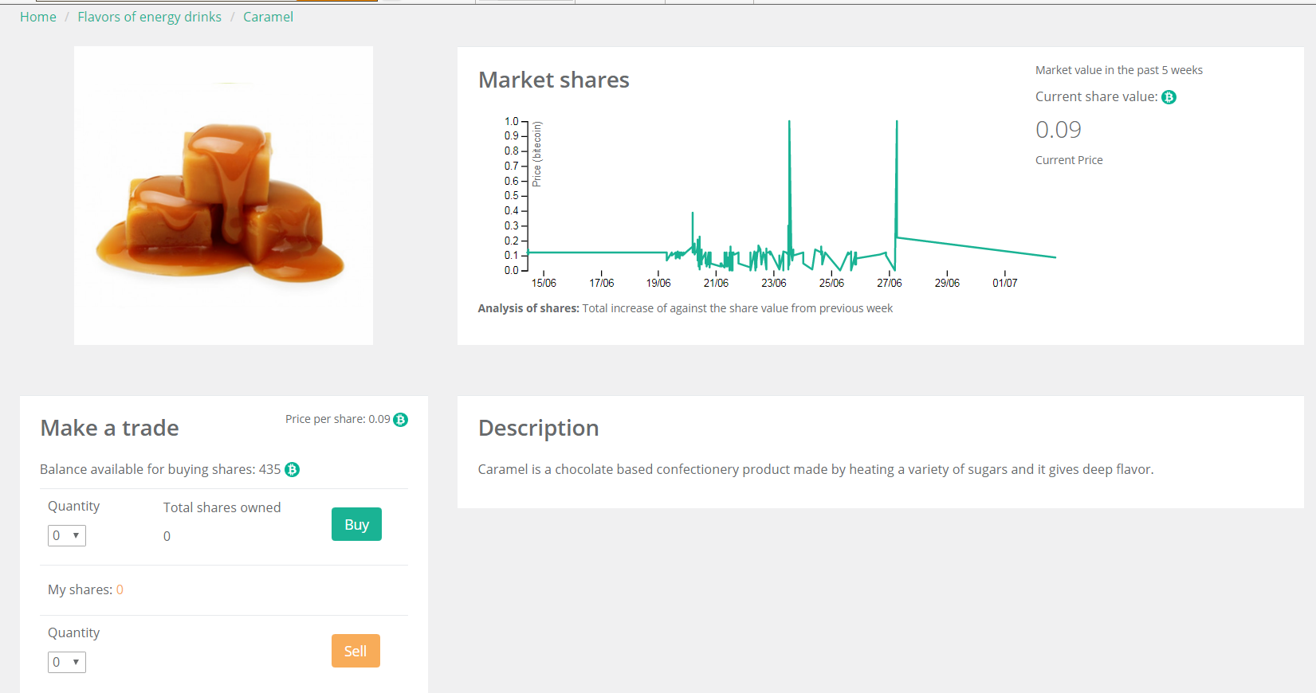
Figure_Apx 19: Caramel flavour trading page
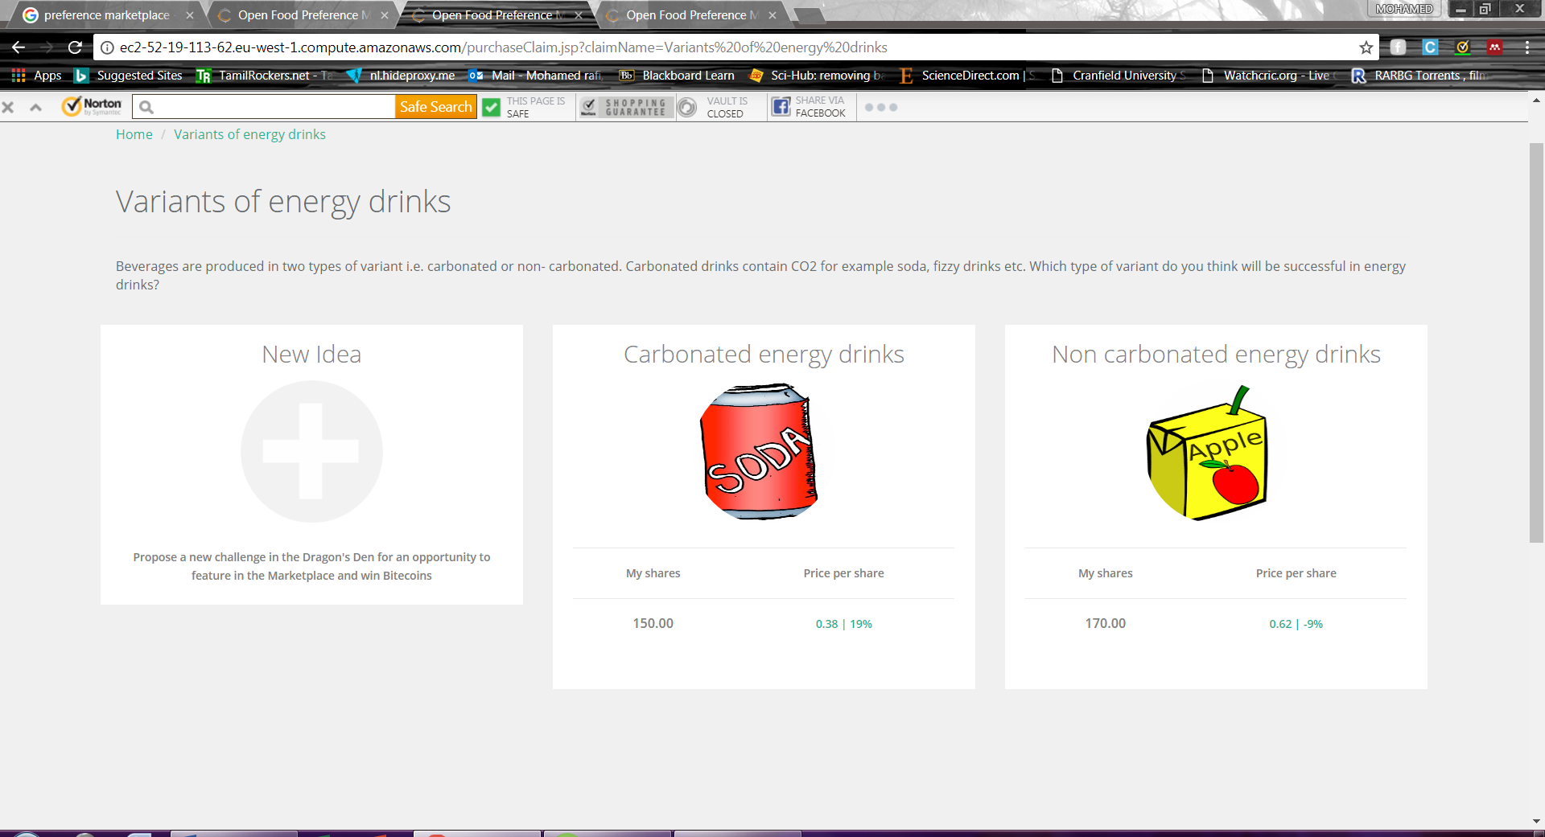
Figure_Apx 20: Sensory attributes of variant of ED in PM
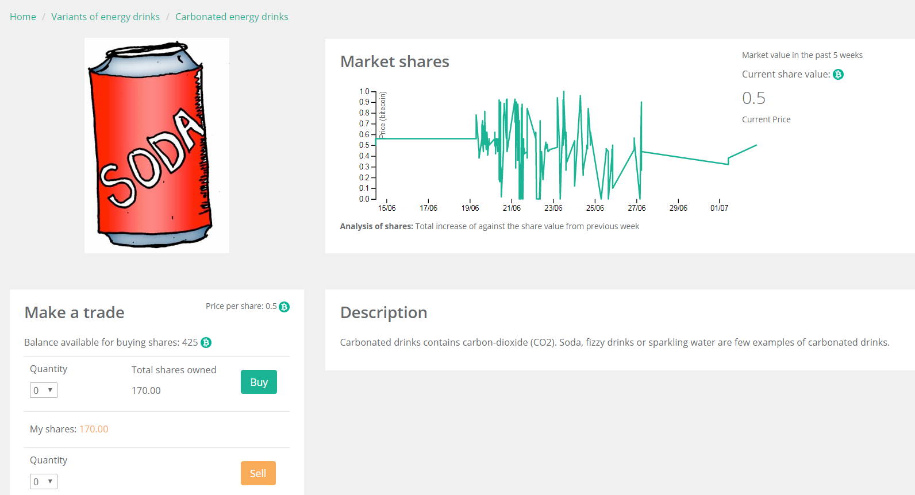
Figure_Apx 21: Carbonated drink trading page
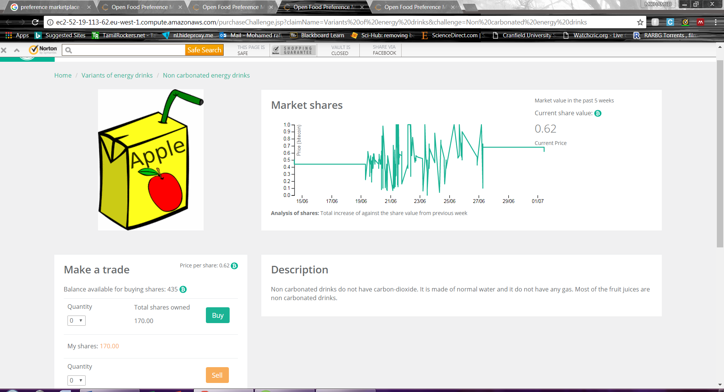
Figure_Apx 22: Non-carbonated ED trading page
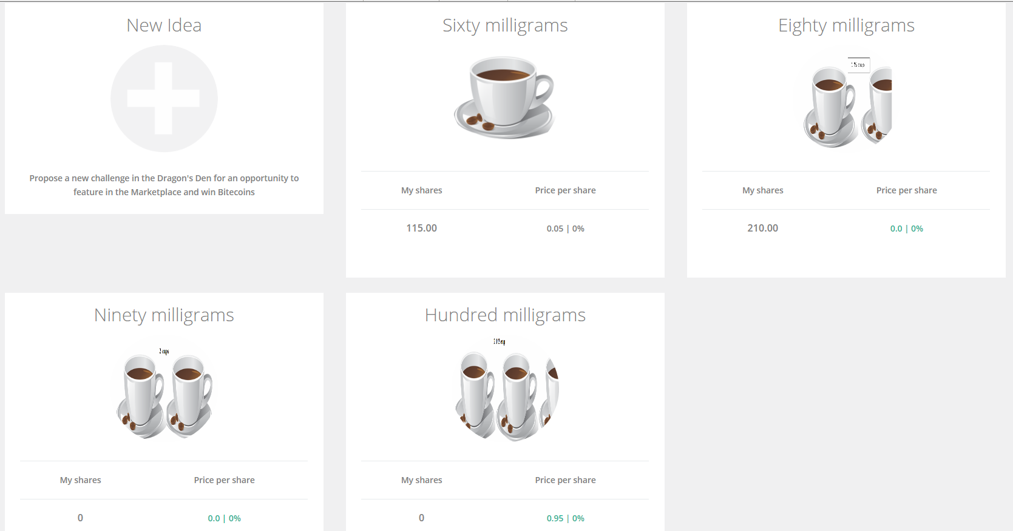
Figure_Apx 23: Sensory attributes of caffeine content in ED
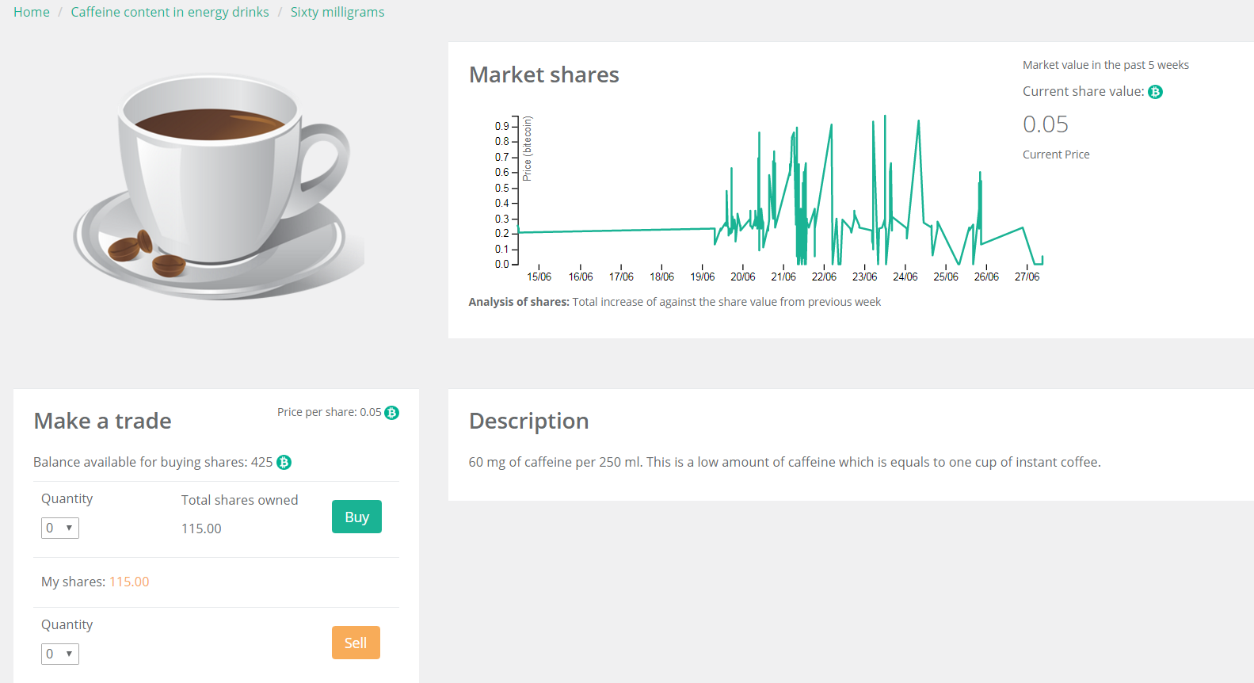
Figure_Apx 24: 60 mg caffeine content trading page
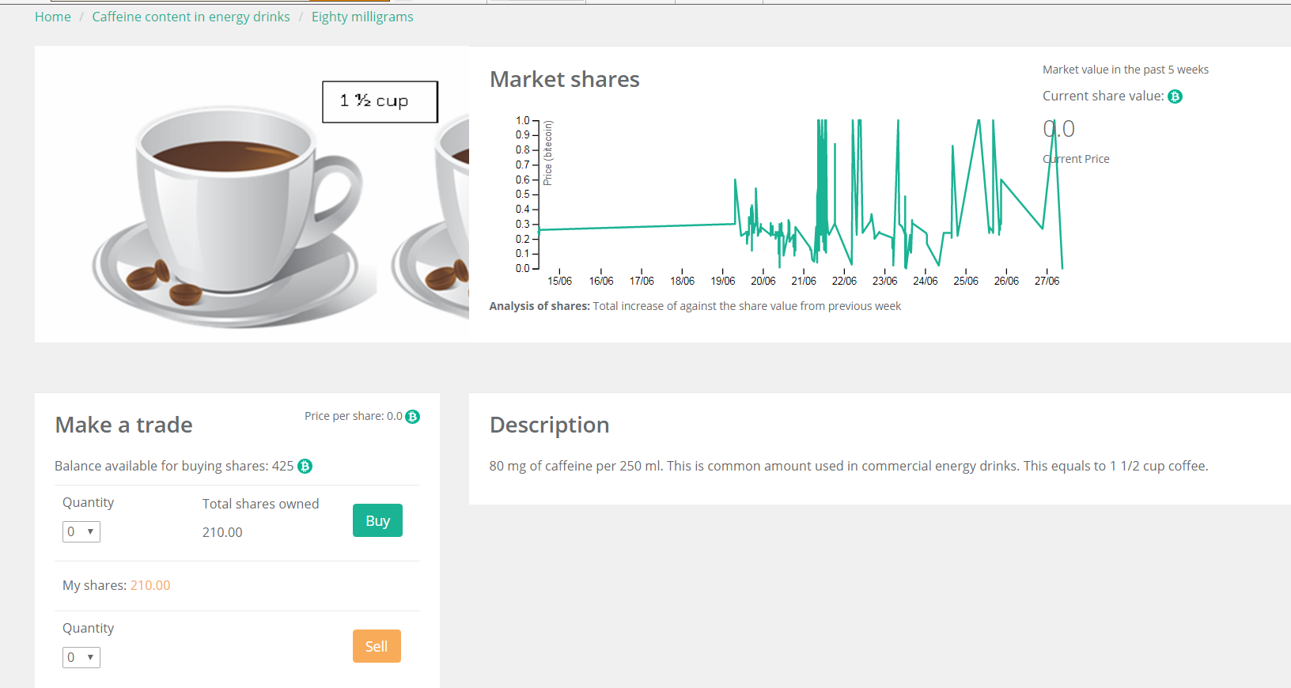
Figure_Apx 25: 80 mg caffeine content trading page
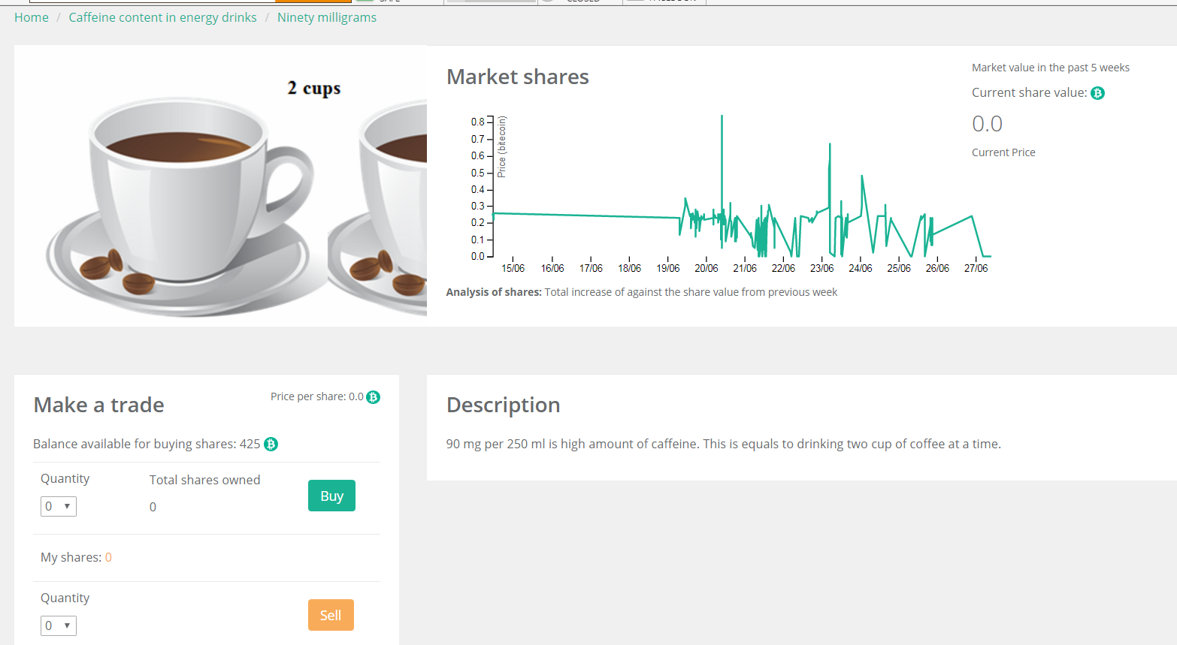
Figure_Apx 26: 90 mg trading page
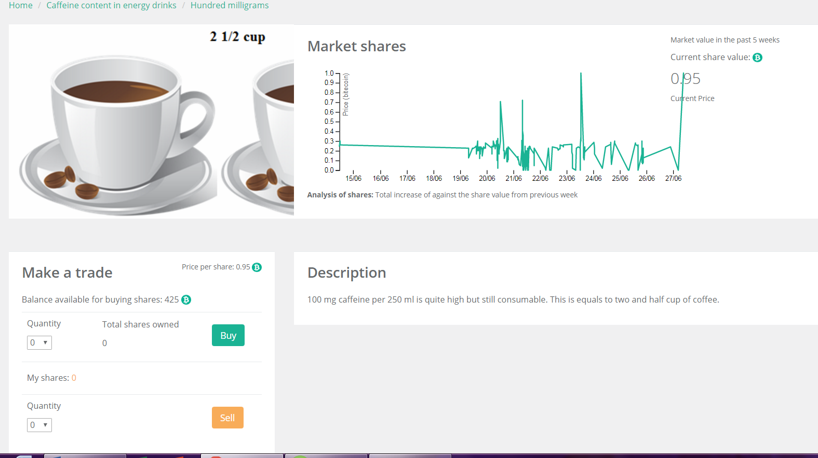
Figure_Apx 27: 100 mg caffeine trading page

Figure_Apx 28: Consent form to participate in sensory evaluation

Figure_Apx 29: Software to control the reactor and pumps

Figure_Apx 30: Script to control the pumps and mixing condition

Figure_Apx 31: Reactor calculation of various parameters
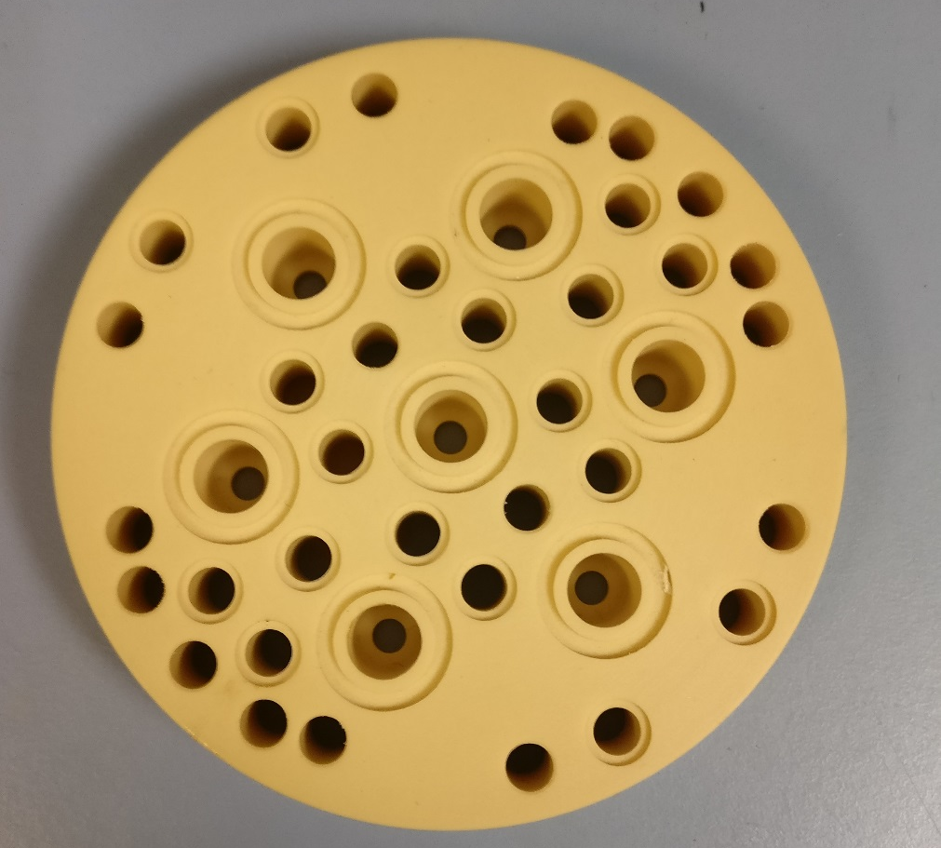
Figure_Apx 32: Reactor baffle disk

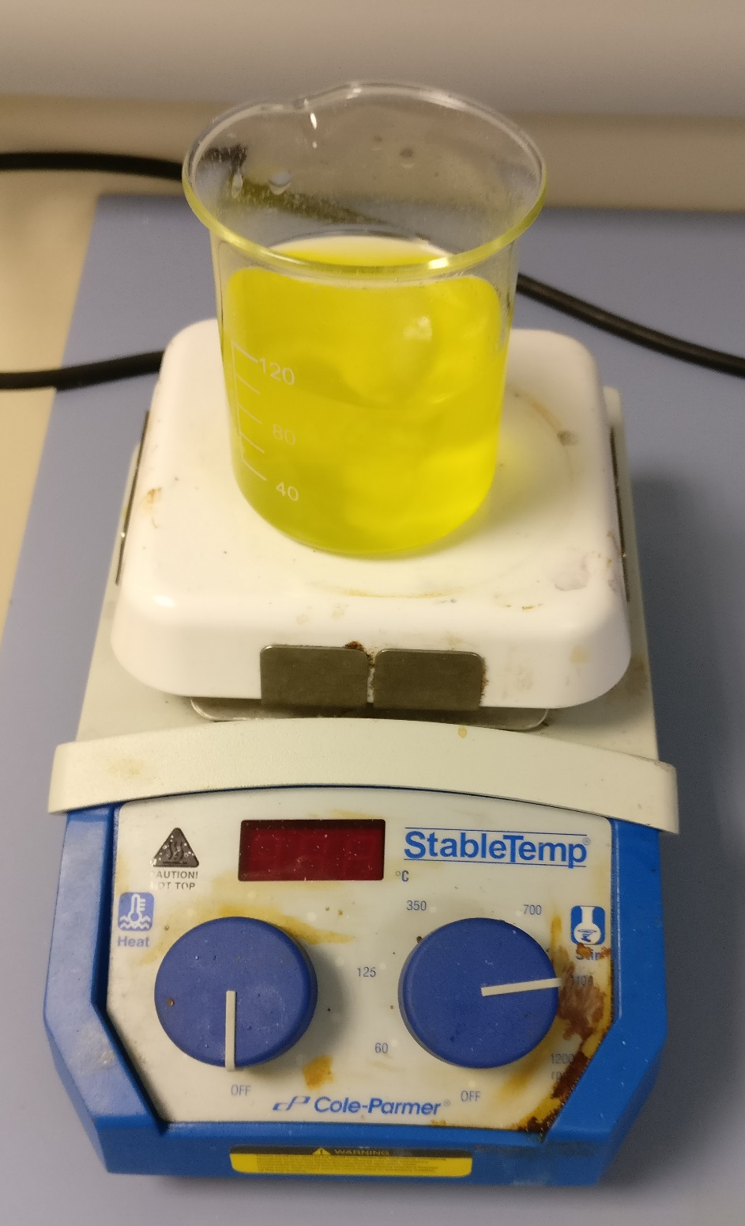
Figure_Apx 33: Magnetic stirrer
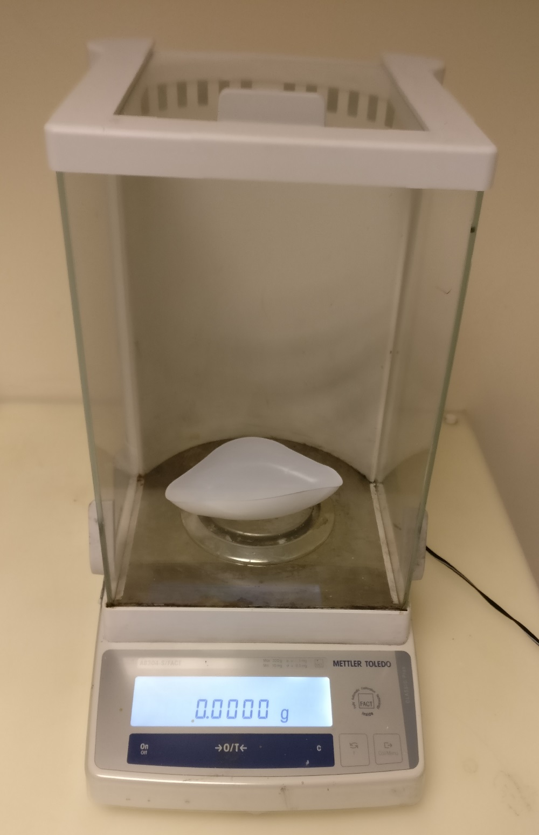
Figure_Apx 34: Weighing machine
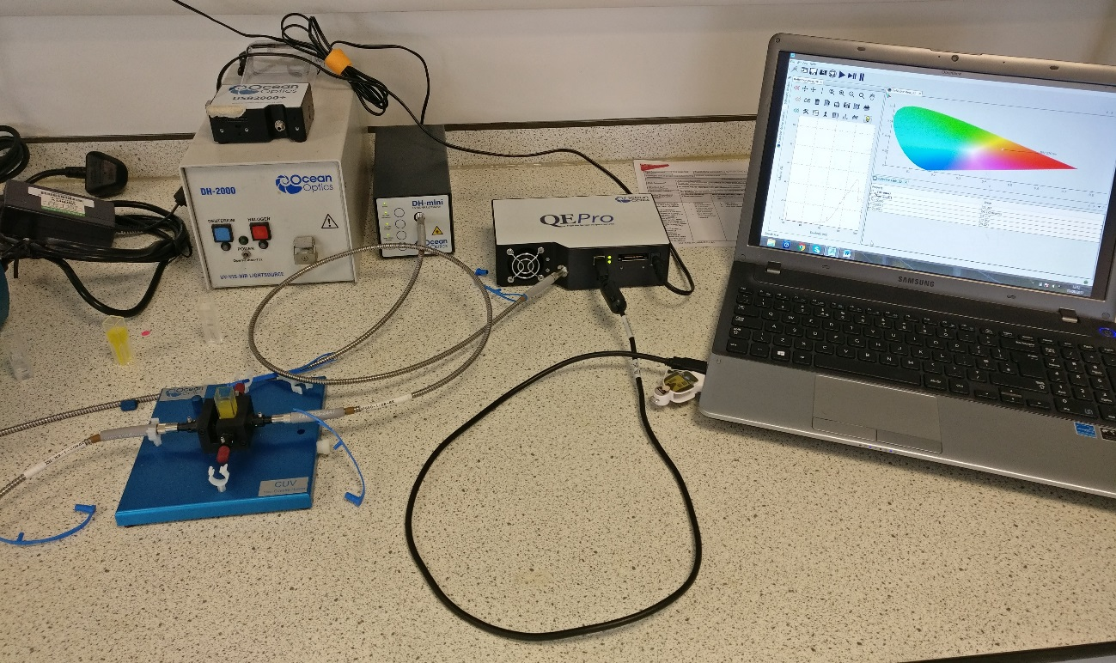
Figure_Apx 35: UV/VIS spectrometer to measure colour intensity
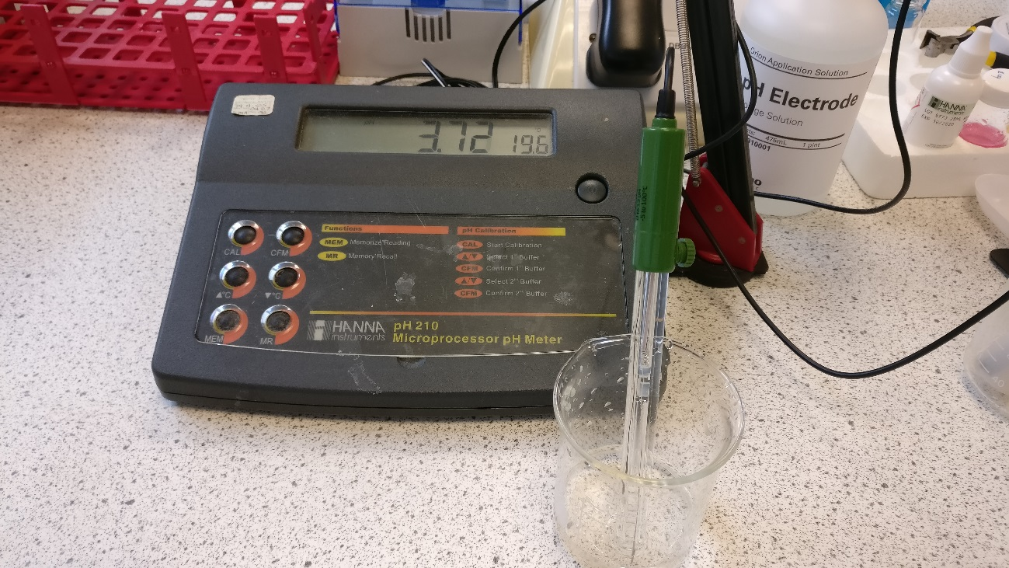
Figure_Apx 36: HANNA instruments pH 211 Microprocessor (pH meter)

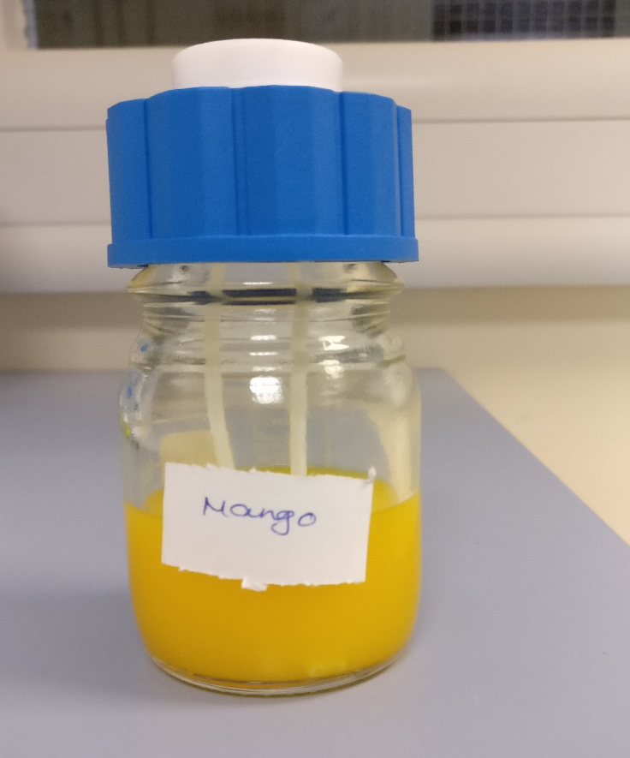
Figure_Apx 37: Mango flavour concentration
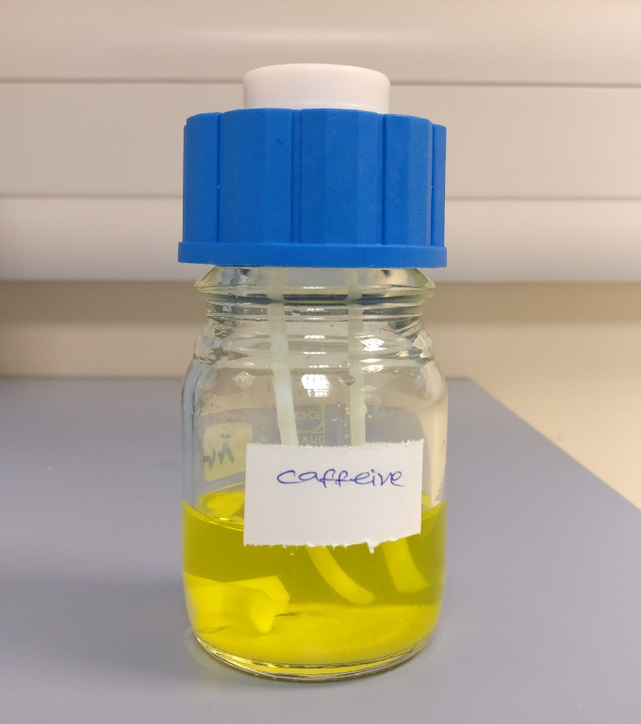
Figure_Apx 38: Caffeine, taurine, B vitamins concentration solution
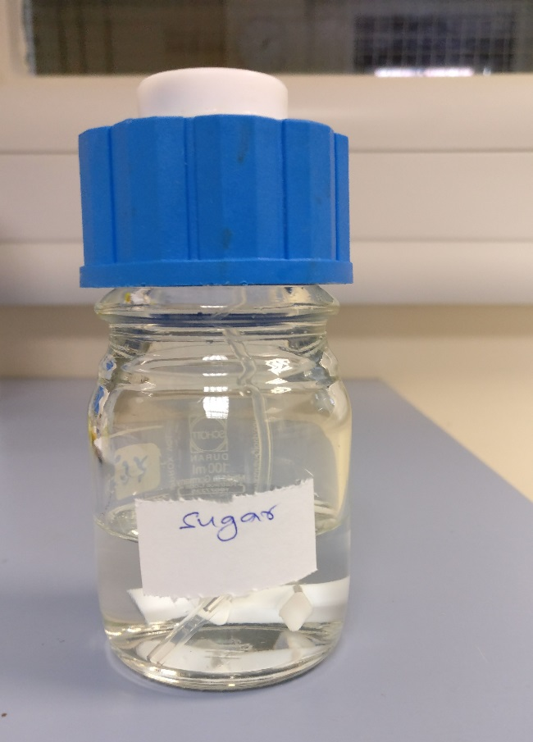
Figure_Apx 39: Sucrose and glucose concentration solution

Figure_Apx 40: Sensory evaluation workshop 1
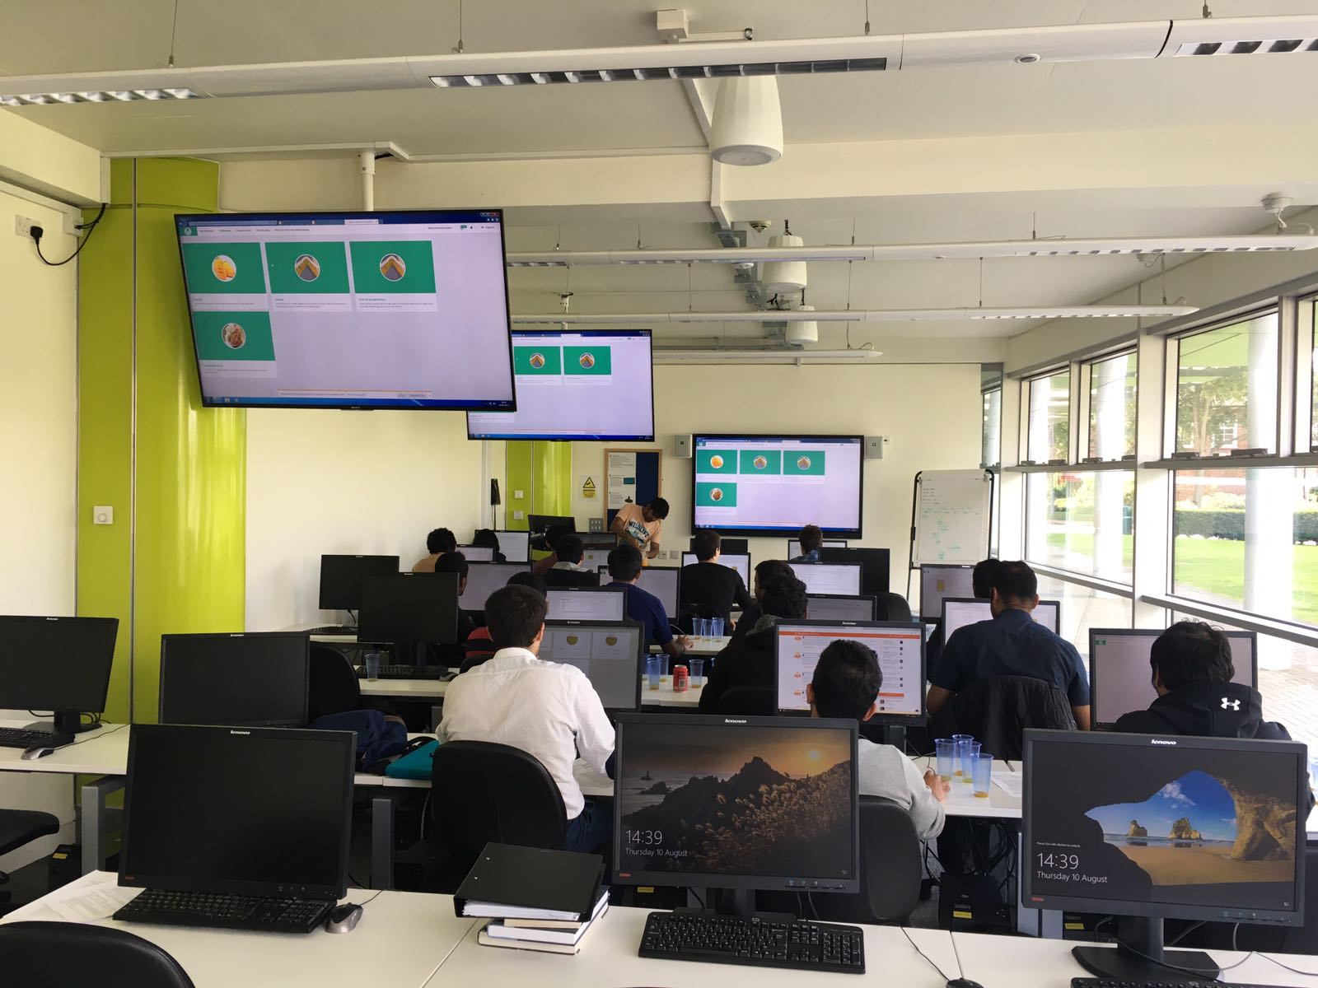
Figure_Apx 41: Sensory evaluation workshop 2

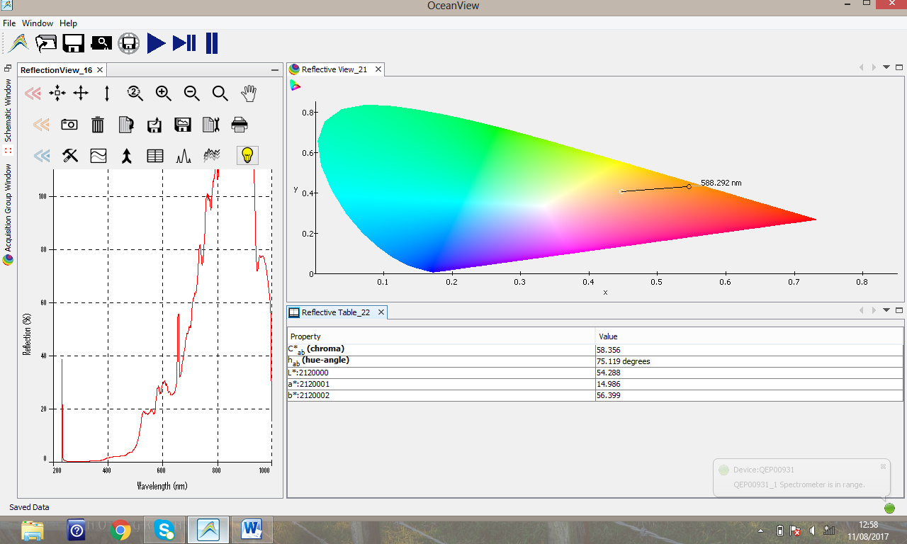
Figure_Apx 42: Sample B colour intensity test

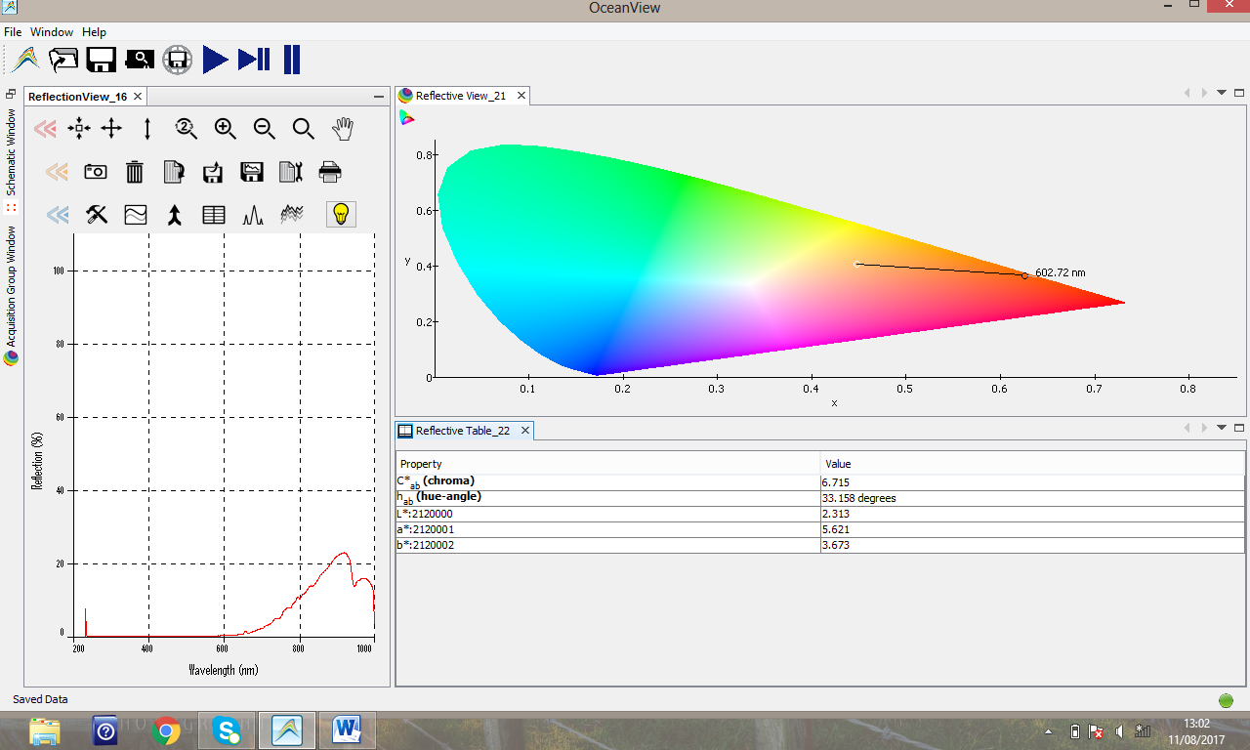
Figure_Apx 43: Sample C colour intensity test

Samples | pH | Residence time in minutes | Colour intensity in nm unite
1 | 3.33 | 7 | 584.473
2 | 3.29 | 7 | 588.693
3 | 3.36 | 9 | 581.26
4 | 3.10 | 7 | 584.049
5 | 3.16 | 6 | 585.179
6 | 3.23 | 7 | 588.44
7 | 3.25 | 5.5 | 587.757
8 | 3.23 | 5 | 585.017
9 | 3.24 | 4 | 589.841
10 | 3.27 | 6 | 594.479
11 | 3.25 | 6 | 596.174
12 | 3.22 | 6 | 596.573
13 | 3.23 | 6.5 | 597.389
14 | 3.29 | 7 | 596.967
15 | 3.25 | 6 | 596.19
Table_Apx 1: Physical properties measurement of samples

