From left to right > First Row: SS1, SS2 / Second Row: H180-4, H240-4 / Third Row: P3001-P400-1
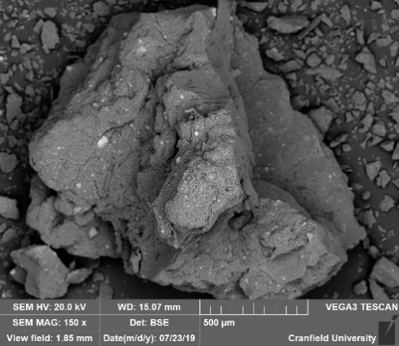 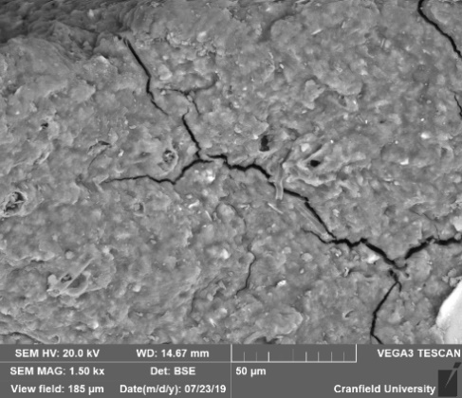
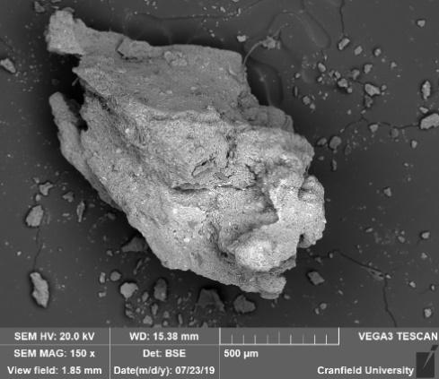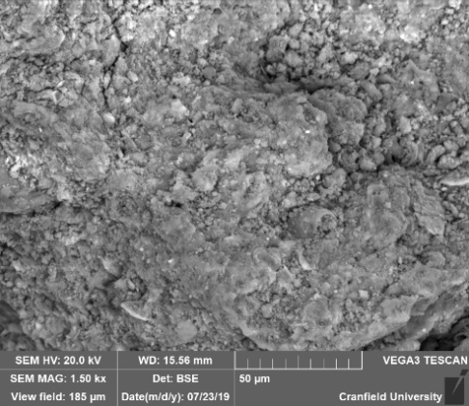
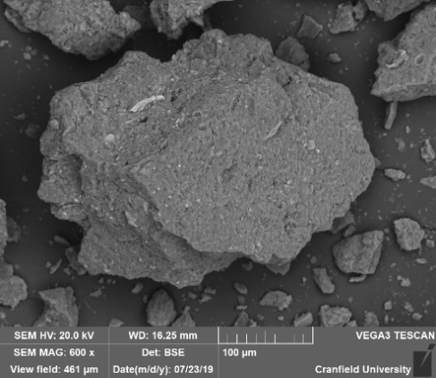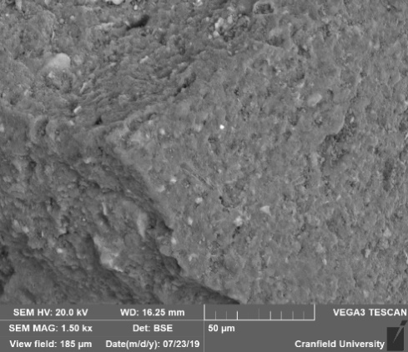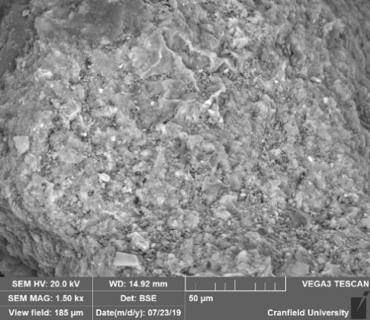
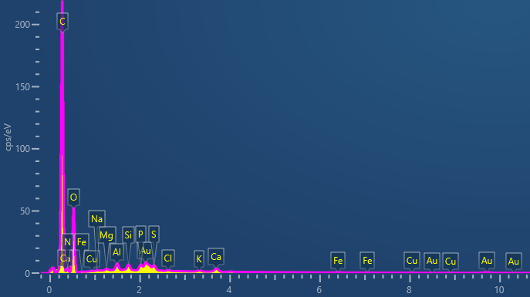
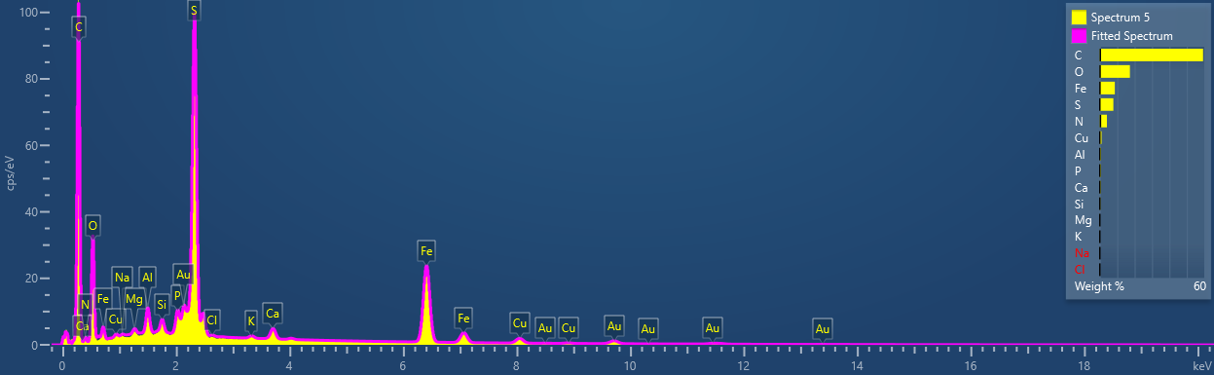
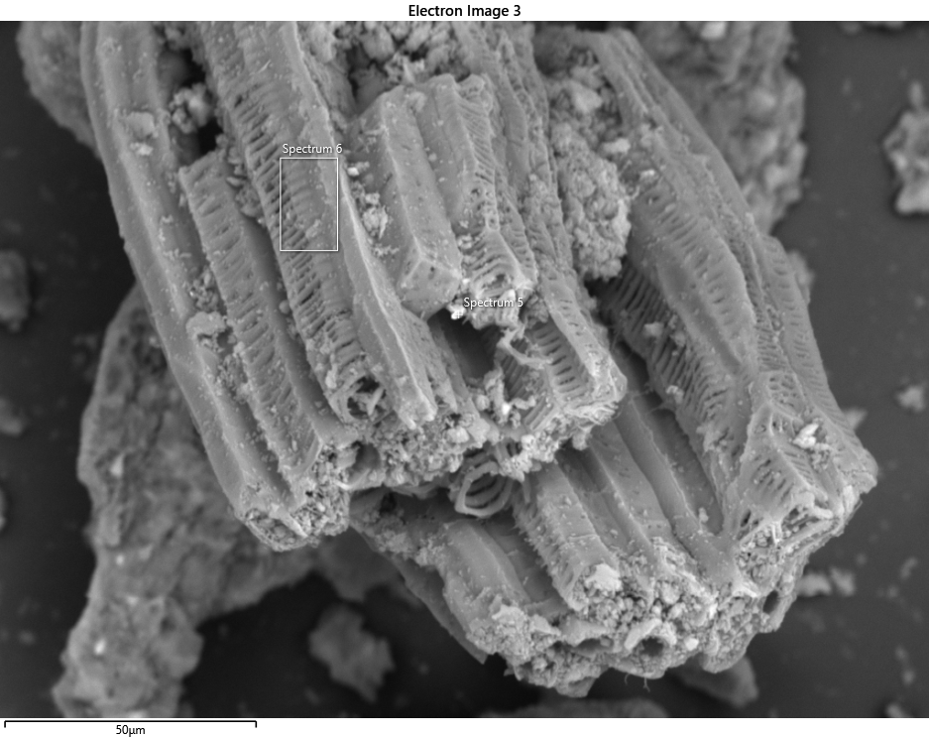
P300-1 Rare
(not representative)
Carbonized algae?

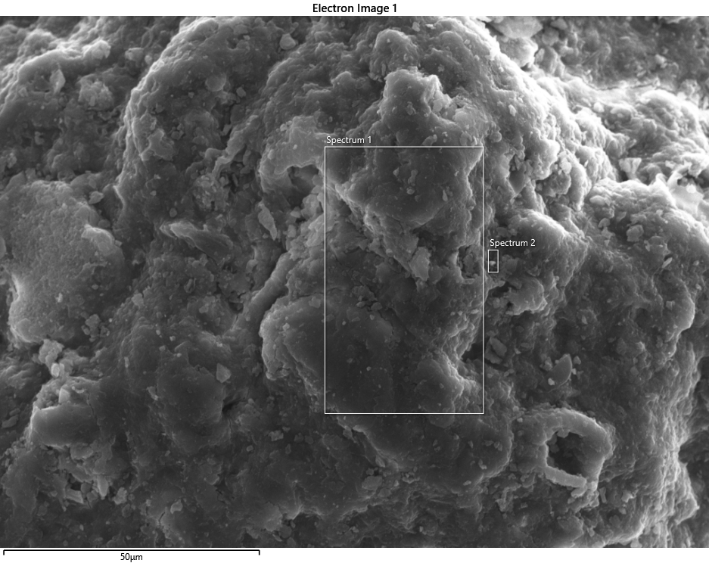
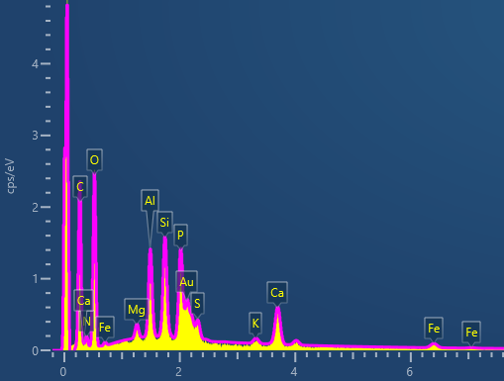
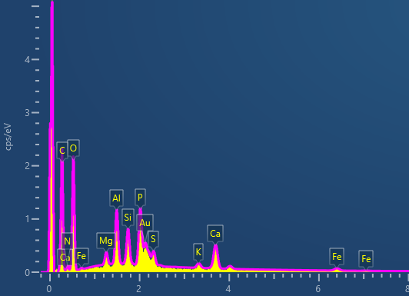
SS-1
(representative)
Not that much N, yes P but Al may be a problem. A bit K. Not that much Iron,

Unfortunately, I could not get on time the SS2 (UK)

